**Document A Manifest Destiny Primary Sources Name:_______________________**

“The American people having derived their origin from many other nations, and the Declaration of National Independence being entirely based on the great principle of human equality, these facts demonstrate at once our disconnected position as regards any other nation; that we have, in reality, but little connection with the past history of any of them, and still less with all antiquity, its glories, or its crimes. On the contrary, or national birth was the beginning of a new history, the formation and progress of an untried political system, which separates us from the past and connects us with the future only; and so far as regard the entire development of the natural rights of man, in moral, political, and national life, we may confidently assume that our country is destined to be the great nation of futurity.”

**John L. O’Sullivan on Manifest Destiny, 1839**

1. What is John O’Sullivan’s view on our connection with the past and future?

2. What does he think our country is destined to be?

**Document B**



3. What does the woman in white represent?

4. What is the overall symbolism of this painting?

5. If you had to come up with a name for this painting, what would it be?

**Document C**

Resolved by the Senate and House of Representatives of the United States in Congress assembled, That

Congress doth consent the territory properly included within, and rightfully belonging to the Republic of

Texas, may be erected into a new State, to be called the State of Texas, with a republican form of government, to be adopted by the people of said republic, by deputies in convention assembled, with the

consent of the existing government, in order that the same may be admitted as one of the States of the

Union.

And be it further resolved, That the foregoing consent of Congress is given upon the following conditions, and with the following guarantees to wit:

First said state to be formed, subject to the adjustment by this government of all questions of boundary

that may arise with other governments: and the constitution thereof, with the proper evidence of its

adoption by the people of said Republic of Texas, shall be transmitted to the President of the United

States, to be laid before Congress for its final action, on or before the first day of January, on thousand

eight hundred and forty-six.

5. To what country is Texas being annexed to?

6. Who has the power to “adjust” boundaries questioned by other countries?

7. What countries might question the boundaries of Texas?

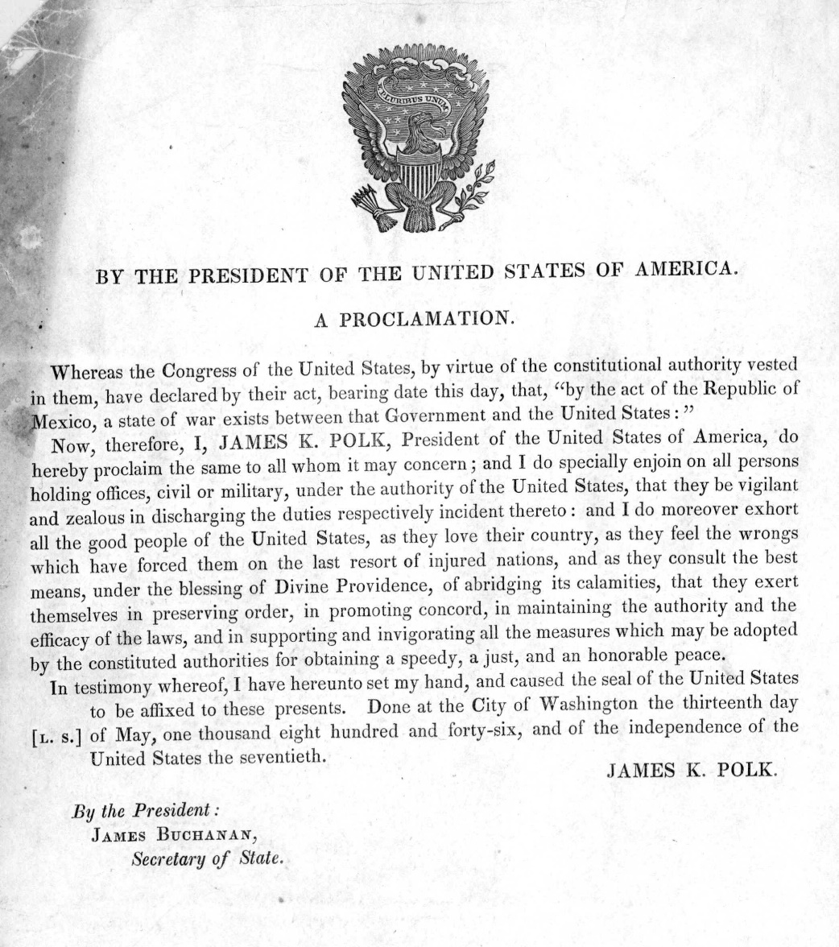

**Document D**

8. Who does President Polk call upon to preserve order?

9. Who does Polk blame for his declaration of war?