Week of April 22nd-28th
The weather has warmed up, go outside and learn!
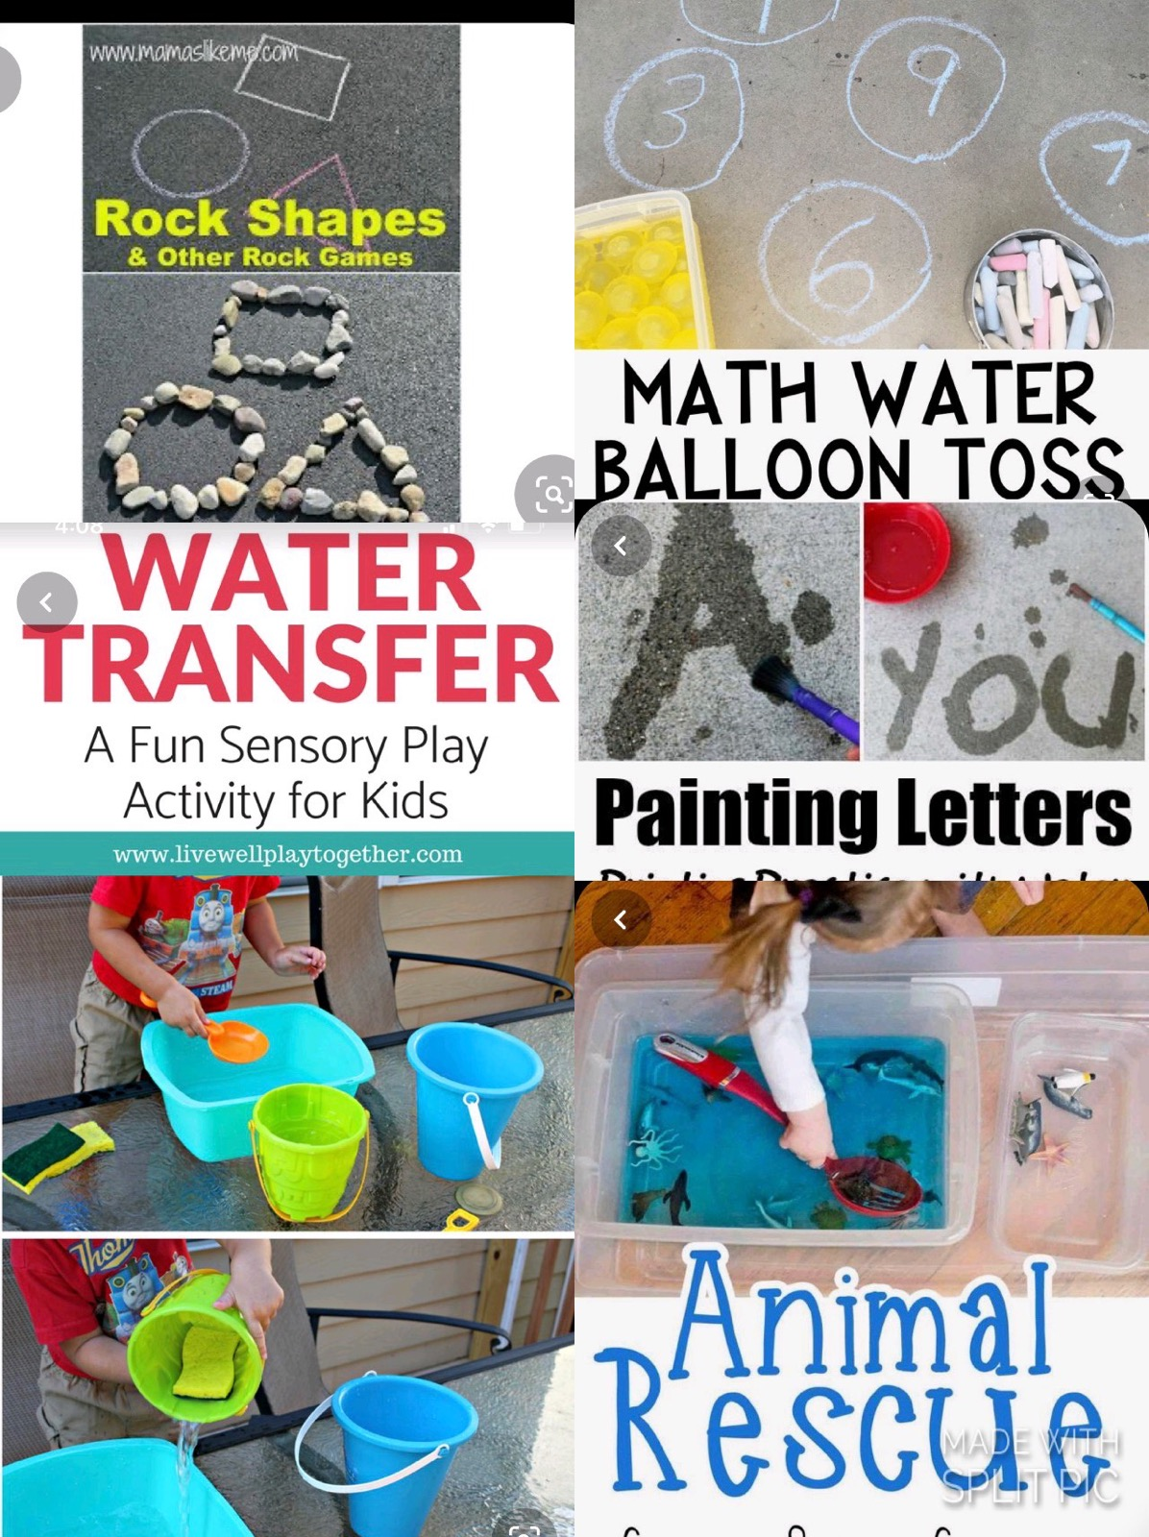

Boom Cards: at least 2-3 times a week. I change them
Download the Boom Cards APP or go to https://wow.boomlearning.com/
Login using your child’s personal login. Password is PHES, unless Ive given you a new one.
StarFall is another GREAT resource. Message me for the Code
Our pinterest has lots of fun activities and ideas to work on at home
https://www.pinterest.com/alexandriawolfdcs/

Circle Time stays the same!!!
It’s so important to keep a routine. Work on the same circle time activities/songs!
Check out my NEW YouTube Channel for easier access to my videos!!
https://www.youtube.com/channel/UCK1t9UDm1TMZdtUm5LJYn1w?view_as=subscriber

Questions of the day:
..\Documents\Distant Learning PREK\week 5 questions.docx
Number 4:
Worksheets
Write the number 4 on pieces of paper and hide them around the house. Make it a Number 4 hide n seek

Letter Dd:
Worksheets
Practice tracing the letter D
Talk about the sound it makes and find things that start with a Dd

Dinosaur Tracing Sheets
*******To access links Press CTRL and the link
