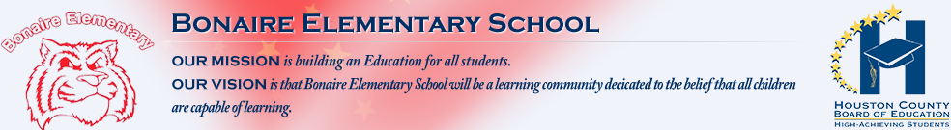
Our Beliefs

- Providing a safe teaching and learning environment for all is a top priority.
- Instructional time should be protected to maximize student learning and achievement in order to support the continuous advancement of all students.
- Stakeholders are committed to the PAWS Life. (Positive Attitude, Always Respectful, Works Diligently & Safety First)
College and Career Readiness
 | 2016 | 2017 | 2018
CCRPI Overall Score | 80.8 | 76.8 | 81.5
Long Range Goals
Bonaire Elementary will:
- Provide high-quality instruction aligned with state and system standards.
- Increase opportunities for stakeholder engagement.
- Continuously plan, implement, and monitor processes and procedures for instructional and organizational effectiveness.
- Consistently build professional learning communities for faculty and staff to promote student engagement and achievement.

External Challenges:
- Limited technology resources
- Meeting the needs of a growing population

Opportunities for Growth:
- Invest in community partnerships
- Address the needs of the 21st Century Learner
- Continue to grow as a school professional learning community
- Provide teacher leadership opportunities through utilization of a Guiding Coalition

Strengths:
- Commitment to academic excellence
- High retention of highly-qualified personnel
- Commitment to build teacher and leader capacity
- Commitment to fostering strong school community and a positive school climate

Key Actions
Actions to be Taken | Related Goal | Timeline
Develop and execute a School Improvement Plan to demonstrate growth on the College and Career Readiness Performance Indicator (CCRPI). | Goal 1 | 2016 - 2019
Implement a balanced assessment approach and utilize data to design and differentiate instruction. | Goal 1 | 2016 - 2019
Facilitate ongoing, two-way communication with stakeholders through multiple modes of media. | Goal 2 | 2016 - 2019
Increase opportunities for shared decision making among stakeholders. | Goal 2 | 2016 - 2019
Provide all stakeholders with a safe and clean learning environment. | Goal 3 | 2016 – 2019
Ensure efficient resource management, including fiscal and human capital. | Goal 3 | 2016 - 2019
Provide sustained job embedded professional learning with school administration, teachers, and support staff to increase best practices and content knowledge. | Goal 4 | 2016 - 2019
Develop a deeper understanding of professional learning communities with an emphasis on essential standards, building common formative assessments as teams, analyzing data from common formative assessments, and providing interventions/enrichment for students based on data. | Goal 4 | 2017 - 2019

