Mrs. Allinder’s English 7
Class Overview
2021-2022

In this class, you are expected to…
BE READY – BE RESPONSIBLE – BE RESPECTFUL

Daily Agenda
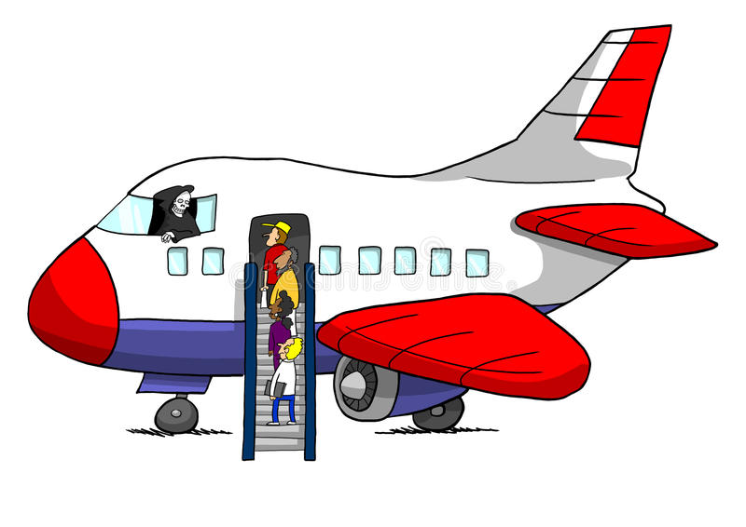BOARD  5-10 minutes | Welcome Work is posted on the board daily. You should immediately get seated, settled, and started…  - GRAMMAR  - VOCABULARY
EXTEND  20-30 minutes | - INDEPENDENT READING  - CONFERENCING WITH TEACHER  - JOURNALING
TAKE-OFF  5 minutes | - RECAP PREVIOUS DAY  - INTRODUCE NEW DAY
FLY  35 minutes | - TEACHER MINI LESSON  - INDEPENDENT PRACTICE  - COLLABORATION with PARTNER or TEAM
DESCEND  5 minutes | - WIND DOWN / WRAP UP  - BRING IDEAS BACK TO WHOLE GROUP
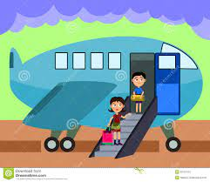 LAND  5-10 minutes | Before you go…  - SHOW WHAT YOU KNOW  This will help me to plan extension activities for the following day.

Supplies
You will be responsible for keeping up with your supplies. Be sure to report daily with the following:
School Issued Device
Binder/Notebook Paper
Composition Notebook
A Book to Read
A Writing Utensil

Homework
There may be times where you are asked to complete classwork for homework or work on assignments throughout the course of the week at home. There is, however, no official homework. You are encouraged to read / write on your own outside of the classroom.

Classroom Library
- You can check out books from me. Only one book should be checked out at a time. If you lose or damage a book, do the right thing – notify the teacher and look into getting a replacement.
- To meet the diverse needs of students, our library has MANY different titles! I read a lot! However, I have not read all of these titles nor can I predict what one individual may find acceptable while another finds it offensive. We will talk about selecting books that are the best fit based on interests, values, maturity, reading levels, etc. However, if at any time you are uncomfortable or know that your parents would kill you for reading a selection on the shelf, I ask that they return the book and notify me of their concerns.

Contact Information
- School Email: lauren.allinder@dcsms.org
- School Status: Reply to number assigned to teacher when welcome message went out
- Schoology: Students and parents can message directly through Schoology accounts

Wish List
A class wish list is maintained through Amazon: https://www.amazon.com/hz/wishlist/ls/11QACBRQSVGZT/ref=nav_wishlist_lists_2?_encoding=UTF8&type=wishlist

