6

**Understandings:**

The students will understand that…

**1.** matter can neither be created nor destroyed but can be changed from one form to another.

2. matter is anything that has mass and volume.(takes of space), and is always either a pure substance or a mixture of substances.

**3.** all matter is made up of atoms and molecules.

**4.** atoms are composed of protons, neutrons and electrons.

**5.** molecules are made of atoms which are bonded

together; therefore molecules are divisible.

**6**. elements possess their own characteristic properties (density, boiling point, melting point, solubility, etc.) and these properties are used to distinguish one element from another.

**7.** elements can be chemically combined.

**8.** elements can bond to form compounds.

**9.** the Periodic Table of Elements is an organized arrangement of elements that can be used to determine an element’s properties.

**10**. there are more than 100 elements on the Periodic Table; these include naturally occurring and “man made” elements.

**11**. compounds are made of two or more kinds of atoms held together chemically (bonded).

**12.** compounds that make up the food we eat provide our bodies with energy.

**13**. mixtures are formed when elements and/or compounds are combined physically.

**14**. mass and volume can be used to determine an object’s density.

**15.** there are four states (phases) in which matter

exists.

**16**. during phase changes, the particles that make up the material move apart or closer together, depending on whether energy is being added or taken away.

**17**. the energy (thermal) of the atoms in matter determines the phase in which it exists.

**18**. when matter undergoes changes, it always involves energy moving into or out of the system, often in the form of heat.

**19**. characteristics of matter, called properties, are used to help us understand how and why matter undergoes the changes that it does; or to predict how matter will behave under conditions not yet observed or studied.

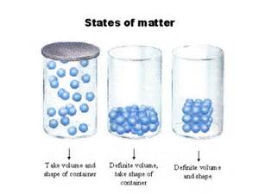

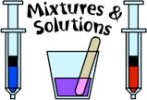



[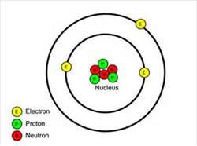](http://www.bing.com/images/search?q=atom&id=81B92FBE294FF63E6BAA067D8FE1014096CFE10F&FORM=IQFRBA#view=detail&id=81B92FBE294FF63E6BAA067D8FE1014096CFE10F&selectedIndex=0)

|  |  |
| --- | --- |
| **Key Vocabulary - Define** | |
| **Particle** | **matter** |
| **Mass** | **weight** |
| **Volume** | **Atom** |
| **Molecule** | **Element** |
| **Compound** | **Mixture** |
| **States of matter** | **Solid** |
| **Liquid** | **gas** |

**UNDERSTANDINGS CONTINUED.**

**20**. properties of matter can be classified as physical or chemical, depending on whether or not a new substance is formed from the starting materials.starting materials.

**21**. physical and chemical changes are two basic processes by which matter changes

. **22.** whether the change is physical or chemical, the total amount of matter always stays the same, even though the material may appear much different after the change as compared to

before the change.

**23**. a physical change in matter alters the form or

appearance of a substance; no new matter is created.

**24**. a chemical change in matter occurs when chemical bonds are formed or broken.

**25.** chemical changes may be classified by the types of changes in reactants and products.

**26.** a chemical equation summarizes a chemical reaction.

**27**. a chemical formula identifies the elements in a compound.

**28**. no matter how many reactants and products are involved, all the atoms present at the beginning of a reaction are present at the end of the reaction.