Dale County Schools
Response to Instruction
Framework
Minimum Requirements
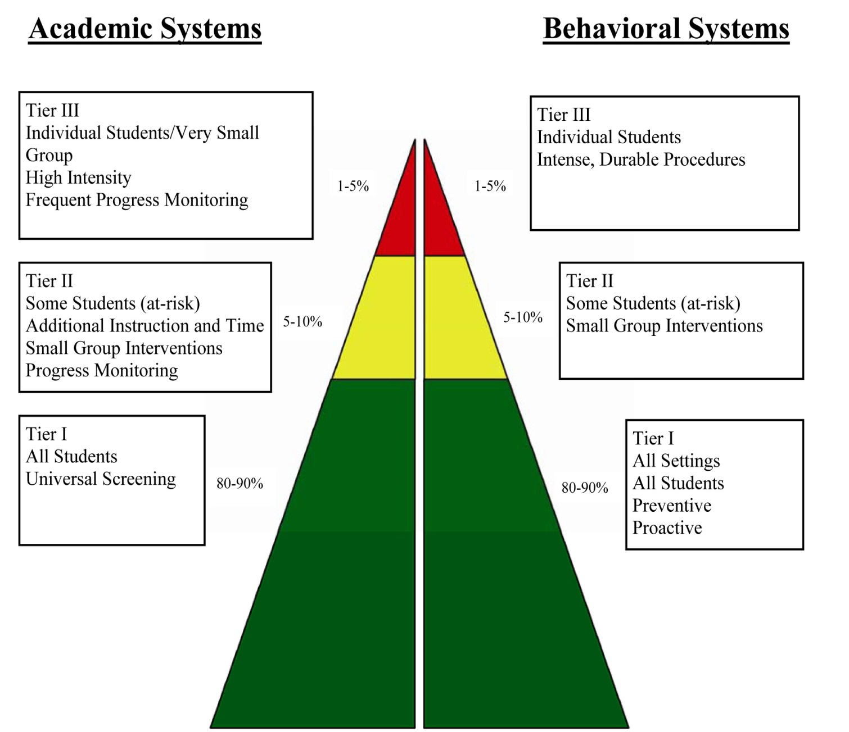

DALE COUNTY SCHOOL SYSTEM
STUDENTS WHO STRUGGLE IN READING, MATH, AND BEHAVIOR
RESPONSE TO INSTRUCTION (RtI)

Each school now has one or more problem solving teams (PST) designed to address the unique and individual needs of each child. In addition to addressing the typical challenges faced by many students, these teams are also designed to address instructional areas for such issues as generalized or specific learning problems or behavior problems. These teams meet at least once per month to review students’ progress. General procedures to address the needs of students are as follows:

Tier I (Core Program)
On-grade level instruction using multiple methods of instruction and awareness of the child’s learning style. Instruction includes such strategies as modeling, re-teaching, providing general remediation, providing corrective feedback, allowing multiple opportunities for student practice, flexibly grouping students, ensuring student engagement, use of pacing guides to direct instruction, use of differentiated instruction, providing accommodations to “level the playing field” for all students, and participation in a screener assessment to identify student needs that will be addressed through the RtI process.

Tier II Intervention
Additional 15-30 minutes of individual or small group instruction every day, which is targeted to specific needs of the student using research-based strategies. Tier II interventions may be short-term and stop once a student has obtained adequate progress toward the targeted skill.

Tier III Intervention
Tier III services are provided in addition to TIER II interventions. An additional 30-45 minutes of individual or small group instruction 3-5 times per week, which is targeted to specific needs of the student using research-based strategies and programs. These programs are taught by qualified and trained personnel. The PST determines which students need additional Tier III interventions and will notify parents of that decision. Tier III students will participate in “progress monitoring“ assessments weekly to determine the success of the interventions. Parents will be notified of the child’s progress. A vision and hearing screening is conducted, along with other assessments that may help to identify any additional problems the child may be having that hinders his/her success. Tier III interventions are intensive and long-term. However, Tier III interventions may stop once a student has obtained adequate progress toward the targeted skills. Lack of progress over time using Tier I, Tier II, and Tier III interventions may result in a referral for an evaluation for special education eligibility.

The RtI process is designed to ensure the implementation of appropriate instruction, which is a necessary component in determining whether a disability is present and if special education services are needed. Parents who are considering requesting an evaluation for special education eligibility should understand that the student will participate in the RTI process.

Dale County Problem Solving Team Checklist

Student Name: _____________________ Grade____ Date ___________ School year________
Teacher referring student & position: _____________________________________________________
Teacher delivering instruction highly qualified: Yes/ No highly qualified in: _______________________
Student has received standards-based instruction: Yes/No
_____ Vision screening from current school year
_____ Hearing screening from current school year
_____ Parent notification and /or update form
_____ Student Information Summary

_____ Student Intervention Plan
_____ Copy of most recent report card
_____ Copy of most recent comprehensive progress report
_____ Copies of State and local Assessments
_____ Work samples (3 to 5 samples ) with analysis sheet on top
_____ Samples are specific to area of deficit
_____ Other records/reports if applicable (Teacher notes, Discipline Files/Notes, Medical Reports)
_____ BASC SOS
______Summary statement of Adverse Affect (SPED referrals only)
Team recommendations: Continue intervention, fade plan, modify plan, discontinue plan
Notes /comments:

Parent Notification

Date: ___________________________

Dear Parent/Guardian,

Your child, has been referred to our Problem Solving Team (PST). Each local school within Dale County Schools has a PST in place to help students who are struggling in academics and behavior. As required by the Alabama Department of Education a problem solving team consisting of teachers, administrators, and other support personnel reviews student data regarding need for assistance: recommends the type of assistance to be provided; reviews data reflecting progress being made by students; and informs parents of this progress and of any recommendations regarding needed changes in interventions.

He/she needs additional support in the following area(s):

_____ MATH

_____ READING

_____ BEHAVIOR

A Problem Solving Team update will be sent home periodically throughout the intervention process.

Parent Signature: ________________________________________ Date: _______________________
Please feel free to contact us with any questions.

Sincerely,

PST Chairperson: __________________________________________ Date: ______________________

Problem Solving Team Update for Parents

Date: ___________________________

Dear parent:

The PST is still working with your child. He/she is receiving additional support in the following area(s):

_____ MATH
Current Average: ________ (See attached documentation)
Current Progress Monitoring Score: ________
Other Data: __________

_____ READING
Current Average: ________ (See attached documentation)
Current Progress Monitoring Score: ________
Other Data: __________

_____ BEHAVIOR
Measurable Goal: ______________________________________________________________
Current Measurable Level of Performance: __________________________________________

Your child is still receiving additional attention, focus, and support in the general education classroom. He/she is being progress monitored on a recurring basis and we are collecting student work samples. Teachers are keeping daily records of small group and differentiated instruction.

Parent Signature: ________________________________________ Date: _______________________

Please feel free to contact us with any questions.

Sincerely,

PST Chairperson: __________________________________________ Date: ______________________

Problem Solving Team Dismissal

Date: ______________________

The Problem Solving Team has determined that your child has met or exceeded the benchmark goal we set for him/her. He/she has maintained that goal for a period of at least 4 weeks.

_____ MATH
Current Average: ________ (See attached documentation)
Current Progress Monitoring Score: ________
Other Data: __________

_____ READING
Current Average: ________ (See attached documentation)
Current Progress Monitoring Score: ________
Other Data: __________

_____ BEHAVIOR
Measurable Goal: ______________________________________________________________
Current Measurable Level of Performance: __________________________________________

Parent Signature: ________________________________________ Date: _______________________

Please feel free to contact us with any questions.

Sincerely,

PST Chairperson: __________________________________________ Date: ______________________

