Pearson eBook Login Instructions
- Go to login.microsoftonline.com
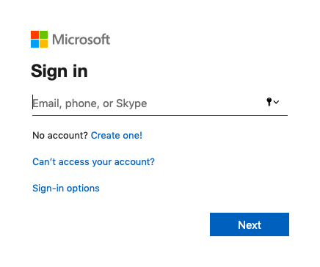
- Enter your school email, then hit “Next.”
Your school email is:
first initial of your first name + first initial of your last name + the last 6 digits of their lunch number
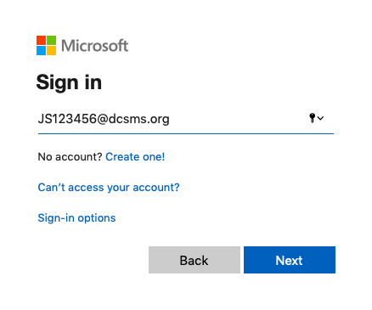

- Enter your password, then hit “Sign in.”
Your school password is:
your school mascot + your date of birth (mmddyy)
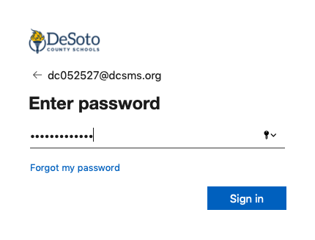
- Once you have logged in, click on the nine dots at the top right of the page.
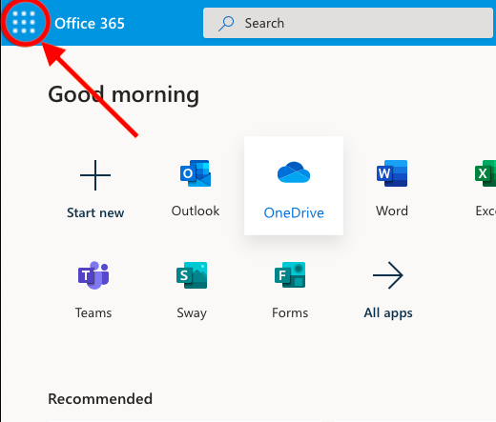

- Choose “Pearson” from the menu on the left side of the page. This will open a new tab in your browser.
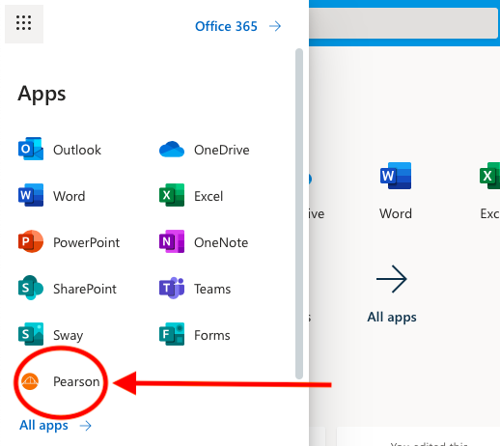
- In your new tab, select “Savvas Realize” at the bottom left of the page. This should bring you to the eBook.
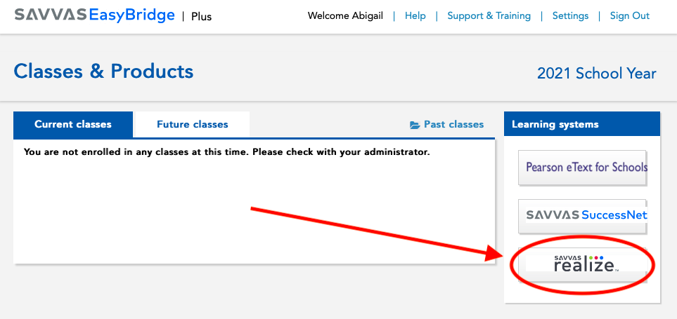

- In the eBook, select “Classes” to see current assignments.
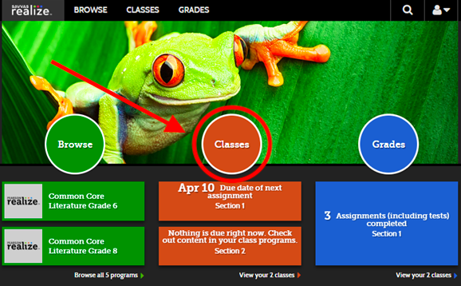

If you have further questions, please visit: https://help.learningservicestechnology.com/realize/en/Student/Content/0_Welcome.htm

