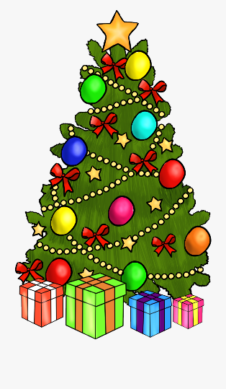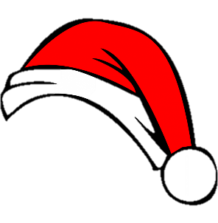

Weekly news from

Mrs. Newburn

**Upcoming Events / Reminders…**

* If you have not sent in headphones for technology, please do so ASAP.
* Thanksgiving break is from November 27th – December 2nd.
* Our Christmas celebration will be Tuesday, December 10th at 6:00pm
* Thursday, December 19th will be our classroom celebration (just the kids and teachers). We will wear pjs that day.
* Looking ahead, Christmas break will be December 23rd – January 5th.

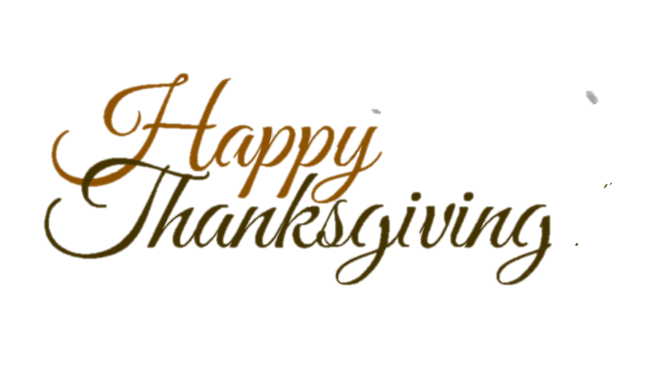

**Skills we are working on…**

* The letters “Aa, Tt, Ff, Ii, Ee, & Ll”, their sounds and how to make them in sign language
* Writing names

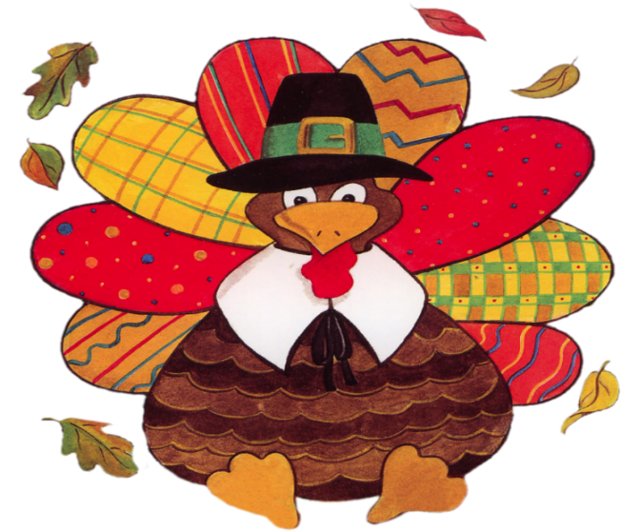

**Things to work on at home…**

**Things to work on at home…**

* Letter recognition….flash cards!!
* The more practice with fine motor skills, the better! Practice writing, coloring, and cutting!