Dear Parent,
Manners are important because they affect our social relationships with others – our teachers, friends, and parents. Good manners can affect how we get along with others, how we feel about ourselves, and how well we do in school with the effort we put forth. Good manners involve being polite in what we say and do. Another marvelous thing about manners is they offer us safety.
This month in classroom guidance we are focusing on manners. We discussed the following questions regarding good manners:
WHAT? being polite in what we say and do
WHERE? everywhere
WHEN? all the time
WHY? it’s the right thing to do and it affects our relationships with others
Using the book, It’s a Spoon, Not a Shovel, we discussed a variety of manners from “wait until others get off an elevator before you get on” to “do not interrupt while others are talking” to how to set a table. It’s important for us to encourage our children to keep their good manners on the tip of their brain so that they may be using them. Please continue to encourage your child to be using his/her good manners. With school and home working together we’ll encourage them to be doing their best.
Thank you for your continued support. As always, please feel free to contact me if you have questions or concerns about your child, your child’s school experience, or our elementary guidance and counseling program.

Annabeth Greene
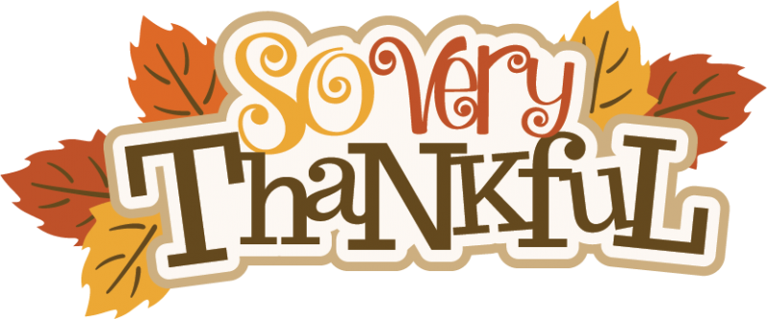
PreK-2 Counselor

