She’s 10, Homeless and Eager to Learn. But She Has No Internet.

Thousands of students living in shelters and doubled up in overcrowded apartments have not received web-enabled devices for online learning.
By Nikita Stewart

Allia Phillips was excited about picking up an iPad from her school in Harlem last week. She did not want to miss any classes and hoped to land on the fourth-grade honor roll again.
On Monday, the first day that New York City public schools began remote learning, the 10-year-old placed her iPad on a tray she set up over her pillow on a twin bed in a studio that she shares with her mother and grandmother inside a homeless shelter on the Upper West Side.
And then, Allia saw nothing.
“I went downstairs to find out that they don’t have any internet,” said Kasha Phillips-Lewis, Allia’s mother. “You’re screwing up my daughter’s education. You want to screw me up? Fine. But not my daughter’s education.”
The Department of Education, which runs the largest school system in the country with more than 1.1 million students, began attempting to teach all students through remote learning this week because schools were closed to slow the spread of the coronavirus.
Shuttering the vast system, which includes 1,800 schools, was a serious challenge for the city, and the large-scale, indefinite school closures are uncharted territory, altering the lives and routines of 75,000 teachers, over one million children, and well over 1 million parents.
Add to that the complication of adapting traditional lesson plans to be taught online, and the city has been faced with an enormous and unprecedented undertaking. Recreating a classroom on the internet is a logistical challenge that comes with a learning curve for students, teachers and parents.
And it is already leaving poor and vulnerable students behind — especially the estimated 114,000 children who live in shelters and unstable housing.
On the first day of remote learning, while some parents in the city were posting cute photos of their children waving to their classmates and teachers as lessons were streamed live, Allia and thousands of other children living in New York City shelters and in overcrowded apartments did not have devices with built-in internet. There are about 450 shelters for families and single adults in the main shelter system, and most of them do not have Wi-Fi available for residents, according to the city Department of Social Services.
The Department of Education has given shelter operators and parents several different dates of delivery, causing confusion and frustration. The new deadline for distribution to all students was this coming Monday, but on Wednesday, the department told shelter operators that deliveries to shelters would begin on that day and would continue through the week.
On Wednesday evening, Richard Carranza, the schools chancellor, posted a photo on Twitter showing an iPad being delivered to a child in a shelter. “It’s happening. Now,” he tweeted. But some shelter operators received no deliveries for students and were awaiting estimated times of arrival.
Students without the proper equipment will fall days, even a week behind their peers, said Christine Quinn, executive director of the nonprofit Win, the largest provider of shelter for families in the city.
“They said Monday. To me, that means never. If they come this late, it might as well be never,” she said. “What has happened is a disaster. If we weren’t in a pandemic, this would be funny, like Keystone cops, but this is a pandemic so it’s not funny.”
Mr. Carranza cheerfully reported Monday evening that the first day of remote learning had gone well, sharing the story of a
principal who had personally delivered a laptop to a student.
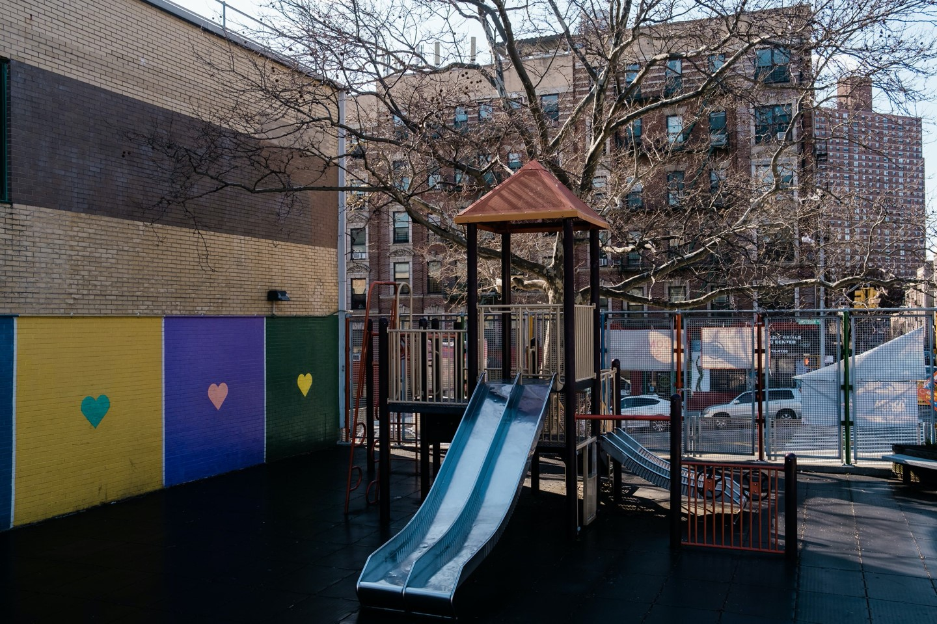
The playground at P.S. 161, where Allia Phillips is a student, sits empty. Students living in homeless shelters often struggle to complete their homework with little space and no privacy. Gabriela Bhaskar for The New York Times
But he acknowledged that children were still waiting for the equipment they need to learn.
“We also cannot talk about remote learning without acknowledging that there is a technology gap that exists among our school communities,” he said. “And I want to start out by saying we are working quickly to make sure every family that needs a device gets a device.”
Mr. Carranza had announced earlier that the city would distribute an estimated 300,000 devices and that students in temporary housing would be prioritized. He said 175,000 had been distributed and that the rest would be given out “in the coming weeks.” The vague timeline has concerned parents and advocates for children.
Nearly 1,600 children, in classes ranging from pre-K to high school, live in Win shelters. As of Thursday, about 1,400 students still needed devices.
“It is clear to me that the administration, to some degree, has forgotten about homeless children,” said Ms. Quinn, former speaker of the City Council.
Ms. Phillips-Lewis said she thought Allia would get a device with built-in internet by Friday, but she was not sure and was not getting a clear answer from LCG Community Services, the nonprofit that runs the shelter where she lives.
On Monday, Allia made do, using her mother’s smartphone to log into Google classroom. She moved to a stool, balanced the phone on her knees and looked down, the light of the screen bouncing off her cheeks.
Around the city, other students were resorting to the same alternative. Sisters Kamiyah Williams, 6, and Chastity Battle, 5, did their class work on their mother’s phone while sitting in a living room in Brownsville, Brooklyn. They live in a small two-bedroom apartment with their mother, two younger siblings and three other people.
Kamiyah said she missed reading her favorite book at school. “My favorite story is talking about animals. Lions,” she said.
Chastity has an artistic streak. “I like painting,” she said.
Both girls are good students, said Tierra Williams, their mother, adding that she did not want them to fail because they did not have tablets. She was trying to help them, but she was having a hard time. “It’s really confusing on the phone because the words are so small,” Ms. Williams said. “I don’t want to miss an assignment because I don’t see it all.”
While the education department was giving shelter operators information to pass along to parents, Ms. Williams, who does not live in a shelter, was awaiting someone, anyone to contact her. “I filled out the forms a few days ago. I don’t know if they are going to call my phone or if they are going to mail it here,” said Ms. Williams, 24.
Inside the city’s family shelters, workers have been bracing for chaos since Mayor Bill de Blasio first announced that the school system would shift to online classes.
Estrella Montanez, the director of the Nelson Avenue Family Residence in the Bronx, said she quickly saw a problem last week when she and her staff knocked on families’ doors to ask if they had devices.
The door-to-door polling showed that only 15 out of 79 families had a computer or tablet. There were 177 school-aged children living in the shelter and they attended more than 100 schools. “When we look at the idea of distance learning, it’s very complicated. Each school seems to be doing something very, very different,” she said.
There was also the glaring fact that the shelter has no Wi-Fi, and Ms. Montanez was hoping a contractor would install Wi-Fi on Wednesday.
She was trying to come up with solutions, like opening up community rooms in the shelter for children who need extra help with work. The spaces could accommodate eight children per room at the same time to adhere to social distancing.
She considered relaxing the shelter’s rules. If a family leaves for more than 96 hours, that family loses their room. But how could she deny children an education? “Maybe students can’t access internet from here, but maybe they have a relative who does that they can stay with for a few days,” Ms. Montanez said.
J’Marion Brown, 14, who lives in the shelter, went to his school himself to pick up a device and his assignments, hoping to keep up with his classes. But he was worried about math. “I have a very, very thick math packet and I’m not too good with math,” he said.
Jennifer March, executive director of the Citizens’ Committee for Children, feared that city officials were not thinking through all worst-case scenarios.
While many students were doing their best on smartphones, Ms. March asked about the ones who might not have the bare minimum access. “Do we even know that all of their parents have working phones?” she asked.
Families are already living on top of each other in shelters or overcrowded apartments, and this was one more stressor, Ms.
March said. “This is a population that has already experienced profound trauma being dislocated,” she said.
She added that students struggle to complete their homework with little space. “The other conundrum is how do you do that well if there’s no privacy?”
Ms. March said her nonprofit was asking the city to consider allowing homeless children who would like to to attend the 93 “regional enrichment centers” that the city has set up in every borough to accommodate the children of essential workers, like health care workers, transit workers and emergency medical workers.
The centers have been underutilized as essential workers stick to other arrangements they had made. In New York where rents are exorbitant and finding quality, low-income housing is difficult, some of those essential workers live in shelters.
For 10 years, Toiyia, a mother who lives in a Win shelter in Brooklyn with her two sons, has worked for Access-A-Ride, a public transportation service for people with disabilities.
Toiyia, who did not want her last name used to protect her privacy, already had devices for both of her sons: Tahir, 8, and Khalil, 18, who is disappointed that his school probably will not have a graduation ceremony.
But the pandemic has changed the way they have to learn. The boys have turned their phones into mobile hot spots.
Khalil, who has been accepted to six state colleges so far, finds himself being Tahir’s de facto principal, counselor and teacher all rolled into one while his mother is at work.
“He knows what he’s doing. He second-guesses himself. I have to guide him,” Khalil said of his younger brother. “He starts to get the hang of it. He’s a smart young man, but he just doesn’t focus all the time so it throws him off.”
Tahir had little to say about his brother’s newfound role and the transformation of their room in the shelter into a classroom. “I’m not happy, but I’m being chill,” he said.
On the Upper West Side, Allia had no big brother and no iPad, but she pressed on completing her assignments on her mother’s phone. She remembered days she spent in the classroom. “Sometimes, when we have equations or something, my teacher calls an assignment, and when we do them, some kids, we kind of do it like a race, but at the same time we are trying to focus and that’s the fun part,” she said.
Her grandmother’s service dog, Buster, panted, and her mother and grandmother tried to give her some space to concentrate.
They moved to the other side of the room.

