Lesson 1
Monday, March 16
Self portraits
Read the following article.
Answer the following 2 questions.
1. What unusual material does the artist use?
2. What unusual material(s) could you use to create a self portrait for yourself? Explain why you chose certain materials and why are they important to you.

ArtDependence Magazine came across a very interesting artist: Andy Brown. Brown found notoriety when he created a portrait of Queen Elizabeth II by stitching together 1,000 used tea bags.
ArtDependence Magazine: What inspired your fascination with the Monarchy?
Andy Brown: Growing up in the UK, and maybe particularly within my family, the royal family felt ever-present. My grandparents drank tea from mugs with portraits of the Queen and Prince Philip on them, and every royal occasion felt like a big event where we were. From postage stamps to money to television and newspapers, where fields battles were fought to pub names ‘The King’s Head' etc., we are surrounded by images and history relating to the monarchy in the UK.
AD: How did you devise the idea of portraying the Queen in teabags?
AB: When I first starting making the tea pieces, I was working with pictures from the Falklands War. I was very young during that conflict, but images from it seemed to be ever-present in the UK in the 1980’s. I started using tea like water color to paint the iconic moments of the war in washes of sepia tones. Within that series, I went through to images of Diego Maradona and his 'hand of god' moment and then the Queen. The next logical step seemed to be to make images from the actual tea bags themselves. The Queen seemed to be the universal icon and symbol which related to all of this and much more, encapsulating a whole nation’s history and future.
AD: How long did it take to make this portrait?
AB: The first tea bag piece was stapled to a wall in my studio. It was a quick sketch really, to try out the medium and find its limitations. It worked well, so I decided to stitch the tea bags on to hessian. They were sewn on to represent the delicate nature and fragility of icons and monarchy. It also was a nice metaphor for the threads which hold us together in making up this symbol that we are related to. It took a long time to complete - over 3 weeks. I used over 1,000 tea bags. Some were used, some unused and some were spilt and the tea leaves were taken out.
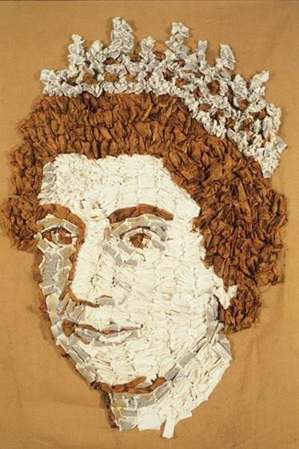
God Save the Queen, 2002. Tea bags on Hessian
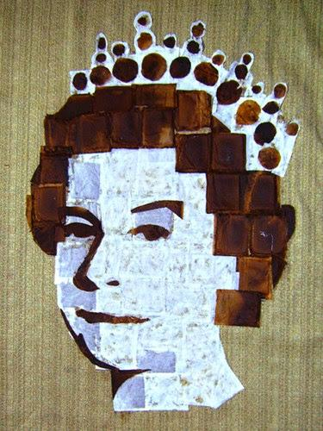
God Save the Queen, 2008. Tea bags on hessian
AD: Is it easy to preserve this work with factors of humidity, etc.?
AB: There have never been any issues with preserving the work. The used tea bags were fully dried before they were used. The original pieces are nearly 20 years old and are still in fine condition.
AD: Did you expect all the recognition that followed from this portrait?
AB: No, not at all. Initially it was not quite what I had imagined, and I was not sure what to make of it. But I have learned this is often a good sign of making breakthroughs in one’s work. Reasonably quickly, I could see it was good, and when people started seeing it, their reaction was more and more positive. It seemed to have something to it, which captured that time, but it also seems to still hold something all these years on. I still did not expect what happened later with many press articles, interviews, a letter from Buckingham Palace, appearances on BBC television and radio, and a question about me in the board game Trivial Pursuit. Making this piece, and what it has given continues to be a wonderful experience. It is great to have felt that appreciation from others and the knowledge that it had something to it which people enjoyed.

Lesson 2
Tuesday, March 17
Happy St. Patricks Day

Do you recognize this face? That's right, it's the Mona Lisa. The Mona Lisa is the most recognized portrait in the world. In this photo she has been accessirized with a green dress and hat and rainbow for St.Patrick's day.

The painting's subject is commonly thought to be Lisa Gherardini, whose husband hired Leonardo DaVinci to paint the work in Florence, Italy around 1503. The less prevalent title for the painting is La Gioconda. The name Mona Lisa roughly translates to "My Lady Lisa." Leonardo da Vinci did not complete the portrait before his death in 1519.

Although in the art world, the painting had always been an acknowledged masterpiece, it wasn't until it was stolen in the summer of 1911 that it would capture the attention of the world. Newspapers spread the story of the crime worldwide. When the painting finally returned to the Louvre two years later, practically the whole world was cheering.

"Mona Lisa" has received plenty of love letters and flowers from admirers. She even has her own mailbox at The Louvre Museum in Paris.

Would you want your portrait to be as famous as the Mona Lisa? Why or why not?
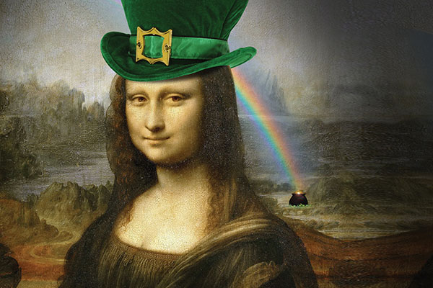

Lesson 3
Wednesday, March 18

Giuseppe Arcimboldo (Italian, also spelled Arcimboldi) (1526 or 1527 – 11 July 1593) was an Italian painter best known for creating imaginative portrait heads made entirely of objects such as fruits, vegetables, flowers, fish and books.

Look at the following 3 portraits. Identify/list the various materials used to make the portraits. Can you guess which title goes with which portrait?
"The Librarian"
“The Lawyer”
"Summer"
"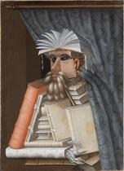"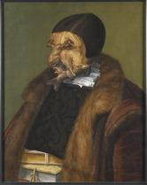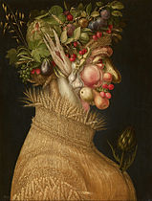

Lesson 4
Thursday, March 14

Let's learn how to tell a viewer about yourselves without drawing your face and to give your art more personal meaning.

1. In a piece of paper trace your hand.
2. At the end of each finger draw a symbol of something you like to do. For example, you might draw a paint brush or a pencil or a soccer ball or a gaming device.
3. Inside your hand write a story about yourself.

Lesson 5
Friday, March 20
Future self portrait

Futurism - An Italian art movement from the early 20th century that emphasized themes such as technology, speed, and youth.

Think about yourself 30 years in the future. Consider the following questions.
What kind of career will you have? Where will you live? What kind of communication devices will we have? What kind of clothing will you be wearing? What will your family/friends look like? What kind of vehicle will you drive? What kind of food will you be eating?

Draw yourself in the future. Write a short paragraph explaining what elements of your drawing are futuristic and why.

