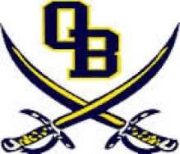

OBMS March Events

March 1: Cheer Tryouts
March 4: Book Fair Ends
March 5: Cheer Parent Meeting (New 2019-2020 Squad)
March 6: NAEP Test for selected 8th graders
Cheer Banquet (2018-2019 squad)
March 7: 9 weeks tests: Science (all grades) and Cyber Foundations (8th grade)
March 8: 9 weeks tests: Social Studies (all grades)
March 11-15: Spring Break
March 21: Report Cards
March 23: Miss Olive Branch Pageant (ages 13-seniors)
Young Band Festival (Hernando High School)
March 26-31: 8th grade class trip to Washington D.C.
March 28: CFA Chicken Biscuits (PTA)

Dates are subject to change and events may be added; updates will be posted on our school website.

