MCj04241300000[1]

Welcome to 4th Grade!!!

**Mrs. Tanya Musselwhite Mrs. Elizabeth Dearing**

**Language Arts/Social Studies Teacher Math/Science Teacher**

Welcome to another exciting year in the life of your child! We hope to make your child’s fourth grade year a positive learning experience as well as enjoyable. We would like to take this opportunity to provide you and your child with some information that will guarantee we have a great year.

**Tiger Pride**

Students will need to show Tiger Pride in everything we do! More information about Tiger Pride and our social contract will be sent home soon.

**Tiger Pride Expectations**

* P- Positive Attitude (See the good!)
* R-Respect (Respect everyone, always!)
* I-Integrity (Do what’s right/ Own your behavior!)
* D-Dedicated (Give your all, finish what you start!)
* E-Excellence (Always do your best!)

**Consequences**

When a student does not meet our Tiger Pride expectations or breaks the classroom social contract, he/she will receive the following consequences.

1 check- Verbal warning

2 checks- Behavior chart check

3 checks- Infraction notice to the student

4 checks- Pride Reflection Sheet and parent contact

5 checks- Office Referral

**Rewards**

Students will earn Tiger Pride Points for positive behaviors to earn rewards.

**Homework**

We will give all homework assignments for the week on Friday in our weekly newsletter, and it must be turned in the next Friday. As always, the purpose of homework is to reinforce the skills taught in class. Students who consistently don’t complete homework have trouble keeping up in class.

**Please note that the student is not graded on accuracy, but whether or not HW is completed.** In addition, we encourage students to read 20 minutes each night. We also encourage each child to practice their multiplication facts daily! Knowing basic facts are crucial in order to master all other math skills.

**Signed Folders**

We will send graded paper folders home every **Thursday**. Pease sign the sheet and keep the graded papers.

**Class Website**

Each week the class websites will be updated with the weekly skills and any other important information about upcoming schools events. You can find our class website through the OGCE home page.

**Schoology Please read information below. It is important that all students become familiar with how to access and utilize schoology.**

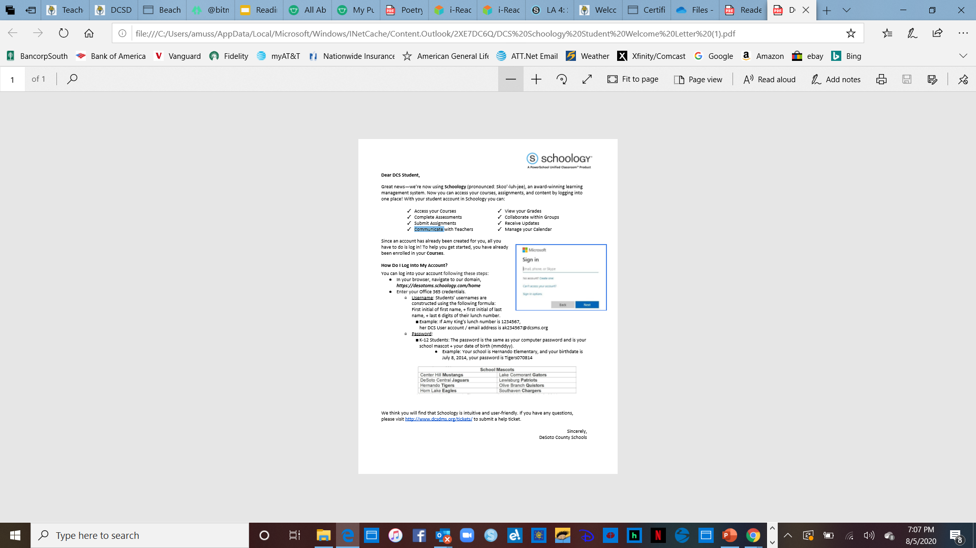

**Mrs. Musselwhite’s Homeroom Schedule** **Mrs. Dearing’s Homeroom Schedule**

7:45 Tardy Bell Rings 7:45 Tardy Bell Rings

7:45-8:15 ELA /Social Studies 7:45-9:00 Math/Science

8:15-9:00 Activity 9:00-9:45 Activity

9:00- 10:40 ELA/ Social Studies 9:45-10:40 Math/Science

**Teachers Switch Classes** **Teachers Switch Classes**

10:40-11:00 Recess 10:40-12:25 ELA/Social Studies

11:00-11:25 Lunch 12:25-12:50 Lunch

11:25-1:35 Math/ Science 12:50-1:10 Recess

1:35-2:10 Tiger Time 1:10-1:35 ELA/Social Studies

2:20 Dismissal 1:35-2:10 Tiger Time

2:20 Dismissal

**Activity Schedule-**

Monday- Computer

Tuesday- PE

Wednesday- Art

Thursday- Library

Friday- Music

**FYI**

* We have a snack time each day. Your child may bring one from home or purchase one each morning.
* Students may pick up breakfast in the cafeteria from 7:00-7:30 at no charge.
* Lunch is $2.75.
* School starts and the tardy bell rings at 7:45 a.m. Students may arrive beginning at

7:00 a.m.

* Your child is strongly encouraged to bring a **WATER** bottle. Please make sure it has a top of some sort to limit spills.
* Please be aware that it is a **MAJOR** transition from 3rd to 4th grade.
* Please send a note each day for **ANY** change on how your child will come home in the afternoon and be sure to remind your child to turn that in as soon as they get to school in the morning.
* In an effort to social distance and decrease the risk of exposure we are not sharing personal supplies this year. Students will keep their backpacks and pencil pouch with art supplies at their desk.
* For any additional information see The OGCE Return to Learn Plan-Parent Guidebook.

We are looking forward to a great year! Feel free to email or text us with any questions or concerns.

[tanya.musselwhite@dcsms.org](mailto:tanya.musselwhite@dcsms.org) Cell phone- 901-491-3645

[elizabeth.dearing@dcsms.org](mailto:elizabeth.dearing@dcsms.org) Cell phone- 901-605-2263

