What is a School-Parent Compact?
A School-Parent Compact is a written agreement jointly developed by parents and teachers. The purpose of the Compact is to help children reach high standards. The Compact is a clear reminder of everybody’s responsibility to take action at school and at home so that children can reach/exceed their academic goals and the goals of the school improvement plan.

The Sharp Creek Compact:
- Links to goals of our School Improvement Plan
- Focuses on student learning skills
- Describes strategies parents can use at home to strengthen students’ skills
- Shares strategies parents can use at home
- Explains how teachers and parents will communicate about student progress
- Describes opportunities for parents to volunteer, observe, and participate in the classroom and in the school in general

TAPE (Teacher and Parent Engagement) Team Meetings
August September October
December February March

Parents as Partners
SCE encourages parent/school partnerships for educating students. Frequent communication regarding student learning is accomplished via Family Engagement Coordinator, Daily Agendas, Class Dojo, Weekly Monday Folders, School Website, TAPE Meetings, Conferences, Parent Portal, School Messenger, SCE Marquee, Newsletters, School Phone messages, text messages, e-mails, Instagram, and the Facebook page.

Better Together Partnership Opportunities
- September 10, 2020 - 5:00-6:00 pm Parent Boot Camp at the Creek - We will explore classroom practices, discuss how parents can support learning, and review our Title I plan.
- November 5, 2020 - 5:30-6:30 pm STEM Night- We will have an incredible time exploring STEM activities.
- February 11, 2021 - 5:30 - 6:30 pm Love for Literature - We will create a love for books with fun literature activities.

Communication about Student Learning
- Grade Level Newsletters
- Postcards to share academic progress and provide positive praise
- Student Agendas
- Monday Folder (graded work and other school information sent home throughout the school on Monday - please return these folders on Tuesday)
- School webpage:
http://sce.carrollcountyschools.com/
- Official Facebook page: https://www.facebook.com/SharpCreekElementarySchool/?ref=bookmarks#
- School Instagram site:
www.instagram.com/sharpcreekelemen
- Parent-Teacher conferences a minimum of twice a year at a mutually scheduled time to discuss a child’s achievement - Designated conference windows in October and March
- Report cards and progress reports will be sent according to the Carroll County Calendar

Sharp Creek Elementary
School-Parent Compact

115 Old Muse Road
Carrollton, GA 30116
770-214-8848

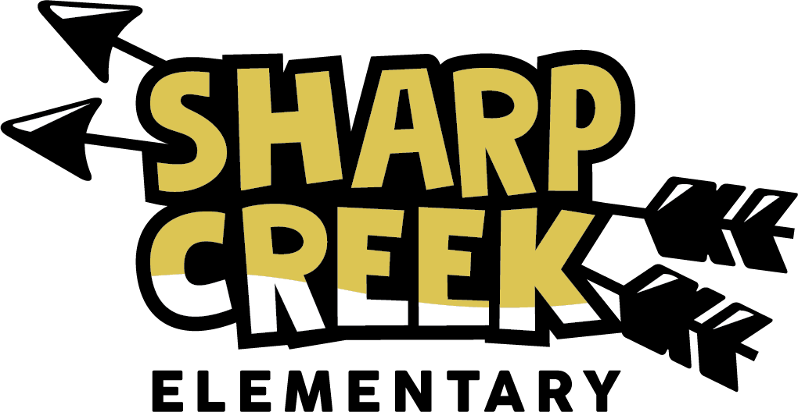

FY21
Revised
August 4, 2020
Dr. Kiley Thompson
Principal
kiley.thompson@carrollcountyschools.com
Brent Vohun
Assistant Principal
brent.vohun@carrollcountyschools.com
Amanda Driver
Instructional Coach
amanda.driver@carrollcountyschools.com

Our Goals for Student Achievement
At Sharp Creek, we are committed to building strong and courageous life-long learners in an energetic and supportive environment. We will provide a premier learning environment by focusing on the Georgia Standards of Excellence to improve both literacy and math.

School Goals
Sharp Creek Elementary’s goals are to:
Increase the percent of students scoring in the proficient level or above by five percent in all areas (English Language Arts, Math, Science, and Social Studies of the Georgia Milestones Assessment.

- Improve literacy for all students through guided reading and writing instruction across the curriculum.
- Integrate STEM activities to increase critical thinking and problem-solving.
- In grades K-2, the focus will be on guided reading and vocabulary development.
- In grades 3-5, the focus will be on vocabulary development and forming ideas in writing.
- Embed three habits for behavior and academics: Be responsible, respectful, and safe.

District Goals
The district goals for the 2020-21 school year:
- Increase the percent of students scoring at Proficient or above on the Georgia Milestones (GMAS) English Language Arts and Math by three percent.

Jointly-Developed Agreement
The parents, students, and staff of SCE developed this School-Parent Compact for achievement. Parents can contribute comments at any time. We welcome your feedback.

Teacher/School Responsibilities:
- Provide links to parent-friendly websites on the webpage and support parents in helping their children effectively at home.
- Present parents with grade level expectations and resources to use in helping their child succeed and reach/exceed expectations in Literacy, Math, Science, and Social Studies.
- Communicate regularly through phone calls, emails, notes, weekly folders, parent-teacher conferences, Class Dojo, Instagram, and updated website.
- Share websites including log in information that parents/students can use at home to help students in ELA and Math.
- Share strategies and practices on how parents can support learning during partnership opportunities and meetings.
- Invite parents to volunteer for various events and assist in the classroom or other areas of the school.
- Report to parents frequently about their child’s progress through the daily agenda, Class Dojo, Monday folders, phone calls, and emails as needed. Mid-term and 9-week progress reports will be provided.
- Provide instructional strategies through Title I events and newsletters.

Family Responsibilities
- Read or listen to my child read 20 minutes nightly.
- Practice sight words with my child.
- Read and sign the agenda nightly.
- Check the Monday Folder each week and return it on Tuesday.
- Practice math fluency facts with my child.
- Attend Partnership Activities provided by the school.
- Use websites and strategies by the teachers to work with students at home with Literacy and vocabulary.
- Attend parent-teacher conferences and other academic workshops.
- Use strategies provided through Title I events and newsletters.

Student Responsibilities
- Practice Math fluency skills.
- Practice sight words.
- Read a minimum of 20 minutes nightly.
- Apply skills learned in the classroom or given through Title I events and newsletters consistently in my assignments
- Speak and write to express ideas with details and clarity.
- Be responsible, be respectful, be safe.

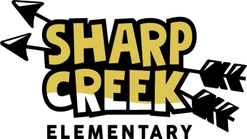

#DreamBig
If you have any questions or concerns about your child’s education, please contact Dr. Kiley Thompson at 770-214-8848.

