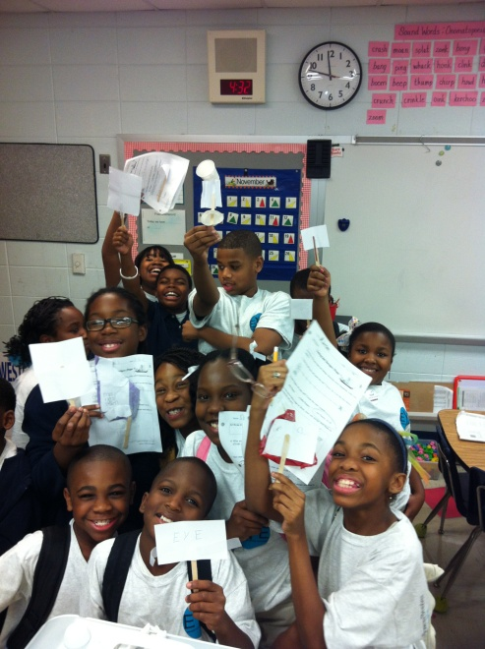

Westlawn Elementary School

Expanding Horizons

21st Century Community Learning Center

Extended Day/Summer Program

**What is the 21st Century Learning Center (21st CCLC) Program?**

21st CCLC is a federally funded program, under NCLB, designed to provide extended learning and enrichment opportunities to students and parents. Activities and classes are provided at Westlawn Elementary School. Westlawn Elementary’s 21st CCLC Expanding Horizons Program offers classes Monday-Friday each week. A summer program will be offered during June.

*Students are learning:*

* Guitar
* Taekwondo
* Art
* Drama
* Fitness
* Reading / Math / Science
* Cooking
* Computer Skills

Students show off their sail designs from E.Y.E.

**21st CCLC Grant Parameters**

* 21st CCLC hours are directly after school to 5:00 p.m. during the regular program, and the time during the summer will be determined by parent survey.
* 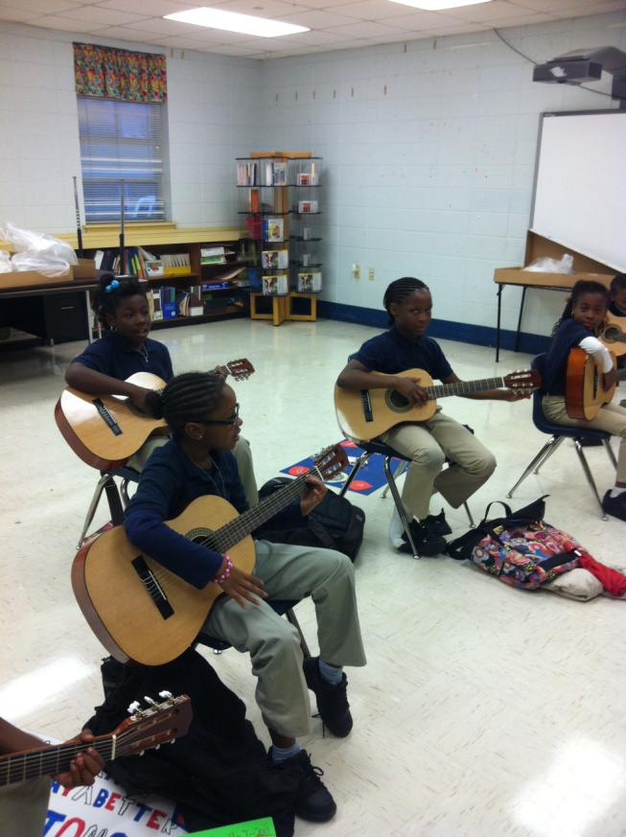Special programs will be held for parents and the adult community members. These times will be determined through survey and based on calendar availability.
* Our site, at Westlawn Elementary School, will provide scheduled access to the computer lab for online learning and to the library for student and adults.
* We must ensure the academic needs of students are met. The academic component of the program should be equal to or greater than the enrichment/recreation program.
* Program Costs: $35.00 per week (financial aid available to qualifying families)

**21st CCLC Program Desired Outcomes**

* Improved academic performance
* improved school attendance
* Reduced disciplinary actions
* Improved social behaviors

Contact and Registration Information:

Jodie McPherson

221-1705

**These 4th grade students are learning to play the guitar!**