BIWEEKLY QUIZ LIPIDS
FOUNDATIONS OF BIOLOGY

Glycerol is a nontoxic, sweet tasting, and viscous fluid that has the chemical formula C3H8O3. Glycerol has three hydroxyl functional groups, which can be esterified with one, two, or three fatty acids to form monoglycerides, diglycerides, and triglycerides. Its chemical structure consists of three hydroxyl groups, which are -OH groups attached to the carbon atoms i.e. a type of alcohol with a hydroxyl group on each of its three carbons.

1. What is glycerol?
- a type of carboxyl with a hydroxyl group on each of its three carbons
- (a type of alcohol with a methyl group on each of its three carbons
- a type of alcohol with a hydroxyl group on each of its three carbons
- a type of alcohol with a hydroxyl group on each of its four carbons

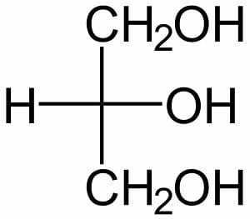
Phospholipids are derivatives of triglycerides. Also known as glycerophospholipids. Glycerophospholipids are major constituents of membranes and are responsible for the membrane being a bilayer. These are more complex structures consisting of a molecule of glycerol to which are attached two fatty acids, a phosphate, and usually one other small molecule (X).Glycerides, more correctly known as acylglycerols, are esters formed from glycerol and fatty acids. Glycolipids are lipids with a carbohydrate attached by a glycosidic (covalent) bond. Their role is to maintain the stability of the cell membrane and to facilitate cellular recognition, which is crucial to the immune response and in the connections that allow cells to connect to one another to form tissues.

2. There are three types of complex lipids. Two of them are Acylglycerols, Phospholipids What is third one?

- Triacyl glycerols
- Glycolipids
- Glycerophospholipids
- Mono acyl glycerol

Simple lipids are the Saturated Fatty Acids and Unsaturated Fatty Acids, as well as esters of these Fatty Acids with various alcohols, such as glycerol (e.g., mono-, di- and triglycerides). Because they are uncharged, glycerides (acylglycerols) are sometimes referred to as neutral fat. Simple lipids cannot be broken down to smaller constituents by hydrolysis. Waxes, which are esters of FAs with higher molecular weight monohydric alcohols, are also simple lipids, and fat in the liquid state is an oil.

3. Which of the following statements is true about simple lipids
- Simple lipids can be broken down to smaller constituents by hydrolysis.
- Simple lipids cannot be broken down to smaller constituents by hydration reaction.
- Simple lipids cannot be broken down to smaller constituents by hydrolysis.
- Simple lipids can be broken down to smaller constituents by hydration reaction.

Although the term "lipid" is sometimes used as a synonym for fats, fats are a subgroup of lipids called triglycerides.Lipids also encompass molecules such as fatty acids and their derivatives (including tri-, di-, monoglycerides, and phospholipids), as well as other sterol-containing metabolites such as cholesterol. Since fats consist of three fatty acids and a glycerol, they are also called triacylglycerols or triglycerides. Triacylglycerol is formed by the joining of three fatty acids to a glycerol backbone in a dehydration reaction. Three molecules of water are released in the process.

4. Glycerol is a type of alcohol with a hydroxyl group on each of its three carbons. Name the reaction joining the three fatty acids (triglycerides).

- Joined by dehydration synthesis
- Joined by isomerism reaction
- Joined by esterification reaction
- Joined by hydrolysis reaction

The difference between cis and trans is that the two H atoms are on the same side of the double bond (cis), compared to being on opposite sides (trans). This may not seem like much of a difference, but it affects the shapes of the molecules. In a cisconfiguration, the double bond creates a kink in the fatty acid.

5. In unsaturated fatty acids, arrangement of hydrocarbon tail around a C=C double bond i.e. TRANS & CIS. Which of the following statements correctly explains trans form of fats.
- One carbon “up” and one “down” across from each other.
- Both carbons are on the same side of the molecule
- One hydrogen “up” and one “down” across from each other.
- Both hydrogen are on the same side of the molecule

Fatty acid chains may differ in length, as well as in their degree of unsaturation.
- If there are only single bonds between neighboring carbons in the hydrocarbon chain, a fatty acid is said to be saturated. (The thing that fatty acids are saturated with is hydrogen; in a saturated fat, as many hydrogen atoms as possible are attached to the carbon skeleton.)
When the hydrocarbon chain has a double bond, the fatty acid is said to be unsaturated, as it now has fewer hydrogens. If there is just one double bond in a fatty acid, it’s monounsaturated, while if there are multiple double bonds, it’s polyunsaturated. In short Hydrogens attached to the hydrocarbon tails of the fatty acids.

6. Lipids can be saturated, mono-unsaturated, and poly-unsaturated on the basis of number of ............
- Hydrogens attached to the hydrocarbon tails of the fatty acids.
- Hydrocarbon attached to the hydrogens tails of the fatty acids.
- Fatty acids attached to the hydrocarbon tails of the hydrogens.
- Hydrogens attached to the fatty acids tails of the hydrocarbon.

7. The presence of a small polar or charged area on a large, nonpolar molecule makes it partially soluble in a unique way. The hydrophilic head of the molecule associates and forms hydrogen bonds with water, while the hydrophobic tail aggregates with hydrophobic molecules, including other phospholipid tails. Molecules with this split structure are called amphipathic (Greek for “feelings for both”).
Choose the correct option for Head group in lipids is always
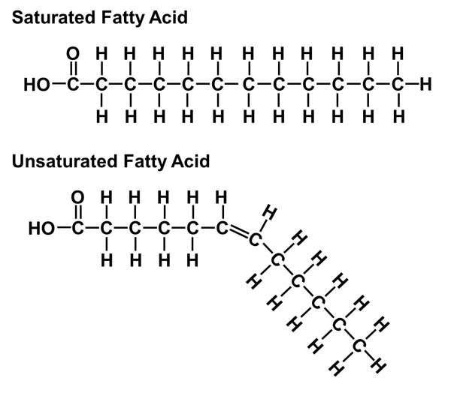
- Polar – so hydrophilic i.e. repels water
- Non-polar –hydrophobic i.e. loves water
- Polar – so hydrophilic i.e. loves water
- Non-polar –hydrophobic i.e. repels water

8 All the following are macronutrients the body needs for good health EXCEPT:

- Vitamins
- Proteins
- Fats
- Carbohydrates
9) Which of the major groups and functions of proteins provide structure for the body and includes collagen?

- Structural
- Transport
- Defensive
- Catalysts
10) Which of the major groups and functions of proteins carry essential nutrients around the body such as hemoglobin?

- Structural
- Transport
- Defensive
- Catalysts
11) Which of the following acts as catalysts to assist in chemical reactions in the body helping to break up and digest food?

- Hemoglobin
- Amino acid
- Enzymes
- Fats
12) All the following are best sources of protein EXCEPT:

- Poultry and eggs
- Nuts and dairy products
- Beef and fish
- Fruit and vegetables

