Name:…………………..……
WORKSHEET CARBOHYDRATES
Chain of monosaccharide Plant Glucose Energy (starch) and structure (cellulose) Monomers Lactose Enzyme 60 Photosynthesis Maltose

- What process produces the majority of carbohydrates that we eat?

- What is the basic structure and function of monosaccharides & disaccharides?

- What forms a polysaccharide?

- Identify the two main functions polysaccharides have in living things:

- What are polymers made up of?

- What type of sugar is found in milk?

- What type of biological molecule is lactase?

- Carbohydrates make up the largest volume of our daily food. ……… % of our food should be from carbohydrates.

- Carbohydrates come mainly from ……………… sources, although milk and milk products contain some carbohydrates in the form of lactose.

- ……………… is the major kind of simple sugar. It is the basic source of energy for all living things.

- …………………… : known as malt sugar, is found in grains.

- Identify the following as monosaccharide, disaccharide, or polysaccharide:
Mono |  | 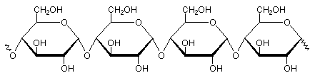
Di |  | 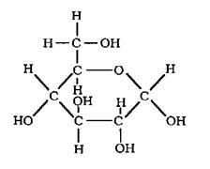
Poly |  | 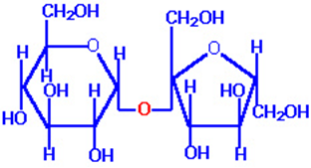

Given below are the questions with two options. Choose and tick mark the correct one. 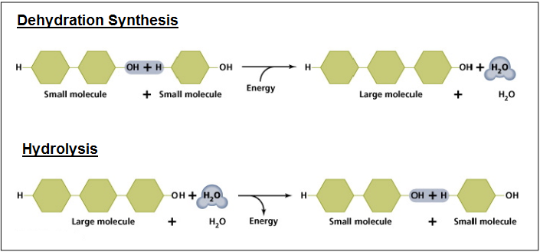
- Briefly describe the process of the dehydration synthesis for carbohydrates illustrated above:
Water comes out to make chain of polysaccharide/ Water goes into the break apart polysaccharide

- Briefly describe the process of the hydrolysis reaction for carbohydrates illustrated above:
Water comes out to make chain of polysaccharide/ Water goes into the break apart polysaccharide

- What is the difference between lactase and lactose?
LactASE is enzyme that breaks down lactose (the sugar found in milk)
LactASE is sugar that breaks down lactose (the enzyme found in milk)

- What organ releases insulin and glucagon? (Pancreas/eyes)

- Where is glycogen stored? Liver/ stomach

- Complete the following table from given text clues: (Starch, Chitin, insect shells)
 | Animal | Plant
Polysaccharide # 1 | Glycogen | ………………………………..
Used for…. | Energy storage | Energy storage
Polysaccharide #2 | ……………………….. | Cellulose
Used for … | Structure (insect shells) | Structure (celery)

Read the following passage and complete the worksheet
Food uses of carbohydrates
Carbohydrates are widely used in the food industry because of their physical and chemical properties. The sweet taste of sucrose, glucose and fructose is used to improve the palatability of many foods. Lactose is used in the manufacture of cheese food, is a milk solids replacer in the manufacture of frozen desserts and is used as a binder in the making of pills/tablets. Another useful aspect of some carbohydrates is their chemical reducing capabilities. Sugars with a free hemiacetal group can readily donate an electron to another molecule. Glucose, fructose and lactose are all reducing sugars. Sucrose or table sugar is not a reducing sugar because its component monosaccharides are bonded to each other through their hemiacetal group. Reducing sugars react with the amino acid lysine in a reaction called the Maillard reaction. This common browning reaction produced by heating the food (baking, roasting or frying) is necessary for the production of the aromas, colours and flavours in caramels, chocolate,
coffee and tea. This non-enzymatic browning reaction differs from the enzymatic browning that occurs with fresh cut fruit and vegetables, such as apples and potatoes.

Name some food as sources of carbohydrates.

Because of ………………………………………. & ………………………………………… properties carbohydrates are widely used in the food industry
To improve the palatability of many foods…………………………………, glucose and ………………………….are used

Write few uses of lactose sugar

Give examples of reducing and non-reducing sugars.

Write other name of browning reaction.

Write some uses of browning reaction.

