Happy New Year!! Please be sure you are ***checking your child’s backpack and folder daily***.

Send a note or email me if needed ([karla.thompson@dcsms.org](mailto:karla.thompson@dcsms.org)).

You can also Stay Connected with Remind. Text @g7fc3f to 81010 Standard text message rates apply.

Visit remind.com to learn more. Thanks to those parents already registered! ☺

**Classroom Newsletter January 6, 2020**

**Mrs. Thompson – 3rd Grade**

**Report Cards – Thursday, 01/09/20**



**Jearon Ford**

**Star Student:**





**Characteristic: determined**

**Teacher Notes:** Happy New Year! We have approximately 3 months before the State Reading Test. Please be sure you are consistently working with your child. Homework is one way to review those skills that should be mastered. I can tell when you have a positive involvement in your child’s education; their attitude shows it every day! ☺ **\* Next GATOR CLUBS – TUESDAY, January 7, 2020**

**Reading:** main idea & details, context clues

**Writing:** opinion

**Math:** fractions

**Science:** animal adaptations

**Thank you for thinking of us!**

**We appreciate all the kind thoughts and gifts you gave us at Christmas.**

**We are very blessed. ☺**



**Classroo**

**Topics**

Well done is better than well said. – Benjamin Franklin

Math Facts Focus!!

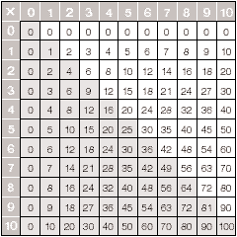

**Daily Homework:**

* ***Read, read, read*** – at least 20 minutes every day; complete daily section of Reading Homework page – ***Turtles and Tortoises***
* ***Practice multiplication facts***; complete daily section of Math Homework page – **Q3:1**

**Upcoming Tests:**

**Reading**

- Reading Quiz: 01/09

- Reading Test: 01/14

**Math**

- Math Quiz: 01/10

- Kicking It Quiz (multiplication facts): 01/10



