Chemistry Lab is an event where participants must learn the year's selected aspects of chemistry and perform a lab or a set of labs regarding those topics.
Since this events rotates topics, each topic constitutes its own page. For topic-specific information, please see those pages, as this page only contains general information that applies to all topics.

Topic Rotation
Chemistry Lab typically rotates between several topic area, with two topics at a time, and one topic rotating in/out each year.
Season | Topic(s)
2018 | Physical Properties, Thermodynamics
2017 | Thermodynamics, Gas Laws
2016 | Gas Laws, Kinetics
2015 | Kinetics, Stoichiometry
2014 | Stoichiometry, Equilibrium
2013 | Equilibrium, Periodicity
2012 | Periodicity, Electrochemistry
2011 | Electrochemistry, Aqueous Solutions
2010 | Aqueous Solutions, Kinetics
2009 | Acids and Bases, Titration Race
2006 | Thermodynamics

Description
As of 2017, the following materials are allowed:
- Category C Eye Protection.
- Lab coat, closed-toed shoes, etc. - see rule 2.c for exact safety parameters
- 5 double-sided Note Sheets per team (sheet protectors allowed)
- 2 Non-camera capable calculators per team

General Chemistry
This section includes general chemistry knowledge that is applicable to most or all topics. For information on specific topics, see the section on Chemistry Lab Topics.

Periodic Table
Main Article: Chem Lab/Periodicity.
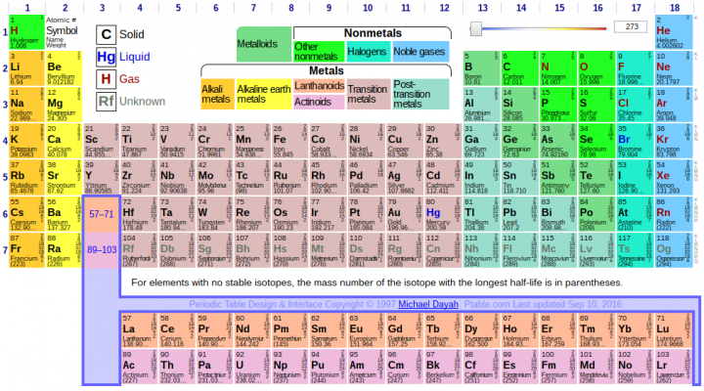
The Periodic Table (click to expand for more detail)
The periodic table of the elements organizes the known elements by properties.
They are numerically ordered by their atomic number, which is the number of protons in the nucleus of an atom. The elements are arranged so they are in columns with similar chemical properties. These columns are called groups. Rows are called periods, and display properties known as periodicity.

Stoichiometry
The Merriam-Webster dictionary defines stoichiometry as "a branch of chemistry that deals with the application of the laws of definite proportions and of the conservation of mass and energy to chemical activity". Stoichiometry deals with calculations about the masses (sometimes volumes) of reactants and products involved in a chemical reaction. It is a very mathematical part of chemistry. The most common stoichiometric problem will present you with a certain amount of a reactant and then ask how much of a product can be formed. Ex::
2A+3B→3C2A+3B→3C
, Given 25 grams B and unlimited A how much C will be produced. This is called a mass-mass problem. These problems can be solved in 4 simple steps.
- Make sure the chemical equation is correctly balanced.
- Using the molar mass of the given substance, convert the mass given in the problem to moles.
- Construct a molar proportion (two molar ratios set equal to each other) following the guidelines set out in other files. Use it to convert to moles of the unknown.
- Using the molar mass of the unknown substance, convert the moles just calculated to mass.
Other forms of stoichiometric problems are finding the limiting reactant and finding the percentage composition. You can find out more about these in the links below.
The process is very similar when given gases (using the ideal gas law), solutions (using molarity) or molecules (using Avogadro's number)
Stoichiometry can be approached in precisely the same way one would approach dimensional analysis. And, when in doubt, convert to moles.

Reaction Types
There are five main types of reactions (single displacement, double displacement, combustion, decomposition, and synthesis). Each of them has a specific form that they take. If you encounter problems dealing with reactions on the test, knowing the basic types can be very helpful because then you will be more likely to see the pattern and understand how to complete the reaction.

Single Displacement
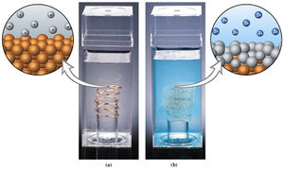
An example of a single replacement reaction. Here, copper reacts in silver nitrate solution to form copper nitrate solution and silver metal. The copper nitrate solution is visible since copper cations are blue in solution.
Also called single replacement reactions. Single displacement reactions are oxidation-reduction reactions in which an element and a compound react to form another element and a compound. This reaction takes on the form
A+BC→AC+BA+BC→AC+B
So the lone elemental reactant, A, forms a compound with C, forcing B out to become an element itself. In order for this to occur, A and B are usually metals that form a cation when compounded with C.
The direction in which the reaction proceeds depends on each element's position in the activity series. A has to be more likely to oxidize than B, because otherwise B will just simple stay in solution and A will remain untouched.

Double Displacement
Double displacement reactions are similar to single replacement, but they are usually not oxidation-reduction reactions. Instead of just one element being traded, double displacement reactions have two similarly formed compounds reacting to form other compounds.
AB+CD→AD+CBAB+CD→AD+CB
This type of reaction is especially important in aqueous solutions, since most precipitation reactions are double displacement reactions. Precipitation occurs when AB and CD are both soluble in water, and when put together, either AD or BC is an insoluble compound and thus precipitates out of the solution. For more information about solubility, see Chem Lab/Aqueous Solutions.

Combustion
Combustion reactions are redox reactions that produce fuel. Thus, combustion reactions are also exothermic reactions since they give off heat. The most common combustion reactions form carbon dioxide, water, and energy. For example, here is the combustion reaction for methane:
CH4+2O2→CO2+2H2O+energyCH4+2O2→CO2+2H2O+energy
Combustion can also occur with nitrogen instead of carbon. There is also combustion with only hydrogen and oxygen, and in this case only water forms as product.
2H2+O2→2H20+energy2H2+O2→2H20+energy
Since combustion reactions are among the most common exothermic reactions, it is a good idea to know the combustion reactions of several important compounds, or at least know how to go about finding it quickly. Since all of them have a similar form, you can guess what the products will be, which will make it easier. For example, for the combustion of a hydrocarbon in oxygen, the two products will be water and carbon dioxide, since the oxygen attaches itself to both carbon and hydrogen parts.

Decomposition
In decomposition, a compound decomposes into its constituent parts.
AB→A+BAB→A+B
This type of reaction usually occurs when the compound AB is unstable, since breaking a chemical bond requires energy. Since it takes energy to break a bond, the vast majority of decomposition reactions are endothermic.

Synthesis
Synthesis reactions are the opposite of decomposition reactions. These reactions have two elements or components bonding together to form a larger compound.
A+B→ABA+B→AB
Since this reaction forms a bond, it is exothermic.

Oxidation and Reduction
Main article: Chem Lab/Electrochemistry.
Oxidation and reduction reactions are those which involve a net gain or loss of electrons - typically, they occur in pairs, with the electrons lost in one reaction being gained by the other. To remember which is which, just remember the simple acronym OIL RIG - Oxidation is Loss, Reduction is Gain. This is a simple way of remembering that whatever is oxidized loses electrons and whatever is reduced gains electrons. The phrase LEO the lion says GER also works (Lose Electrons-Oxidation, Gain Electrons-Reduction)

Aqueous Solutions
Main article: Chem Lab/Aqueous Solutions.
An aqueous solution is a solution where the solute is dissolved in water.

Equilibrium
Main article: Chem Lab/Equilibrium.
Equilibrium refers to properties of chemical solutions which respond to changes in concentration (as well as other factors such as temperature).

Thermodynamics
Main article: Chem Lab/Thermodynamics. Also see the page for the separate event Thermodynamics.

Acids and Bases
Main article: Chem Lab/Acids and Bases
Acids and bases are two complementary classes of substances displaying unique properties, most notably the production of H⁺ ions (for acids) and OH⁻ ions (for bases) in solution.

Titrations
Main article: Chem Lab/Titration Race
A titration is a controlled chemical procedure that involves adding a known amount of one substance, typically in solution (the titrant) to another solution, typically until neutralization. This is frequently done with acids and bases.

Gas Laws
Main article: Chem Lab/Gas Laws
Gas Laws refer to the chemical and thermodynamic laws governing the physical behavior of and reactions involving gases.

Event Strategy
Like all events, Chem Lab requires a strategy for you to be able to do your best.
- It is very helpful if one or both partners has taken AP Chemistry, since some of the topics covered in this event are advanced and not covered in normal high school chemistry classes.
- Try to split the work between you and your partner so that in studying, you can cover both topics.
- If you get a longer test, ask if you can remove the staple and split the test, so that you can cover more of the test in less time.
- Try to arrange your team so that you have one person who is good at quickly performing labs and one person who is good at computations and writing. This should facilitate the labs.
- Make sure to work not just quickly, but efficiently, on the labs. Do them as quickly as you can, but if you end up with inaccurate results then going quickly didn't help you a whole lot. Also, do not take shortcuts unless you are absolutely, positively sure you can.
- Make sure you have all of your protective equipment, as you may be disqualified if you do not have it.

Links
- Stoichiometry links
- Study for the AP Chem test
- Some Chemistry tests
- Solubility rules and evolved gases list for aqueous systems
- Chem lab video: oxidation/reduction
- Infinity Flat's Chem Notes 1
- Infinity Flat's Chem Notes 2
Retrieved from "https://scioly.org/wiki/index.php?title=Chemistry_Lab&oldid=55979"
Categories:
- Event Pages
- Lab Event Pages
- Chem Lab

