Parent(s), progress reports go home tomorrow. Please be sure you are checking your child’s backpack and folder daily. Continue to encourage reading and homework completion. Write any comments or suggestions below, send additional note, or email me if needed (karla.thompson@dcsms.org). Thank you for your support!

You can also Stay Connected with Remind. Text @g7fc3f to 81010 Standard text message rates apply.
Visit remind.com to learn more. Thanks to those parents already registered! ☺

Classroom Newsletter February 10, 2020
Mrs. Thompson – 3rd Grade
Living Wax Museum
This Friday, February 14, 2020
8:45 – 10am
Teacher Notes: Living Wax Museum is this Friday. You may send in the presentation board now, but no later than the 13th - so we can set everything up. Please be sure your child has their costume ready to wear on Friday! Thank you again for your continued help!
* Next GATOR CLUBS: TUESDAY, February 18, 2020

Reading: central message, main idea & details, context clues
Writing: persuasive writing; justifying opinion
Math: measurement with a ruler to nearest ¼ inch & line plots
Social Studies: historical figures

Star Student: Macon Lambert
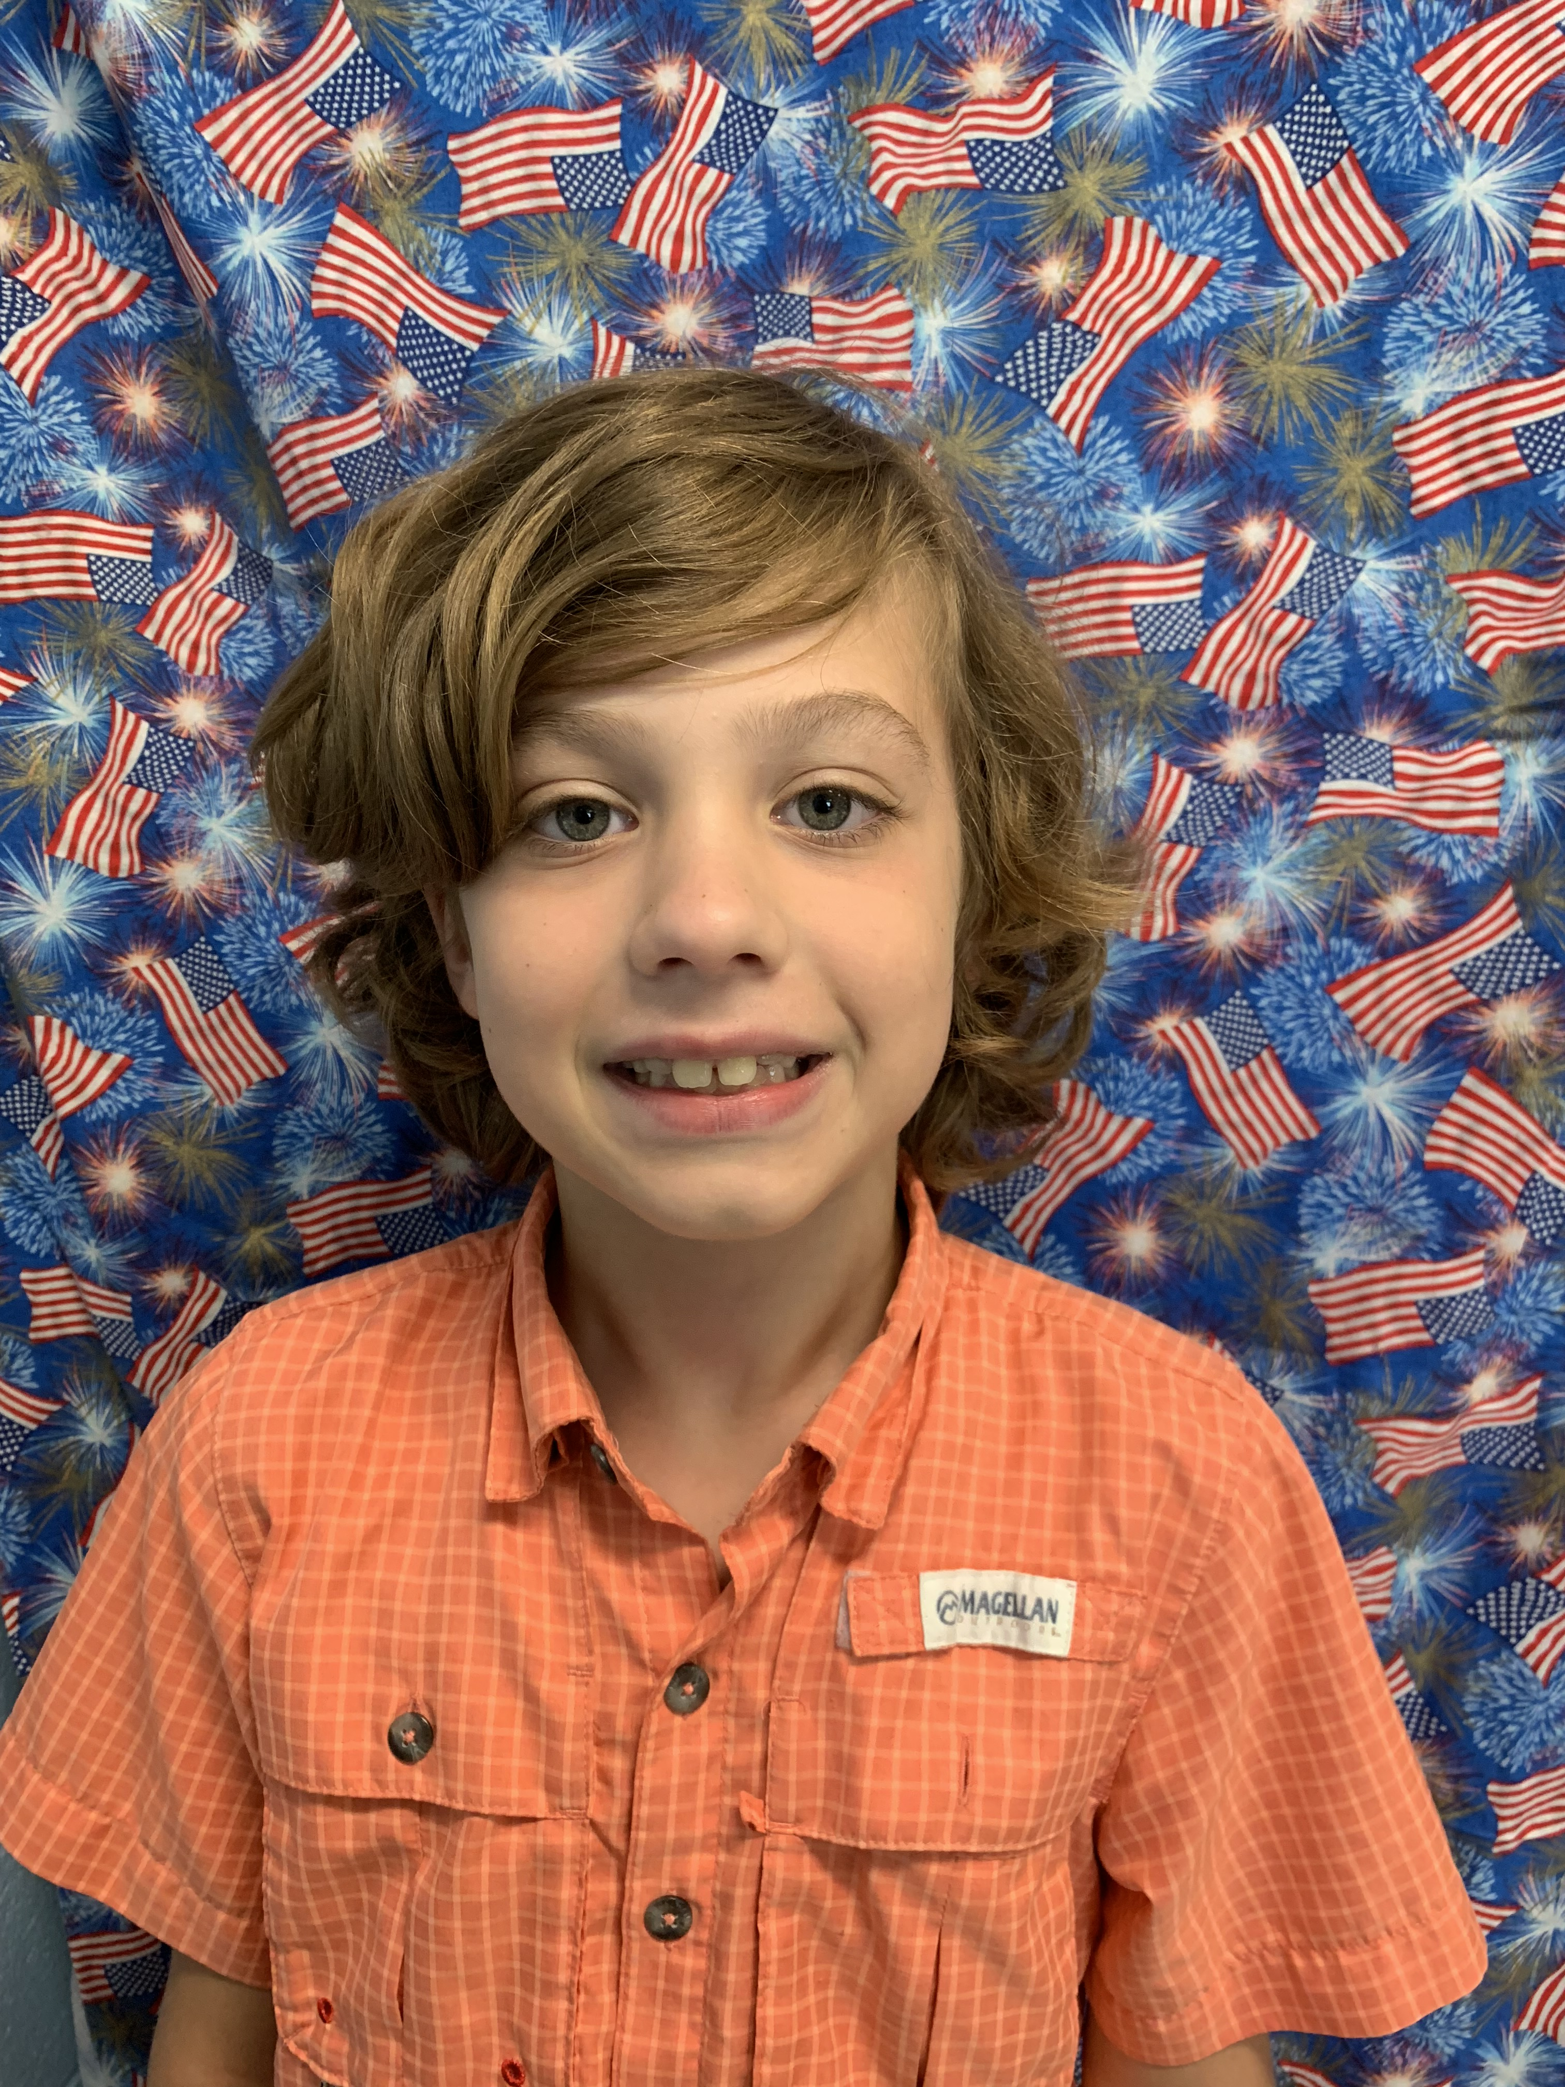
Characteristic: observant

Classroom
Topics

The more we value things, the less we value ourselves. – Bruce Lee
Reading Strategy Focus –
Find the Main Idea
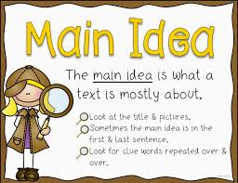

Daily Homework:
- Read, read, read – at least 20 minutes every day; complete daily section of reading homework: Magic Cleo
- Practice multiplication facts; complete daily section of homework: Q3:6

Upcoming Tests:
Reading
- Reading Test: 02/13/20
Math
- Kicking It (multiplication facts) Quiz: 2/11/20
- Math Test: 02/12/20

