[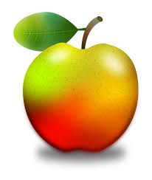](https://www.google.com/url?sa=i&rct=j&q=&esrc=s&source=images&cd=&cad=rja&uact=8&ved=0ahUKEwjq0d6enKfWAhWF7CYKHRluCX8QjRwIBw&url=https://pixabay.com/en/apple-apples-fruit-fruits-orchard-1993505/&psig=AFQjCNECjCiwtsBuvNPCKYwW9tAnjpcb_Q&ust=1505565912034599)

Weekly news from Mrs. Newburn’s Class

* This week we will still be focusing on the letter A and APPLES!!! We have a lot of fun activities planned involving apples.
* There is NO SCHOOL on Wednesday, September 11th – the teachers will be in a training all day :-/
* Each night when you check your child’s folder, please remind them of how important it is to follow the rules at school! There are 18 kids in our class (14 of them are boys), so it’s important that they all follow the rules to keep our day moving along smoothly!
* If you are able to send in some apples for our “apple activities” that would be great! Just a few…we don’t need a million ☺

**Upcoming Events / Reminders…**

[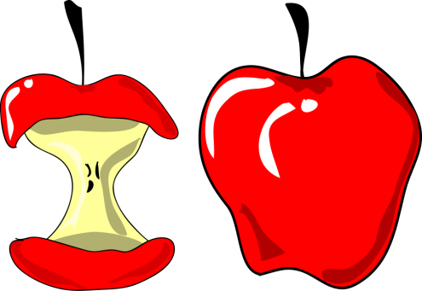](http://www.google.com/url?sa=i&rct=j&q=&esrc=s&source=images&cd=&cad=rja&uact=8&ved=0ahUKEwjgnbSrnafWAhUCYiYKHc0ZAAgQjRwIBw&url=http://www.clipartsfree.net/clipart/11927-apples-clipart.html&psig=AFQjCNG0R3b1lNgG2ZEH-hFZwjoMMzxkBQ&ust=1505566201701411)

**Skills we are working on…**

* The letter “Aa”
* Identifying first name
* Following the school rules

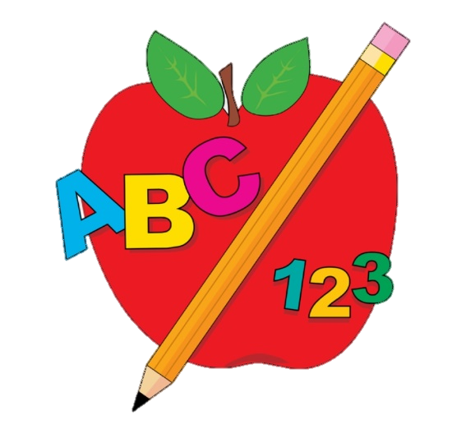

**Things to work on at home…**

* Rules….classroom and hallway
* Writing their name
* Holding their pencil correctly

As always, if you have any questions or concerns, don’t hesitate to contact me. [erin.newburn@southern.k12.oh.us](mailto:erin.newburn@southern.k12.oh.us)