Welcome to Mrs. Matthews’ Class
5th Grade Science and Social Studies
2019-2020
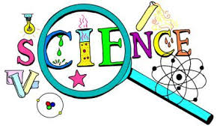
This year I have some amazing science investigations and social studies units planned for your learning experience. Here are a few things to know as we get this year started!

- This year will study physical science (properties and states of matter, mixtures and solutions), life science (plant growth and survival, ecosystems), and Earth science (moon phases and seasonal changes, Earth’s natural resources). Be aware that physical science will be our largest unit.
- Students will keep up with an organized Science Notebook. This will be interactive as we explore investigations, but it will also serve as the main study tool in preparing for quizzes and tests. Please note that this notebook will be graded periodically for organization, completion, and/or accuracy of classwork and investigations.
- Your child will be taught safety rules and expectations and will be held accountable for abiding by these at all times. Failure to do so will result in time out from our hands-on activities.
- Homework will be assigned as needed throughout the year.
- It will be important for your child to have access to the internet. A lot of our new curriculum can be accessed online for review and reinforcement.
- Science grades will be equally weighted this year.
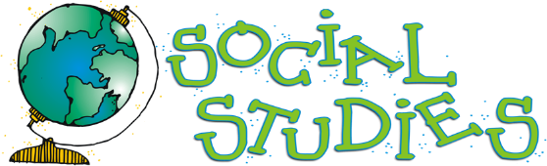

- In social studies we will learn about the 5 themes of geography, map skills, local, national, and global geography, and explorers and the early American colonies.
- We will keep a social studies notebook with study guides, notes, as well as class activities.
- Social studies grades will be equally weighted.
Contact Information:
- 662-890-7705
- Kelly.matthews@dcsms.org
- Remind: Text @scinss1920 to 81010 to sign up for text reminders.

