**Instructional Focus**:

**Reading**- Unit 4 Testing Week

**Phonics Skills**: Unit 4 Testing Week

**Grammar Skill:** Unit 4 Testing Week

**Math** – Topic 12 Measurement and Data

**Science/ Social Studies** – State of Alabama

**Leader in Me** – Habit 7 “Sharpen the Saw”

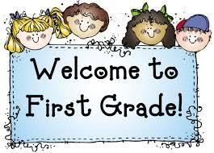 Week of April 26th – April 30th

Mrs. Lyness’ Newsletter

Spelling Words:

No Spelling Words this week. We are reviewing for Unit 4 Test.

I am sending home 3 pages of homework.

**\*Compound Word Practice**

**\*Adjective Review Practice**

**\*Fluency Passage Practice**

**Important Dates Coming Up**:

April 30th – Special Snack/ Spirit Day

May 31st – No School; Memorial Day Holiday

*If you can send in some Clorox Wipes and Paper towels that would be greatly appreciated.

High – Frequency Words:

Please review the page I am sending home of High Frequency Words. Your child will be tested on these on Friday.

*It is VERY important your child not miss this week of school. They need to be here for review and for the test.

Thank you!