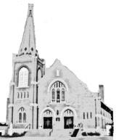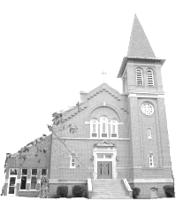Good Teacher Area Faith Community
St. Edward & St. Eloi Catholic Churches
Pastor: FatherTodd Petersen (507.227.2657)
Email (tpetersen@dnu.org)

Parish Secretary: Caren Buysse – 872.6346 Formed: formed.org (Z8Q2WJ) St. Eloi Facebook: St. Eloi Catholic Church
Area Faith Website: goodteacherafc.com St. Edward & St. Eloi Email: St. Eloi Website:
Religion Ed Coordinator: Tina Myhre cbuyssegoodteacherafc@gmail.com steloicatholicchurch.weebly.com
goodteacherafcre@hotmail.com
St. Edward Facebook: St. Edward Catholic Bulletin Coordinator:
Deacon: Bruce Bot – 872.5465 Church Bulletin Email: stedscatholicchurchbulletin@gmail.com
Travis Welsh – 829.0986 St. Edward Website: stedschurch.com
Jason Myhre – 829.2829 Catholic Charities: 1.866.670.5163
Victim’s Hotline: 1.800.422.4453
Office Hours: 8:00 – 11:45 am 12:45 – 4:00 pm Office Mailing Address: Facebook: One More Time Thrift Store
Tuesday, Wednesday, Friday 408 N. Washington St.
Minneota, MN 56264

SUNDAY, SEPTEMBER 27, 2020
TWENTY-SIXTH SUNDAY OF ORDINARY TIME

Sunday, September 27
8:00 am Confession at St Edward
8:30 am Mass at St. Edward (For the Parish Family)
10:00 am Confession at St Eloi
10:30 am Mass at St Eloi (George DeSutter)

Monday,September 28
12:00 pm Mass at St Eloi Convent (Presider’s Intention) *for more Mass times contact Sisters of Mary Morning Star
6:00 pm – 9:00 pm VIRTUS Virtual Training

Tuesday, September 29
12:00pm Mass at St. Eloi Convent(Lois Chlebecek)
7:00 pm KC Meeting at Minneota KC Hall (Rosary at 6:30 pm)

Wednesday, September 30
10:00 am 10:15 am Confession at St Edward
10:30 am Mass at St Edward (Fuzzy Downing)
12:00 pm Mass at St Eloi Convent (Dan VanKeulen)
6:30 pm Adoration of the Blessed Sacrament at St Edward
3:15 pm – 4:15 pm RELIGIOUS ED for Grades 1-5 AT ST EDWARD
6:30 pm – 7:30 pm RELIGIOUS ED for Grades 6-11 at ST EDWARD

Thursday, October 1
7:00 am Mass at St Edward (Emil & Bertha Louwagie)**Confession before Mass
12:00 pm - Mass at St Eloi Convent (Alfred & Irene Rabaey and Family)
5:00 – 7:00 pm Adoration at St Edward

Friday, October 2
12:00 pm - Mass at St Eloi Convent (Ruth Jacob)
2:00 pm Confession at St Edward
2:30 pm Mass at St Edward (Jason Steffes)

Saturday, October3
12:00 pm - Mass at St Eloi Convent (Paula Vlaminck)
4:45pm Confession at St. Edward
PRAY FOR BISHOP LEVIOR

It is with sadness that we announce that Pope Francis has accepted the early retirement of Bishop LeVoir. Bishop LeVoir is currently away to attend to his physical and psychological health. Please pray for him, and pray for our next bishop. Following is the prayer the Diocese of New Ulm has provided.

Prayer for a new bishop
Almighty God,
Who by the Holy Spirit moves the hearts of Your people,
Direct the counsels of those who are appointed to choose a bishop for the Diocese of New Ulm,
That we maybe given a pastor who in faithfulness and wisdom shall lead your peoplein the way of holiness.
Through Jesus Christ our Lord. Amen.
Mary, Mother of the Church, pray for us.

5:30 pm Mass at St Edward (Ed Polejewski)

Sunday,October 4
8:00 am Confession at St Edward
8:30 am Mass at St. Edward(Craig Ahman)
10:00 am Confession at St Eloi
10:30 am Mass at St Eloi(Tom Brewers)

Dear Parishioners:

We offer our prayers and support to David Rabaey who has formally been accepted as a seminarian at St. John Vianney College Seminary, University of Minnesota. In addition to Tanner Thooft and Josh Bot, our two parishes are well represented in the seminaries. College seminary is really about discernment - the seminarians are asking themselves what does it mean to be a Catholic man, who is the Church, who is Christ, and are they called to serve Him and the Church. In short, being is a college seminary only means they are discerning the priesthood - they are not saying they will be priests. As a former seminarian myself, I am aware of those that discerned, like me, follow the Lord into the priesthood, but I also know those that discerned that the Lord was calling them somewhere else. Those that entered the seminary with a willing heart open to the Lord’s will were successful either way! Our prayers for them aid in this. In a few weeks, we will have National Vocations Awareness week, and at that time, we can focus more on the need we have to prayer for more to hear the Lord’s call to lives of service as priests or religious, but also loving husbands and wives.
As we approach the election, there are a number of issues in my mind that we need to take with us to the polls. The books that we made available last weekend lay them out well. This week, one issue might be the meaning of family and the support of family life. Families in general are under attack, and some political movements are expressly opposed to intact nuclear families. Unfortunately, some of those movements are not only tolerated, but embraced, by some politicians. Fatherlessness, families that are divided, where children are not raised with both of their biological parents for one reason or another, are more easily ‘controlled’ by government and in fact become dependent on government. This is directly opposed to liberty and human flourishing. Consider what we witnessed in the confirmation hearings of Brian Buescher for the US District Judge in Nebraska. He was deemed unsuitable because he belonged to the Knights of Columbus, known for their support of traditional families and family values. I will leave it to you to recall who raised that concern the most - it might shock you.

In Christ,
Fr. Todd

ROSARY CRUSADE

Come and join the 2020 Public Square Rosary Crusade. Our nation is in great need of public prayers, repentance, and conversion. We pray to God for the protection of traditional marriages, the sanctity of Life and the conversion of our Nation through the Rosary of His Most Holy Mother.
Please join us in praying for our nation on October 10, 2020 at 12:00 pm. We will be gathering at Veteran’s Park in Minneota.
For more information call Marian at 872-6807.
Thank you and God Bless You!!
SUNDAY OFFERING

A message to all of you during these challenging times. There is no manual for leading parishes through a pandemic, and we are faced with tough decisions every day. That is why I am asking all parishioners, if you are able, please continue your financial support of your parish to help us make up for our loss of Sunday offering. All parishioners of St Edwards can give on-line here: https://www.osvonlinegiving.com/4628 . St Edward and St Eloi parishionersmay bring in your donation and take it to the drop off box that has been set up in the old mail slot on the west side of the KC Hall by the side door facing Washington Street. There is a sidewalk that leads to the door. You can slip your envelope in that slot and it will be collected that way.You may also mail your gift to the parish office.
I want to especially thank those who are signed up for automatic giving and those who have been sending their envelopes. Your faithfulness is more important than you can imagine. Our parish staff is praying for you during this unprecedented crisis. Please know that you can contact the parish office if you have an emergency need. We are still the Church, even when we cannot come together.

Radio Rosary – Week of September 14 – September 20

Sept. 28: In memory of Marylin (Persoon) Tillotson by Leonard and Marian Louwagie
Sept. 29: In memory of Mary Timmerman by Leonard and Marian Louwagie
Sept. 30: In memory of Mike Anderson by Carol Louwagie
Oct. 1: In memory of Gary Timmerman by Laurence and Ardyce Louwagie
Oct. 2: In memory of Mary Timmerman by David and Diane Hennen
Oct. 3: In memory of Mary Timmerman by Laurence and Ardyce Louwagie
Oct. 4: In memory of Gordy Boerboom by Carolyn Boerboom and Family
To schedule a Radio Rosary – Call Carol Louwagie: 507.532.6081
Radio Rosary funds/memorials: Checks payable to “Radio Rosary”
Mailing Address:
Radio Rosary, 2894 310th St
Marshall MN 56258
MASS READINGS & PRAYERS FOR VOCATIONS
September 27 – October 3
SUNDAY, Sept. 27 – Pray for Paul Van De Crommert, Fr. Steven Verhelst, Dcn Paul Treinen
Ezekiel 18:25-28; Psalm 25:4-9; Philippians 2:1-11; Matthew 21:28-32
- How might I better imitate Jesus’ emptying way of relating to others?
MONDAY, Sept. 28– Pray for Fr. Matthew Wiering, Fr. Paul Wolf, Dcn. Travis Welsh
Job 1:6-22; Psalm 17:1-3, 6-7; Luke 9:46-50
- How might I best begin to eliminate the “Us-Them” divide in my actions?
TUESDAY, Sept. 29– Pray for the Women Religious in the Diocese
Daniel 7:9-10, 13-14; Psalm 138:1-5; John 1:47-51
- What praise might I formulate today for God’s presence in my life?
WEDNESDAY, Sept. 30 - Pray for All men and women whom God is calling to the Priesthood or Religious Life
Job 9:1-12, 14-16; Psalm 88:10-15; Luke 9:57-62
- How might I rededicate myself to a greater attention to God’s will?
THURSDAY, Oct. 1– Pray for Pope Francis
Ecclesiastes 1:2-11; Psalm 90:3-6, 12-14, 17; Luke 9:7-9
- What most keeps me from recognizing and welcoming the poverty within me?
FRIDAY, Oct. 2 -Pray for Bishop John LeVoir, and for our new Bishop
Ecclesiastes 3:1-11; Psalm 144:1-4; Luke 9:18-22
- What most keeps me from allowing Jesus to show his loving care and concern for me?
SATURDAY, Oct. 3– Pray forFr. Christian Adike, Fr. Garret Ahlers, Dcn. Arthur Abel, Joshua Bot (Sem.)
Ecclesiastes 11:9—12:8; Psalm 90:3-6, 12-14, 17; Luke 9:43-45
- How has Jesus’ love for me most changed me and my behavior this year?

SACRAMENTS OF THE CHURCH
- Baptism, Marriage, Anointing of the Sick, Becoming Catholic –
Call the church office: 872.6346
- Eucharist to Shut-ins:
St. Eloi – Sandy Nuytten 829.9690
St. Edward – Call the church office 872.6346
- Baptism Prep: To set up a baptism date, call Caren at the office. Check the church website for Godparent Requirements.
- RCIA: Jesus Christ came to reveal the fullness of God’s love for us and we continue to celebrate that love through praise, sacraments, service, and community. If you or someone you know is interested in joining our church or in learning more about the Catholic Church, contact Deacon Bruce Bot 507.828.7012.

POPE FRANCIS’s PRAYER TO OUR LADY FOR PROTECTION DURING covid-19 Pandemic

Pope Francis composes a prayer to Our Lady, Health of the Sick, to implore her protection during the Covid-19 coronavirus pandemic.

In these days of trial, as humanity trembles at the threat of the [coronavirus] pandemic, I would propose that all Christians join their voices together to heaven.” – Pope Francis

O Mary, you shine continuously on our journey as a sign of salvation and hope.We entrust ourselves to you, Health of the Sick.At the foot of the Cross you participated in Jesus’ pain,with steadfast faith.You, Salvation of the Roman People, know what we need.We are certain that you will provide, so that,as you did at Cana of Galilee, joy and feasting might return after this moment of trial.Help us, Mother of Divine Love,to conform ourselves to the Father’s willand to do what Jesus tells us:He who took our sufferings upon Himself, and bore our sorrows to bring us,through the Cross, to the joy of the Resurrection. Amen.

We seek refuge under your protection, O Holy Mother of God.
Do not despise our pleas – we who are put to the test – and deliver us from every danger, O glorious and blessed Virgin.

SCRIP NEWS- Scrip will be sold again after Masses beginning Sept. 12th. Please remember to social distance when buying scrip along with wearing masks.Don’t forget you can preorder scrip on the scrip website. Forgot to pick up your scrip before going shopping? There is also a new app to add to your phone you can upload scrip right at the national chain stores.
Have questions contact Caren at the Church office or Julie Pohlen.

NOVENA FOR LIFE
To help our church, community and country establish a culture of life for all nations, the Knights of Columbus and their families will come together in both public and private acts of prayer to promote the protection of life from conception to natural death.

To help promote this reverence toward life the Knights will have a Novena, nine days of sustained prayer. The Novena will be from Mar. 21 to Mar.29. We will be saying a prayer at all the week-day and week-end masses during this time. We will also be saying several rosaries during some of the masses and in private. We ask all parishioners to join us for this most spiritual event. Consider attending daily masses and saying an extra rosary for this noble cause.
Life is a very special gift; let us pray to protect it for everyone.

TMIY
Men mark your calendars! We will be restarting TMIY on Friday September 18 at the Knights Hall for those that are comfortable meeting in person. We will also have an online option for those that choose not to meet in person. Doors will be open at 5:45for fellowship &breakfast, we should be wrapped up shortly after7:00this is open to all men even if you have not participated in the past. More information will be forthcoming or contact Brian Timmerman 507 829 5490

KC MISSION
The Knights of Columbus have initiated an Adopt a Parish Program for Christians in Iraq. Christians there have been persecuted for many years and are in great need of assistance to help them recover. Our Minneota council is 1 of 4 that have been selected in the state of Minnesota to help with this initiative.
We have adopted Mart Shmoni Chaldean Catholic Church in Perka Village, Dohuk, Iraq. Our council`s goal is to reach at least $2500 by June 30, 2020.We would like to give as many people as possible to the opportunity to help with this noble cause. If you would like to make a donation, make checks to: `Knights of Columbus`. In the memo put `Adopt a Parish`.You can put it in the collection basket in an envelope marked `Minneota Knights` or send to:
Brad Hennen
2243 330th ST.
Ghent, MN. 56239
Thank-You,
Knights of Columbus council 14420

RELIGIOUS ED (CCD)
RE/CCD - We are off to a great start to Religious Ed! We have 82 families registered with 145 students in grades 1-11. We are in need of VIRTUS trained helpers for various areas, so if you are willing to help, please contact Tina Myhre at goodteacherafcre@hotmail.com. Please keep our families in your prayers!

RE/CCD Snacks - We are looking for donations of pre-packaged snacks for the RE kids when they come after school on Weds each week. Now that sports are back on for the fall, many will come right from practice. Since we are not offering a meal at this time, we would like to be able to offer something for them, especially grades 7 and up and those who can't drive uptown to buy a snack. If you are willing to donate, please drop off at Parish office, St. Ed's Church basement or cry room. Please make sure to label that they are for RE/CCD.

RE/CCD Adoration - We are in need of helpers for Adoration on RE nights (Weds) from 6:30-7:30. If you are able to help, please contact Tina Myhre, goodteacherafcre@hotmail.com or sign up online at https://volunteersignup.org/7CQ9F

SCHOENSTATT GIRLS GROUP
Schoenstatt Girls Group will meet by Zoom this fall (date to be determined) and hopefully move to in-person later in the year. Please let me know as soon as possible if your daughter/daughters are interested in attending. It has been a difficult year but hoping Schoenstatt can bring girls together if it is by Zoom or in-person to lean on our Mother Mary for strength and wisdom as well as the girls giving support to each other.

Schoenstatt Girls Group is for all girls ages 6-16. The Schoenstatt Girls' meetings include games, crafts, and songs; they provide an opportunity for girls and you women to grow in their faith, their love for God and Mary, and to share this experience with other girls their age.

For more information about Schoenstatt please visit the website at: www.schoenstattmn.com. For more information about joining the girls' group, please contact Jean Callens, jcallens91@aol.com or 507-828-3472 or Sr. M. Josephine at 507-794-7727 or schgirlsyouth.mn@schsrsmary.org.

APPLES WANTED
The Pie Ladies are looking for apples to make their delicious pies!! If you have any to spare, please bring them to the St Edward Church basement on or shortly before September 22. Thank you and God Bless!

THRIFT STORE
Our hours are Wed. – Fri. 11:00 - 5:00 pm& Sat. 10:00 am -3:00 pm. We are currently taking donations again.

Please consider helping our school and parish through your work at the store. Your time and help will be very much appreciated.

THANK YOU
Thank you to all of you who are giving back to God some of your
Time, talent, and finances that God has given you. Our churches
and their mission and ministry would not exist without your
giving.
ST. ELOI NEWS

 | ACTUAL | BUDGETED |  | DIFFERENCE
Adult | $2,610.00 | $2,294.90 |  | $315.10
Loose | $133.00 | $146.15 |  | -$13.15
Commodity
Easter
Year-to-date | $31,991.49 |  | $21,593.38 | $10,398.10

ST ELOI LITURGY SCHEDULE

Sunday, September 27th, 10:30 AM
Sacristan: Darla Timmerman
Altar Servers:
Lector: Steve Hennen
Musicians: John Rabaey and Family
Eucharistic Minister: Dan Sik
Ushers: Ron Sussner, Tim VanKeulen and Corey Kack

SISTERS OF MARY MORNING STAR NEWS
St. Eloi Convent Masses: Call 428.3919 for times.
Masses on Monday, Wednesday, Thursday, Friday, Saturday
Vespers: 6:15 pm Adoration: 7:30 – 8:30 pm

ST. EDWARD NEWS

 | ACTUAL | BUDGETED | DIFFERENCE
Adult | $2,051.00 | $4,829.92 | -2,778.92
Youth | $0 | $5.69 | -$5.69
Loose | $70.00 | $153.85 | -$83.85
Online Giving | $500.00 | *Added to the adult envelope total
Commodity | $1,292.00
Easter
Year-to-Date | $40,629.56 | $59,219.94 | -$18,590.38

ST EDWARD FALL FESTIVAL
Due to the uncertainty caused by Covid, it was decided not to have the Carnival and dinner this year, but to have just the raffle. We will have Holy Mass at 6:30 Pm on Monday, October 12 with the pulling of the raffle tickets following, with location to be determined. Prizes are being collected and tickets will be printed and distributed shortly.

ROSARY SOCIETY MEMBERS
Our general intention throughout the year is for world peace and an increase of vocations to the priesthood and religious life. July is for blessings on America and our families. We need, and welcome, new members to complete our roses. If you have any questions and/or would like to join, call Judy Bot (872.6525) or Marian Laleman (872.6807).

ST EDWARD LITURGY SCHEDULE

Saturday Oct 3, 2020
Sacristan: Mary Ann Christensen
Servers: Tucker Thooft
Lector: Nate Welsh
Eucharistic Minister: Deb Thooft
Ushers: Bruce Novotny

Sunday Oct 4, 2020
Sacristan: Cindy Novotny
Servers: Kylee Loyson
Lector: Julie Janiszeski
Eucharistic Minister: Seth Myhre
Usher: Jeff Claeys

ONLINE GIVING
Online giving helps you maintain your giving even if you cannot attend Mass. This helps the parish streamline our cash flow, especially during bad weather or vacation times. Go to our parish website and get started today. www.stedschurch.com
HOSPITALITY COMMITTEE
- If you know of anyone who is sick or new to the parish, please call Marlene Polejewski at 507-872-6042.
PARISHIONERS WHO ARE ILL OR ASKING FOR PRAYERS – If you know of anyone from our parish who is sick or has had surgery recently or is ill and would like to be remembered in prayer during the weekend Masses; ask them to contact the church office. The Parish Secretary will add their name/names to the petitions.

THANK YOU!!!
We want to thank all of the parish members and Knights of Columbus for the wonderful roofing jobs done on the Rectory and Knights Hall.
**Thank you Ed Laleman for taking time to level out the mound of dirt around the Parish Office parking area.

THANK YOU!
We also would like to thank all you ladies who have come in these past few months and have done extra cleaning in the kitchen, church, and school. May God bless each and every one of you for your generous donation of time and energy!!!

HOW WAS I SUPPOSED TO KNOW?
Remember to check out our Facebook page (St. Edward Catholic Church) or the website (www.stedschurch.com) to keep with updated information.

GARDEN GOODIES
ST EDWARD’s SCHOOL would like to thank everyone who has been so generous so far this year with their garden donations!! We especially thank Seth and Teresa Myhre for cucumbers& tomatoes, Neal Bot for sweet corn,and Jan Bot &Mary Schreiber for tomatoes. Everything has been delicious and very much appreciated!! We are continuing to look for anyone who may have any excess of garden goodies that they are willing to donate!! Please contact Cynthia Moorse at 507-872-6391 or send an email to stedsbulletin@gmail.com. Thank you so much!! God bless you all!!

CONCERNED CITIZENS ANNOUNCEMENT
UNITED STATES CONFERENCE OF CATHOLIC BISHOPS

Dear Friend,
I am pleased to announce that the FDA recently approved Sanofi Pasteur’s request to switch from using an aborted fetal cell line (MRC-5) to using an ethical animal cell line to produce its polio combination vaccines Pentacle and Quadracel. The drug company has also chosen to discontinue production of its stand-alone polio vaccine, Poliovax, which also used MRC-5 for its production, and to retain another stand-alone polio vaccine, IPOL, that is ethically produced. Furthermore, Sanofi-Pasteur’s ongoing effort to develop a vaccine for COVID-19 also does not rely on cell lines linked to elective abortion.
As you may already know, the only vaccines readily available in the United States for some contagious diseases (e.g., rubella, chickenpox, and Hepatitis A) have been manufactured using fetal tissue from induced abortions. This creates a problem of conscience for some parents.
As recommended by the Pontifical Academy for Life in 2005 and reiterated in its 2017 Note on Italian Vaccine Issue, a long-term solution lies in working to ensure that future vaccines and other medicines are not based on cooperation with practices that demean human life. The 2005 statement noted that physicians and parents “have a duty to take recourse to alternative vaccines (if they exist), putting pressure on the political authorities and health systems so that other vaccines without moral problems become available.” This applies to products with a connection to abortion, such as vaccines, as well as to projected therapies from destruction of human embryos for their stem cells.
This move from Sanofi Pasteur is an encouraging indicator that for-profit companies creating vaccines are beginning to recognize there is no need to use cell lines derived from aborted children.
One important step we can take to ensure the production of ethical vaccines is to recognize and thank drug companies, like Sanofi Pasteur, when they move away from unethical vaccine production. We can hope that, with some encouragement, other vaccine manufacturers may consider creating other morally acceptable vaccines.
Any motivation to create additional, morally acceptable products will certainly be strengthened if we can show a market demand for ethical sources.
Please (https://www.votervoice.net/USCCB/Campaigns/77153/Respond) to thank Sanofi-Pasteur and to encourage others to do so as well.
Thank you in advance for spreading this good news and for sharing your own gratitude with the manufacturer. We welcome these opportunities where we can illustrate the Church’s eager embrace of scientific advancement when it upholds the dignity of the human person and the precious gift of human life.
In Christ,
Greg Schleppenbach
Associate Director

ST. EDWARD SCHOOL NEWS
Principal: Jaci Garvey Secretary: Trudy Banks
Office: 872.6391

We held our Student Council election on Tuesday. I am so proud of all 13 students who applied for these five positions. They ran a clean, competitive race. In the end, the students and staff elected Kylie Callens, Elena Myhre, Wyatt Pohlen, Niara Gorecki and Randy Sorensen to our 2020-21 Student Council. We look forward to great things from them!

Tomorrow is another turn in day for marathon pledges. Everyone that turns in a pledge tomorrow will receive a prize from Mrs. Garvey’s prize bucket; their names will go into a drawing for a chance to win some play dough. So far we have collected $5,995.00. Great job everyone! Go out this weekend and get your pledges!

Our next school Mass is Wed., September 30th at 10:30am. The 7th and 8th grade students will be leading us.

There will be no school for St. Edward School on Monday, October 5th due to the Teacher Faith Formation Day. There will also be no afterschool program on that day.

We are happy to announce that Photoworks will be here on Tuesday, October 6th for school picture day! We will send order forms home in next week’s parent folder. Preschool children who are not in school on that day are welcome to come in for pictures. Please watch for more information.

Thank you to all who filled out our parent survey. Given the results on the survey, we have decided that St. Edward School will keep our MEA Break as planned. That means that we will not have school on Wednesday, Thursday and Friday, Oct. 14 – 16, 2020.

Coats for Kids have started their annual winter gear collection. They have placed a collection bucket in our entryway. Please consider donating gently used coats, hats and mittens prior to October 13th.

In our school handbook we stress that riding the bus is a privilege; this year it is especially so. 4.O Bus Service is asking all students riding the bus, at any time of day, to wear their face coverings. If students are not wearing their face coverings while on the bus, 4.O Bus Service has every right to not allow students to ride.

Did you know that the St. Edward School Cafeteria is licensed by the State of Minnesota and that Mrs. Moorse is a Certified Food Safety Manager recognized by the Minnesota Department of Health? These designations hold our cafeteria to higher standards than many restaurants. To that end, we are inspected at least twice yearly by MDH. Inspectors look for cleanliness, nutrition compliance and that we are following our approved food safety program. We also participate in the Farm to School program which encourages the use of locally grown foods. Please rest assured that all food brought into the school and served from the cafeteria meets USDA safety requirements.

The Schoenstatt Girls Group will meet by Zoom this fall. Hopefully we will be able to move to in-person sessions later in the year. Schoenstatt Girls Group is for all girls ages 6-16. The Schoenstatt Girls' meetings include games, crafts, and songs; they provide an opportunity for girls and young women to grow in their faith, their love for God and Mary, and to share this experience with other girls their age. For more information about Schoenstatt please contact Jean Callens, jcallens91@aol.com or 507-828-3472.

May God Bless,
Jaci Garvey, Principal

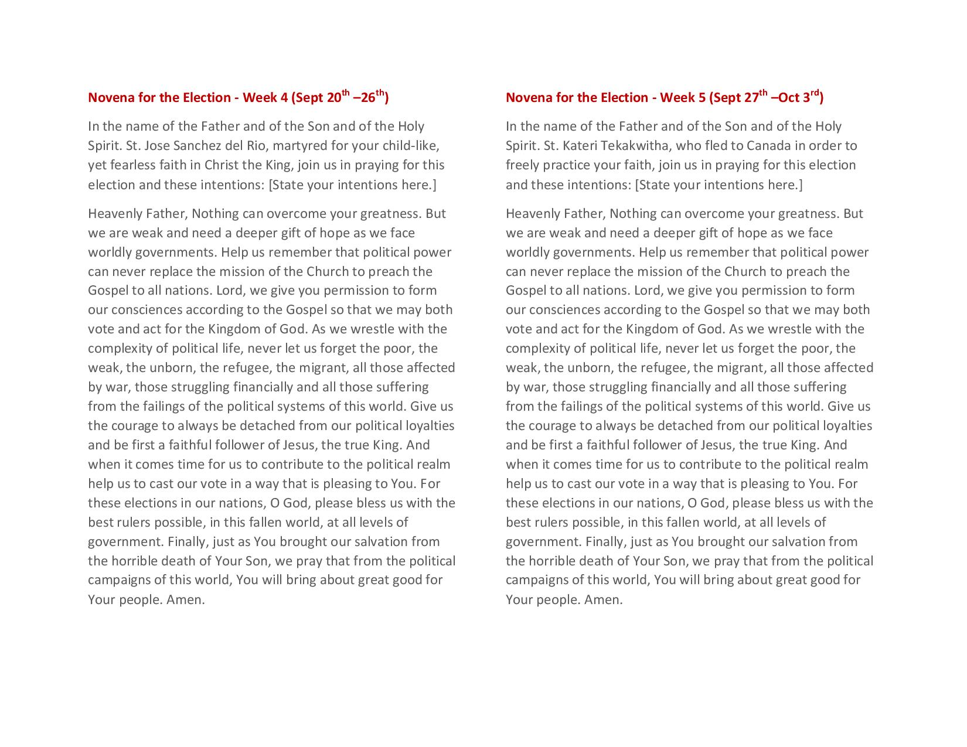

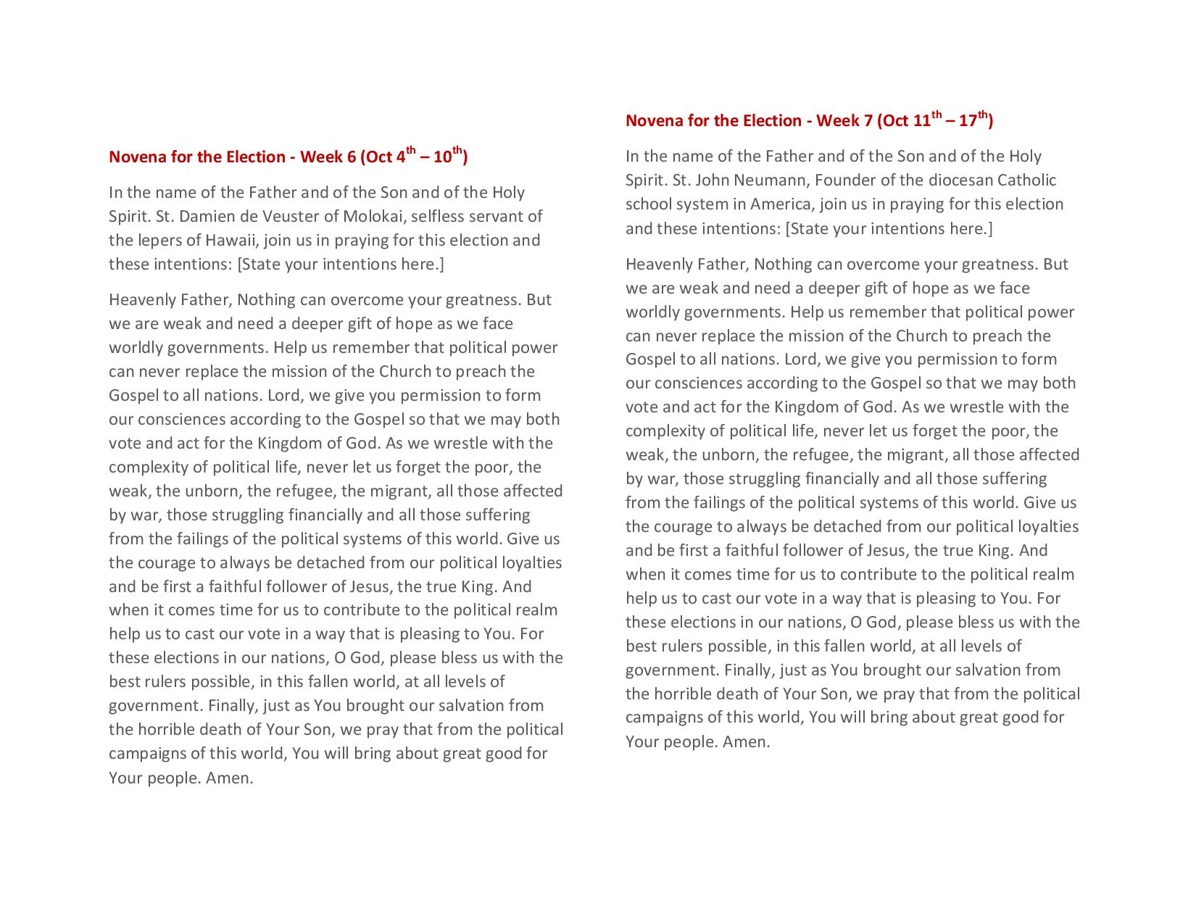
Liturgical Schedule for Oct 2020
Reminder to please find your own replacement if you can’t make your scheduled date

Saturday Oct 3, 2020
Sacristan: Mary Ann Christensen
Servers: Tucker Thooft
Lector: Nate Welsh
Eucharistic Minister: Deb Thooft
Ushers: Bruce Novotny

Sunday Oct 4, 2020
Sacristan: Cindy Novotny
Servers: Kylee Loyson
Lector: Julie Janiszeski
Eucharistic Minister: Seth Myhre
Usher: Jeff Claeys

Saturday Oct 10, 2020
Sacristan: Margrit Rabaey
Servers: Tara Sterzinger
Lector: Claren Novotny
Eucharistic Minister: Claren Novotny

Sunday Oct 11, 2020
Sacristan: Fran Sturm
Servers: Robert Beisler
Lector: Fran Sturm
Eucharistic Minister: Fran Sturm

Saturday Oct 17, 2020
Sacristan: Mary Ann Christensen
Servers: Kylie Callens
Lector: Fred Rabaey
Eucharistic Minister: Dawn Vlaminck

Sunday Oct 18, 2020
Sacristan: Ruth Bot
Servers: Lane Loyson
Lector: Joe Callens
Eucharistic Minister: Diane Hennen

Saturday Oct 24, 2020
Sacristan: Margrit Rabaey
Servers: Gabe Sterzinger
Lector: Mary Kampa
Eucharistic Minister: Mary Kampa

Sunday Oct 25, 2020
Sacristan: Joe Callens
Servers: Joe Beisler
Lector: Teresa Myhre
Eucharistic Minister: Dawn Vlaminck

