KA Newsletter

Mrs. Blatch
Email: kimberly.blatch@southern.k12.oh.us

10/28/19-11/1/19

Notes & Reminders
- Students should wear black on Wednesday.

- Remember to check ClassTag regularly in order to receive important reminders and photographs from our adventures in kindergarten! Please let me know if you need assistance signing up or using the program.

- We are in need of baby wipes for classroom use. If you would like to donate a package, we would appreciate it!

- Students are asked to bring their Halloween costumes to school on Friday, November 1st. There will be a costume parade in the gymnasium beginning at approximately 1:15.

Skills & Concepts
Students will...

- Identify the names and sounds of p & j RF.K.3
- Isolate beginning and ending sounds RF.K.2
- Express stories through a combination of drawing, dictating, and writing W.K.2
- Identify and write the word “black” RF.K.3
- Count quantities of 0-10 K.CC.5
- Recognize and write 0-10 K.CC.3
- Identify and describe shapes K.G.1-3

Specials
Monday: Gym
Tuesday: Technology
Wednesday: Music
Thursday: Art
Friday: Technology

Words to Practice
yellow
blue
green
red
I
purple
pink
a
see
orange
to
do
black

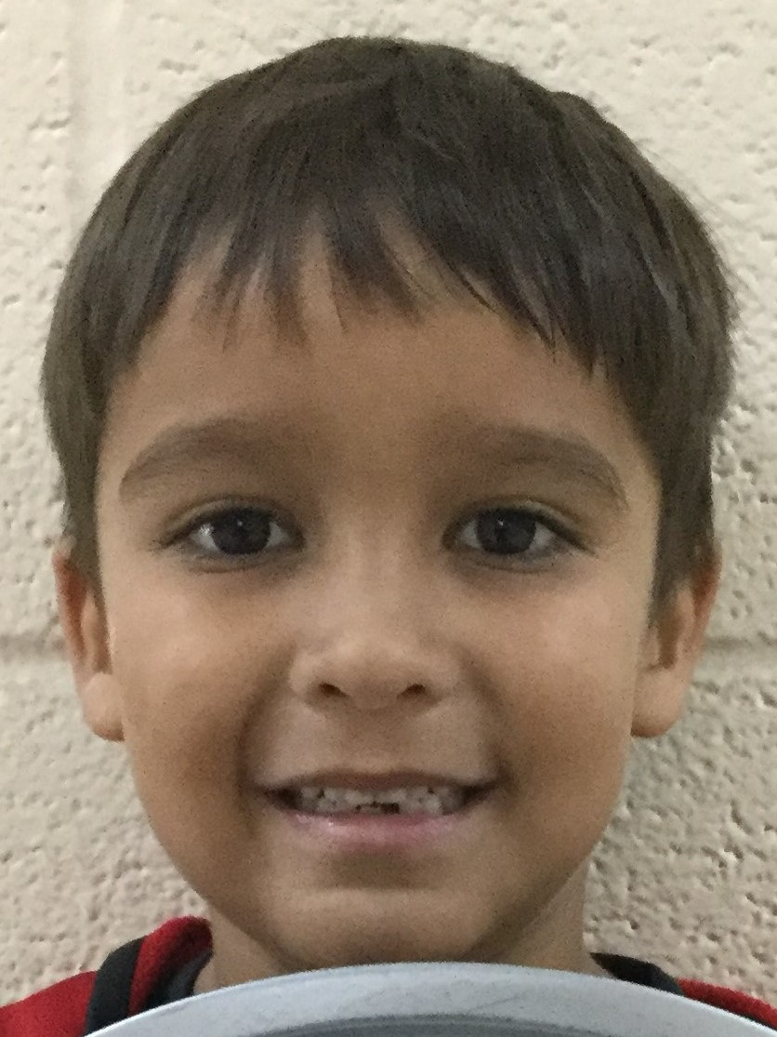
Meet Sylus Bryan

Sylus is 5 years old and he has two brothers and two sisters. Sylus’s favorite color is red and he likes to eat toasted cheese sandwiches. Sylus’s favorite part of kindergarten is playing Teach Your Monster to Read on the iPad during Literacy Centers.

Please check the school’s website for upcoming events and important information. www.southern.k12.oh.us

