STRESS MANAGEMENT WORKSHEET
Stress isn’t always a bad thing. List examples of when stress can be good and when stress
can be bad.
GOOD BAD
STRESS STRESS
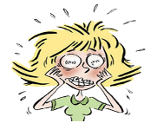

Choose One:
Write or draw what stress would look like if it could be seen.

Write or draw what stress would smell like if were a thing.

Write or draw what stress would sound like if it could be heard.

