Summer 2005

STI Professional Development
Doc-To-Help Standard Manual

Employee Manual

Information in this document is subject to change without notice. Student and school data used herein are fictitious unless otherwise noted.

© 2004-2005 Software Technology, Inc. All rights reserved.

Microsoft, Windows and Word are registered trademarks or trademarks of Microsoft Corporation in the United States and other countries.

Other product and company names herein may be the trademarks of their respective owners.

Software Technology, Inc.
4721 Morrison Drive, Suite 200
Mobile, AL 36609-3350
1-877-844-0884

This manual was last updated on July 5, 2005. Any subsequent changes made to the application will be discussed in the release notes that accompany each update.

Contents

Index 18

Getting Started
Logging In
To access the features of the STI PD system, you must first log in. To do this:
- Enter your Username and Password in the appropriate fields and then use the drop-list to select the LEA to which you belong.
- Click the CLICK TO LOGIN button when you are ready.

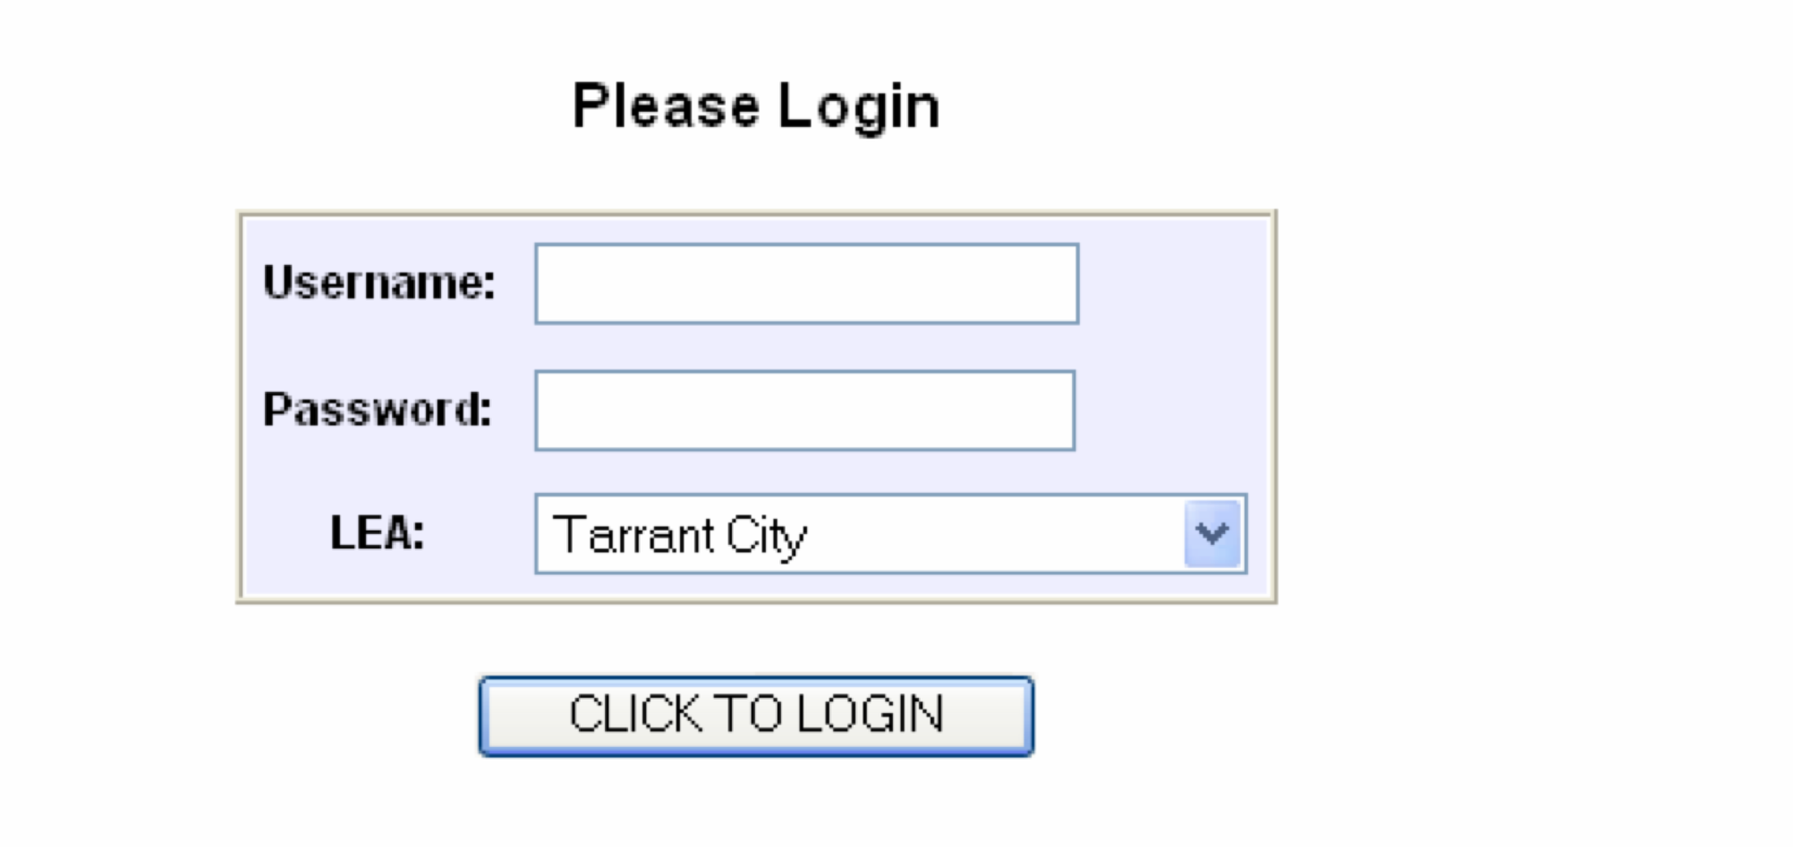

PD Titles Catalog
Searching PD Titles Catalog

Step 1
To begin your search for available Professional Development Titles, click on the PD Titles tab located on the menu bar. This will open up the PD Titles screen.

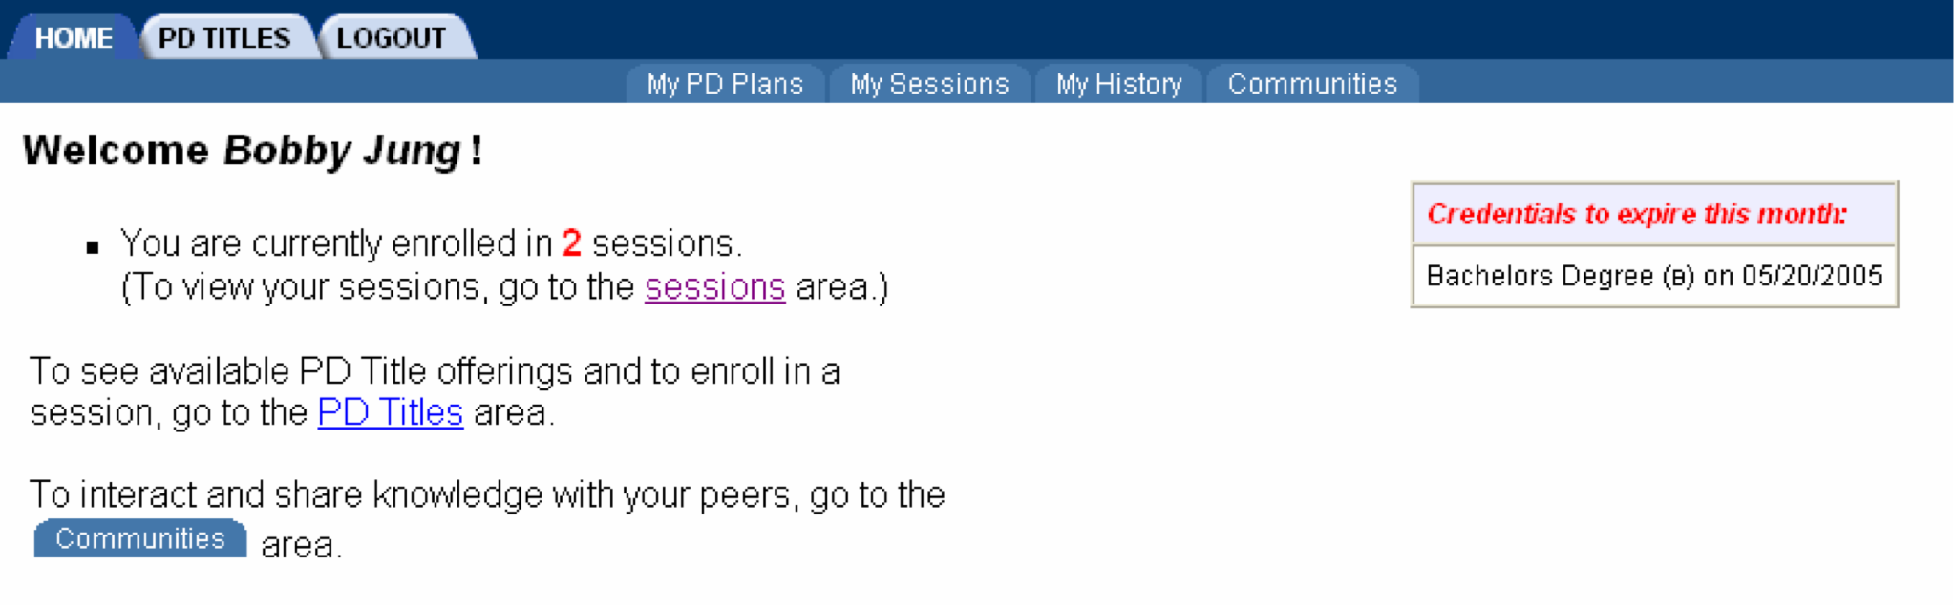

Step 2
Click the Search the PD Titles Catalog link. This will bring up the search screen.

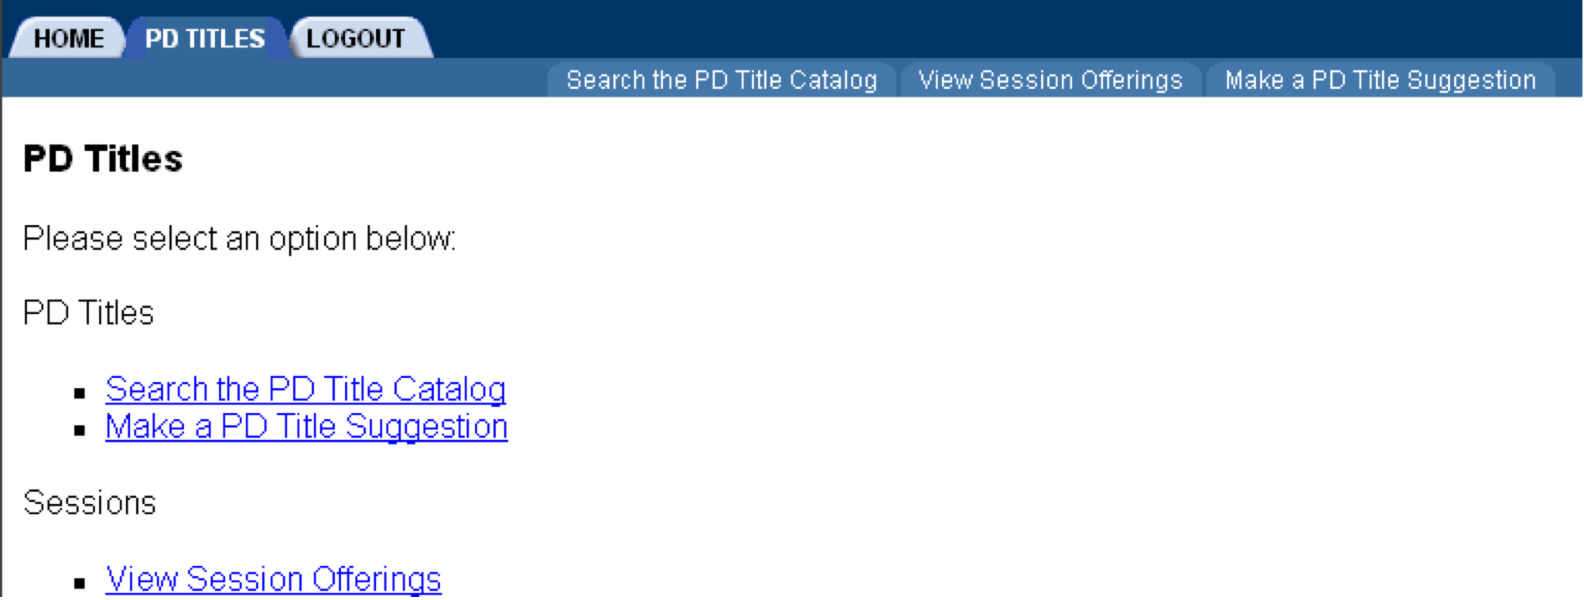

Step 3
Enter your search criteria in the data fields provided and click the Search Now button to proceed with the search.
- To view all PD Titles, leave the data fields blank.
- The search parameters may also be narrowed by checking the applicable content and/or grade level boxes.

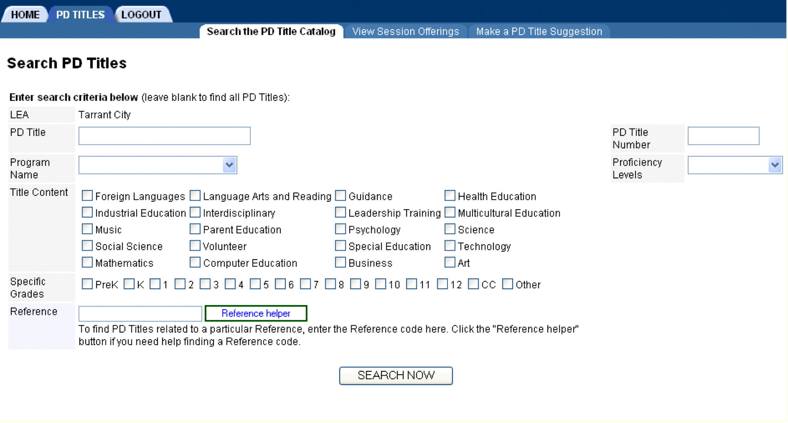

Step 4
All PD Titles matching your search criteria will be displayed. To view details of a session schedule or to enroll, click on the VIEW SCHEDULE link.
Note: To continue with your search, click the Do Another Search link located both at the top right hand corner and bottom of the screen.
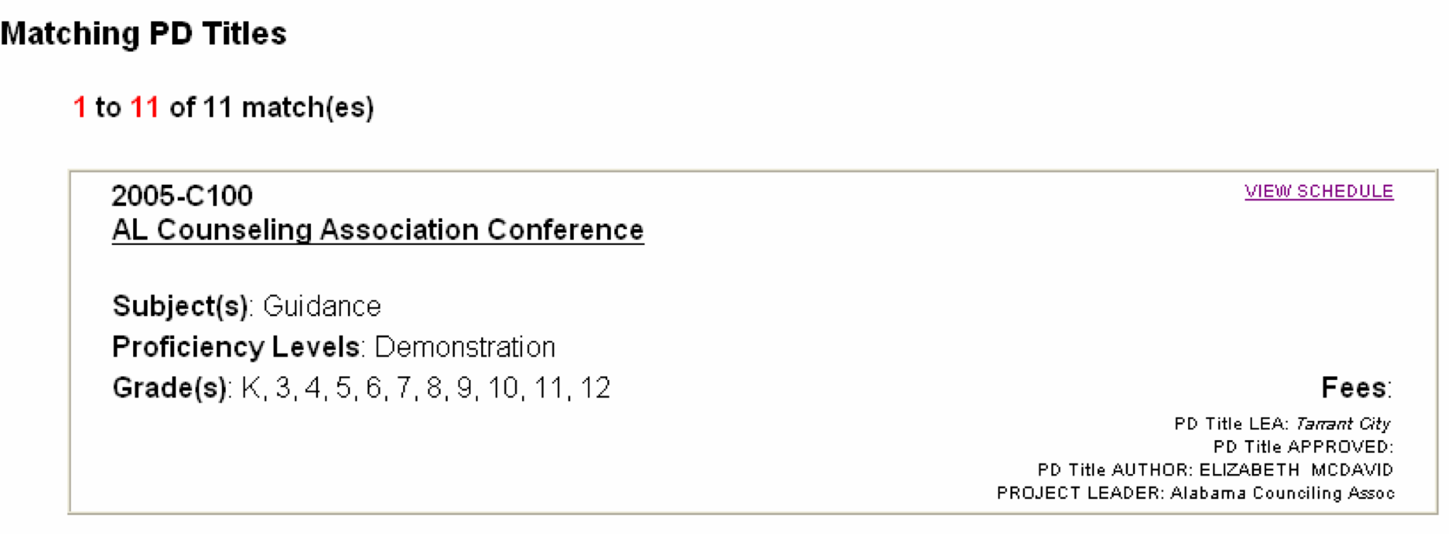
Enrolling for a Session

Step 1
Click VIEW SCHEDULE link (located on your Matching PD Titles screen) for the session in which you wish to enroll (see previous page). A detailed schedule will be displayed. To enroll in a specific session, click the ENROLL NOW link.

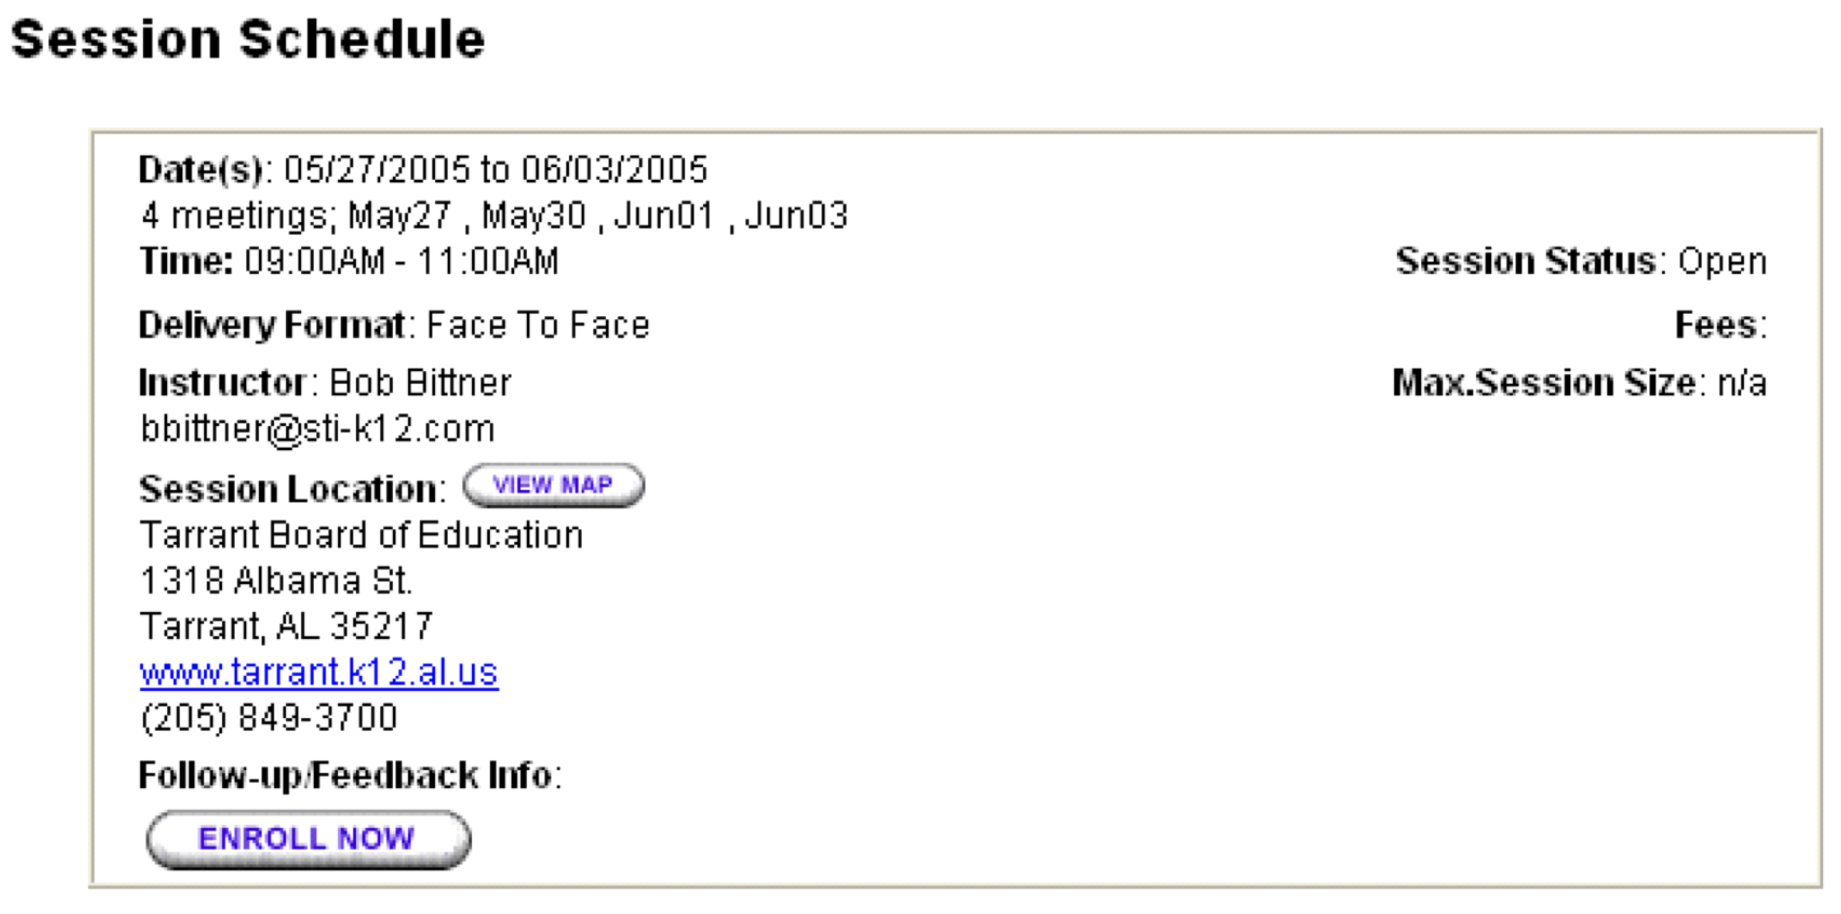

Step 2
You will be asked to confirm session enrollment. Be sure to verify details of the session. Additionally, if this session accepts online payments, then you need to complete the “Payment Information” fields. The PD system will also let you know if there are any conflicts with other sessions in your schedule. To continue enrolling for the session, click Yes. Click Cancel if you do not wish to enroll in this session.

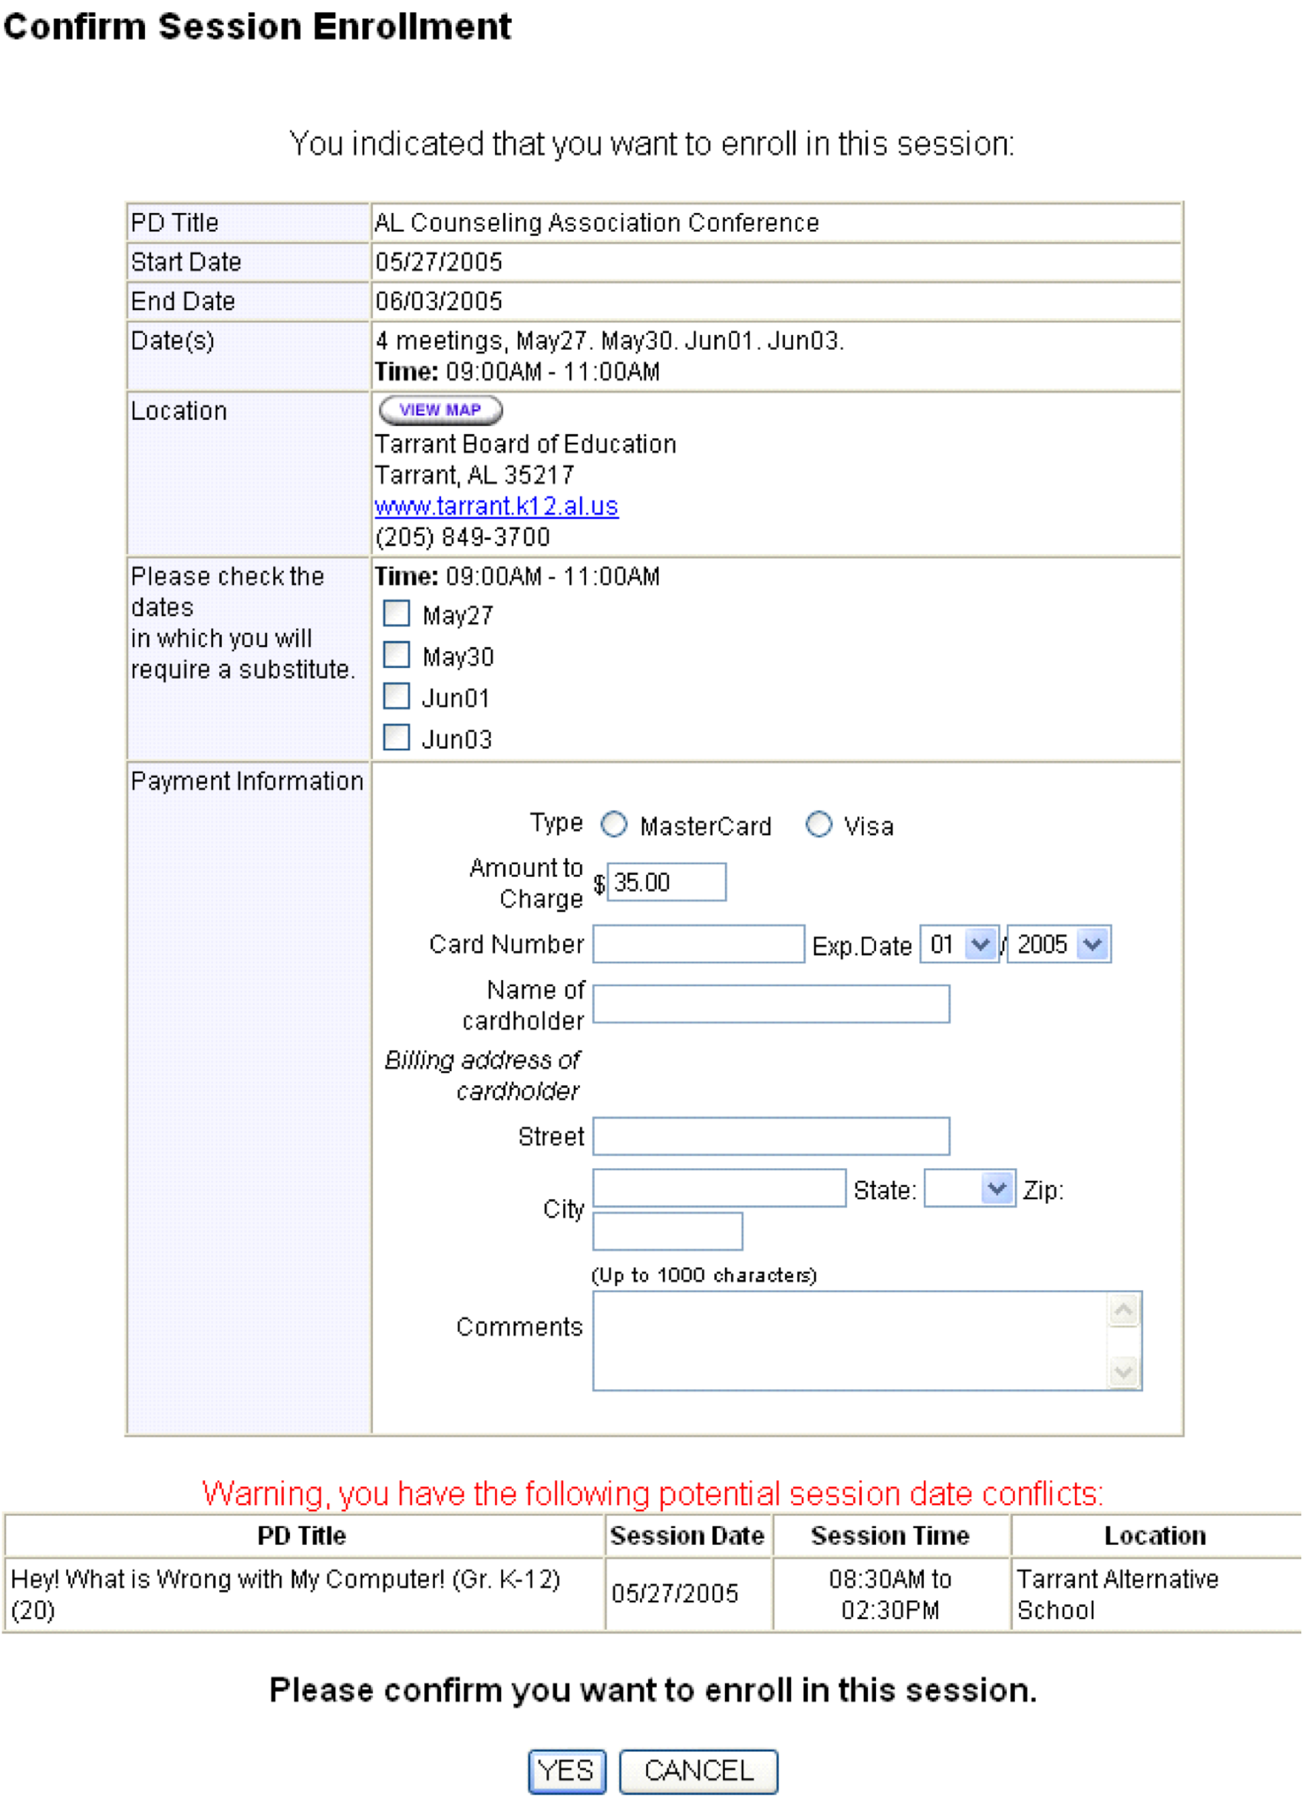

Step 3
When you have enrolled for the session, a confirmation screen will appear. Click Close This Window to exit.

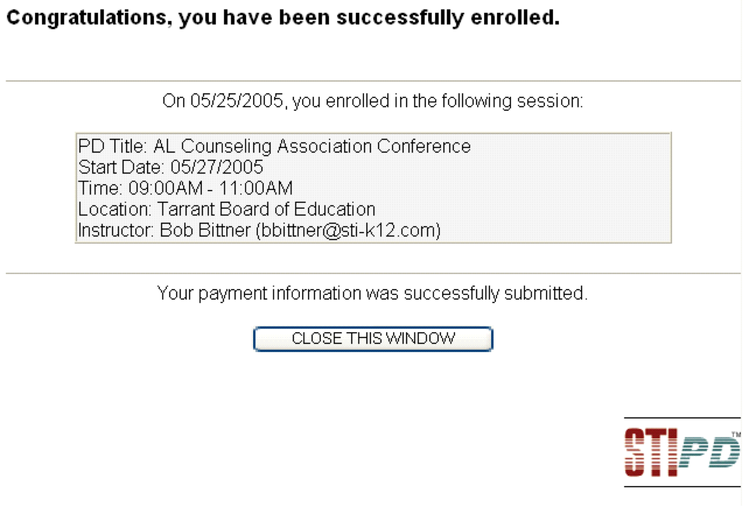

My Sessions
Viewing Session Schedule Calendar

Step 1
To view your schedule of sessions, click the My Sessions link located on the menu bar.

Step 2
To view the details of a specific session, click on the appropriate session in the calendar.

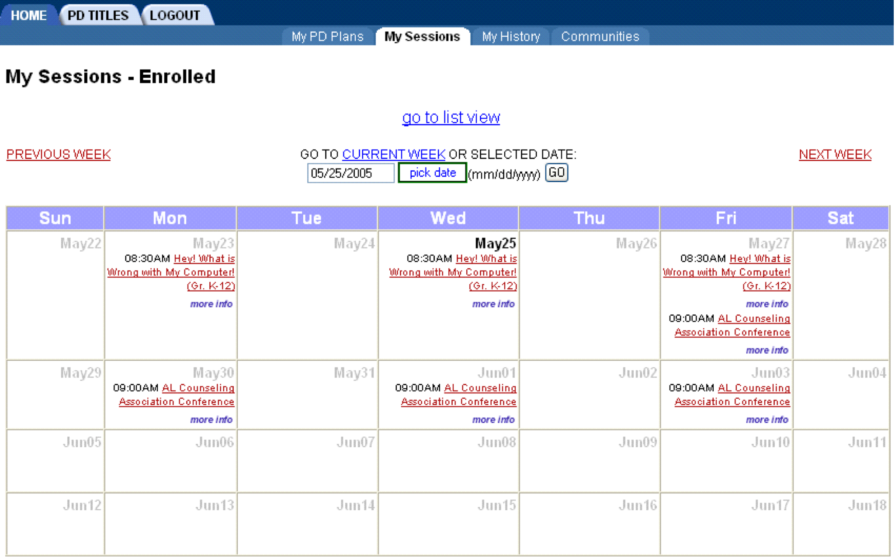
Note: For your convenience, this screen allows you to view different months, weeks or even days.

Step 3
You may submit a session request by clicking on the SUBMIT SESSION REQUEST button. You may also view your attendance and session status history. If you have not yet submitted your payment information for this session, or if your payment information has been declined, you may click on the Submit or Re-submit link under the Payment Info column in order to update your payment information. (This only applies if this session requires online payment information).
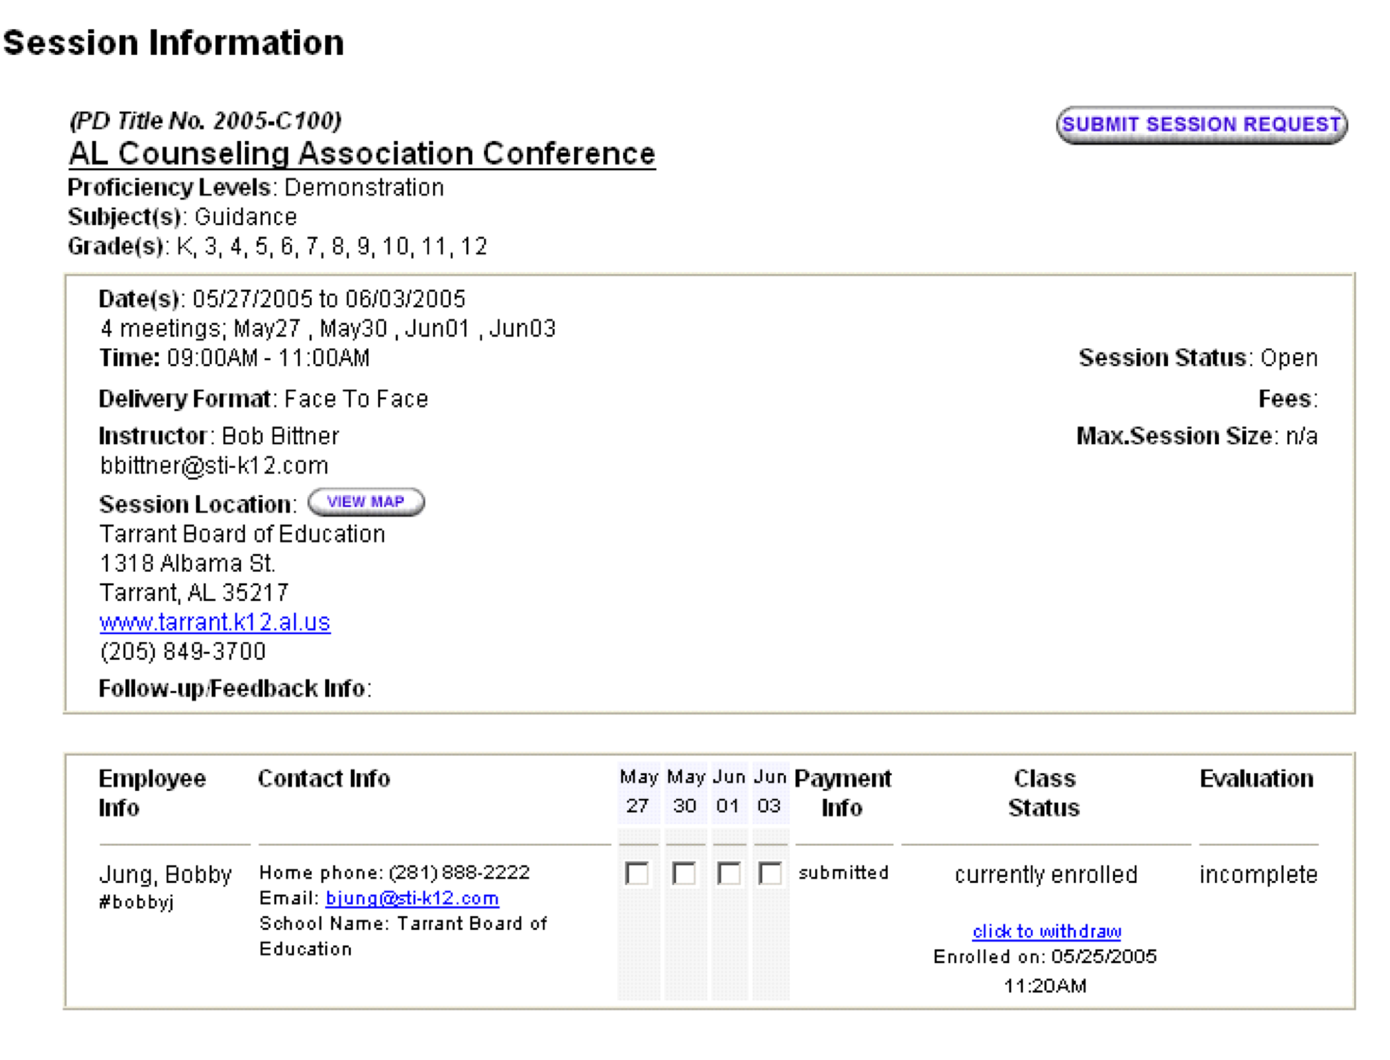

Step 4
You may indicate when the session schedule would best suit your needs and also edit or delete any previous PD Titles requests you have submitted.

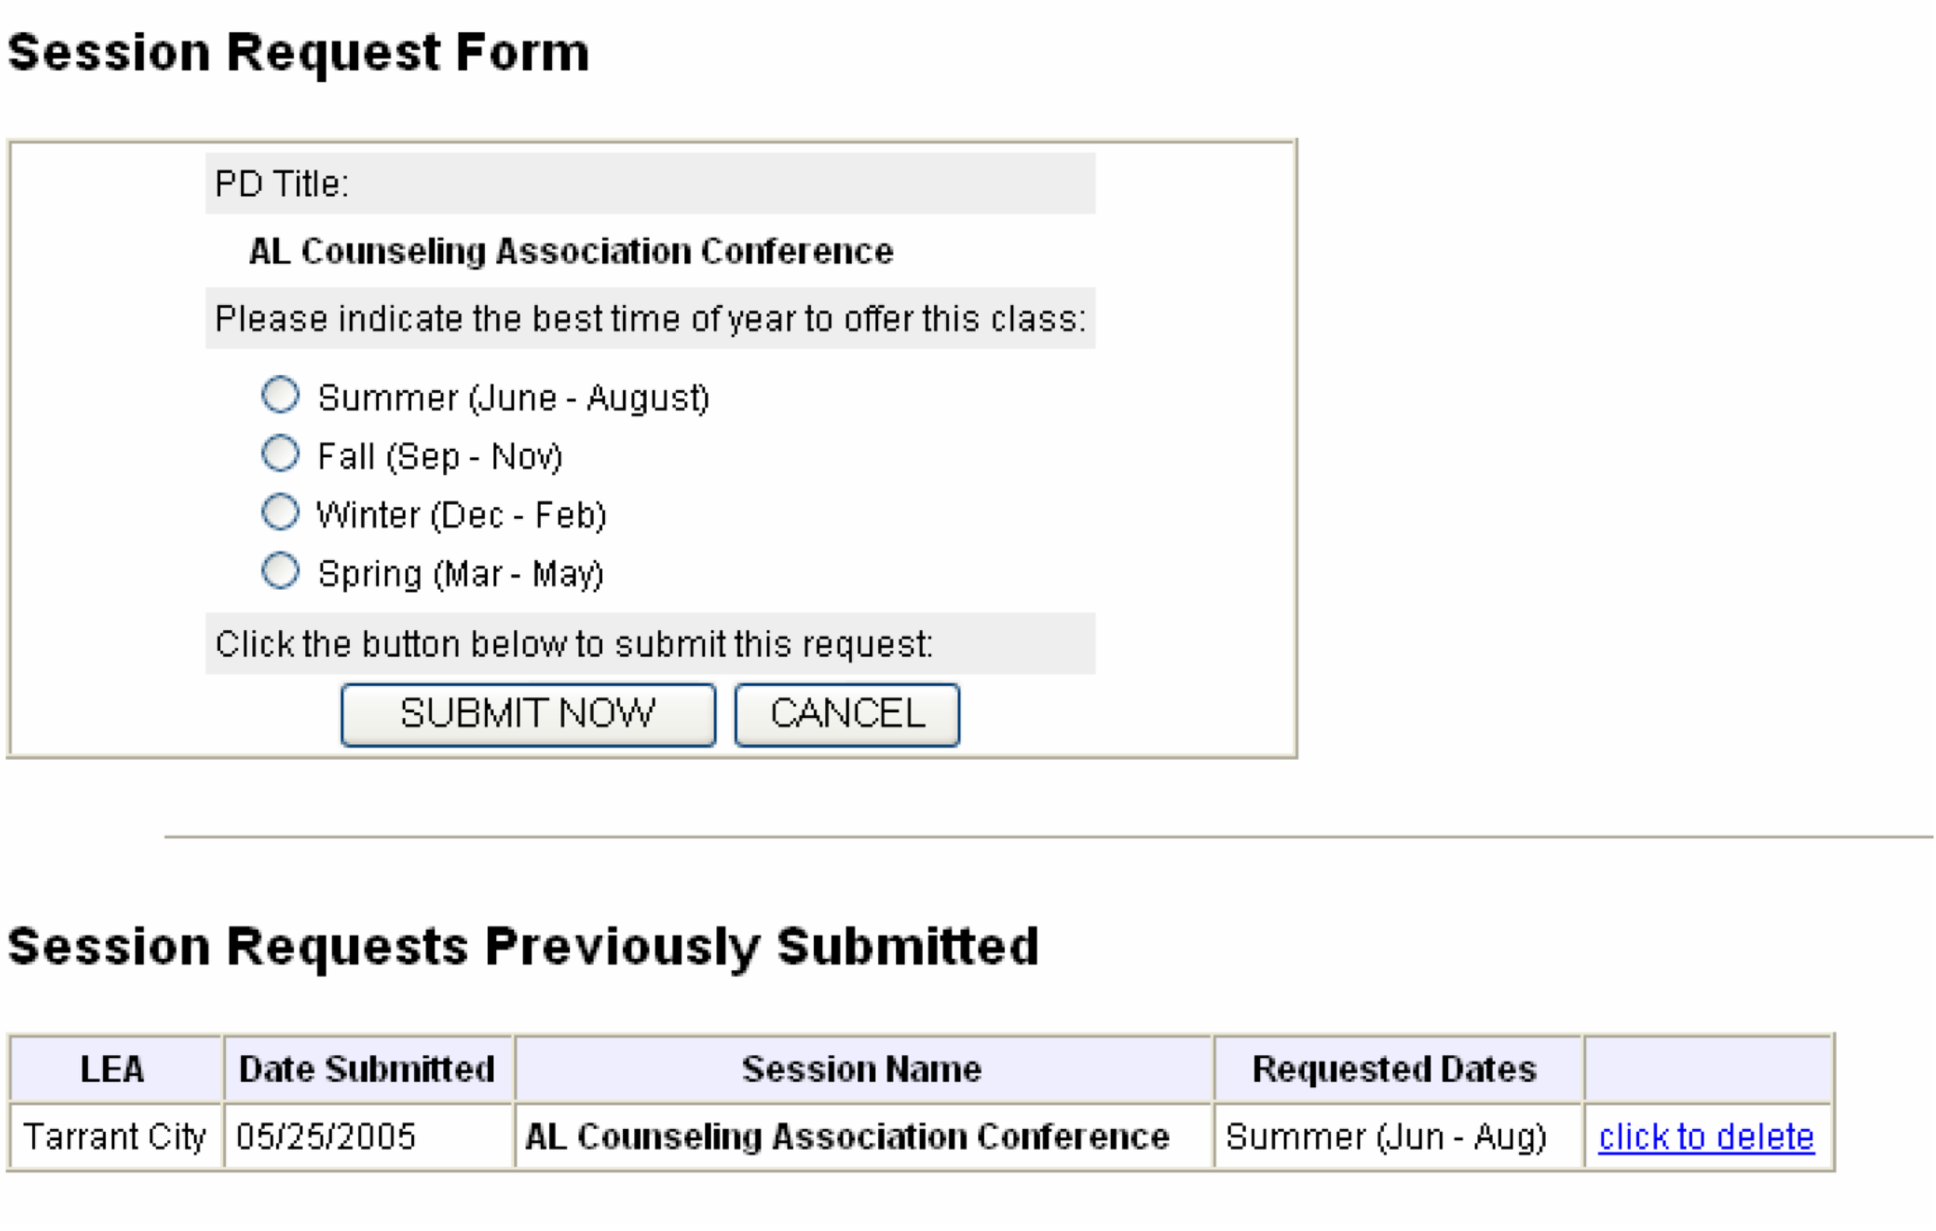

My Training History
Viewing Training History

Step 1
To view your training history, click the My History link located on your menu bar.

The My Training History screen outlines the dates, names and locations of your training sessions. In addition, your proficiency level, attendance, points, credits and status for each session are provided. To filter your history by date range, enter the desired dates in the Start Date and End Date fields and then click the Filter by Date Range button. (You may leave one or both fields empty).

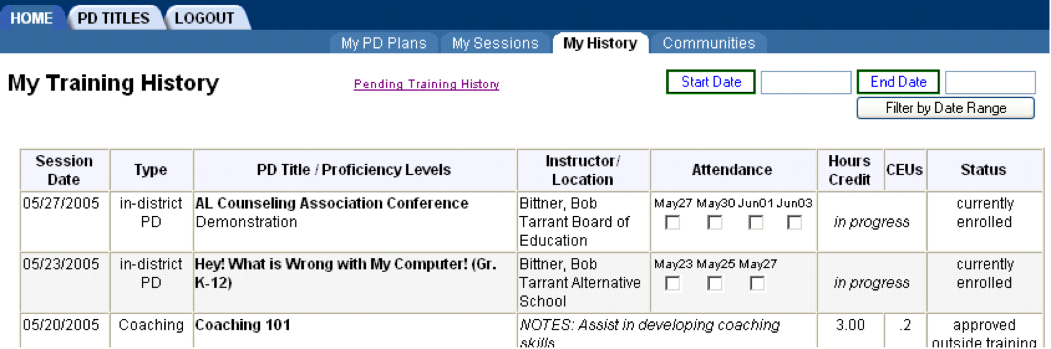

Step 2
If you scroll down this screen, you may view and submit new training items for approval.
Click submit new training history item for approval to add items to be approved for your history.

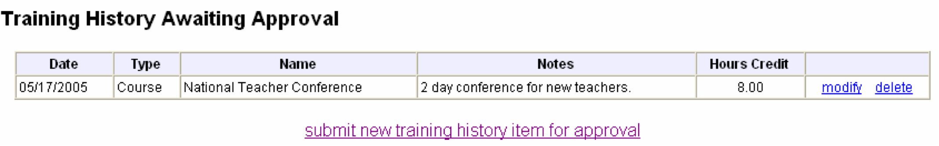

Step 3
Select any additional session(s) for training history and click the Add link to add the record. If you do not wish to add to the training history, click Cancel.

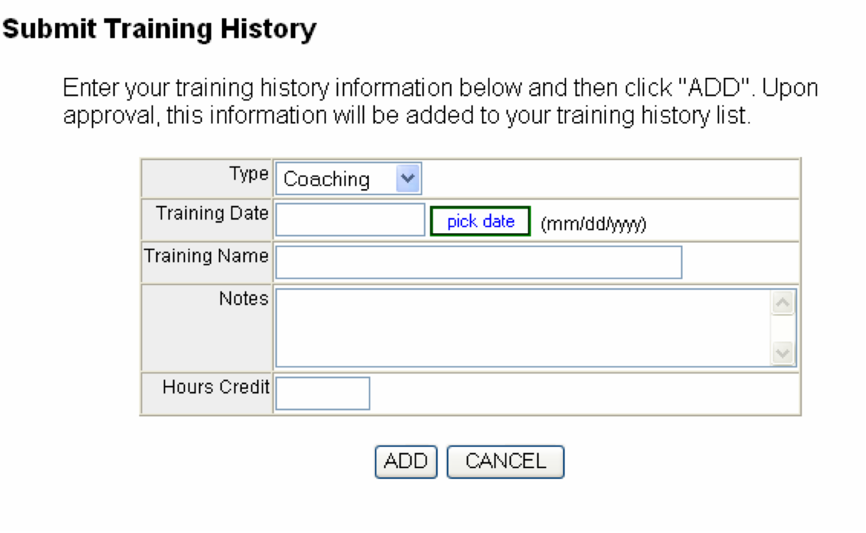
Note: These additional sessions will be added as pending approval items from your manager.

My PD Plans
Creating a New PD Plan

Step 1
To create a new PD Plan, click the create a new PD Plan link on the main page.

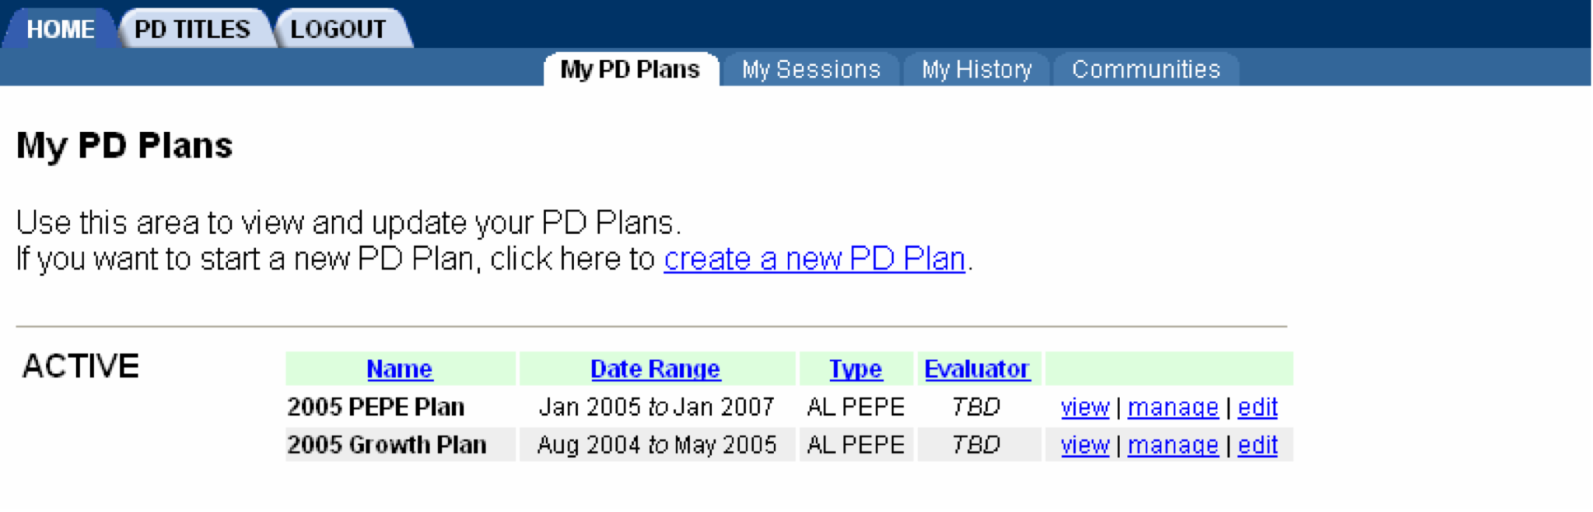

Step 2
In the new screen that appears, complete the Create New PD Plan form and then click the CREATE NOW button to continue If you change your mind at any point, click the CLOSE THIS WINDOW button to cancel and discard your information.
Note that for Date Range, you may select any range as long as the ending date is after the starting date. For Status, you should select PENDING if you plan to add information to this PD Plan later (such as Goals and Objectives).

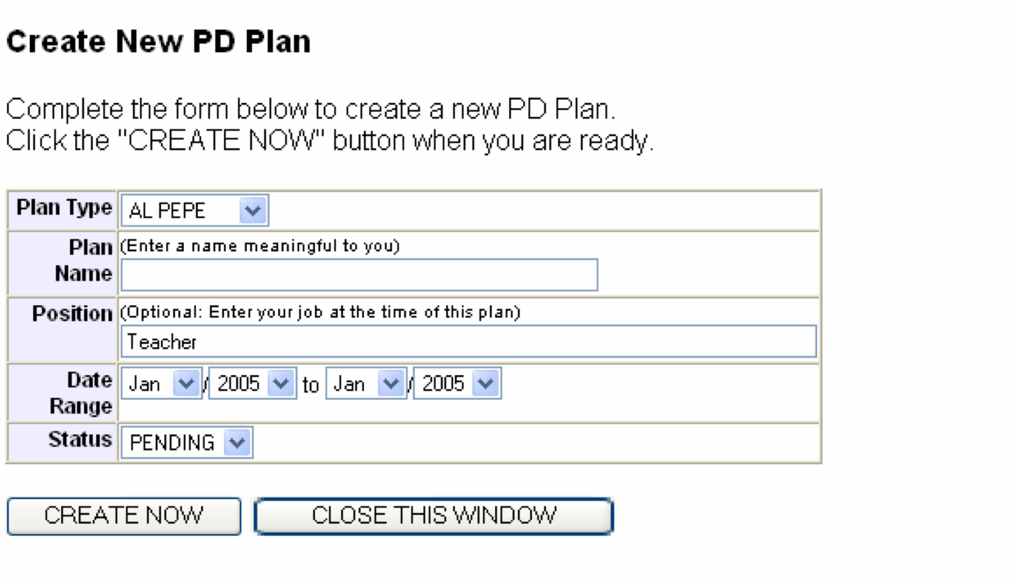
Your new PD Plan will appear in your list of PD Plans. It is now available for you to either manage or edit as necessary.
Managing a PD Plan

Step 1
Click on the manage link to begin managing the goals and objectives of your PD plan.

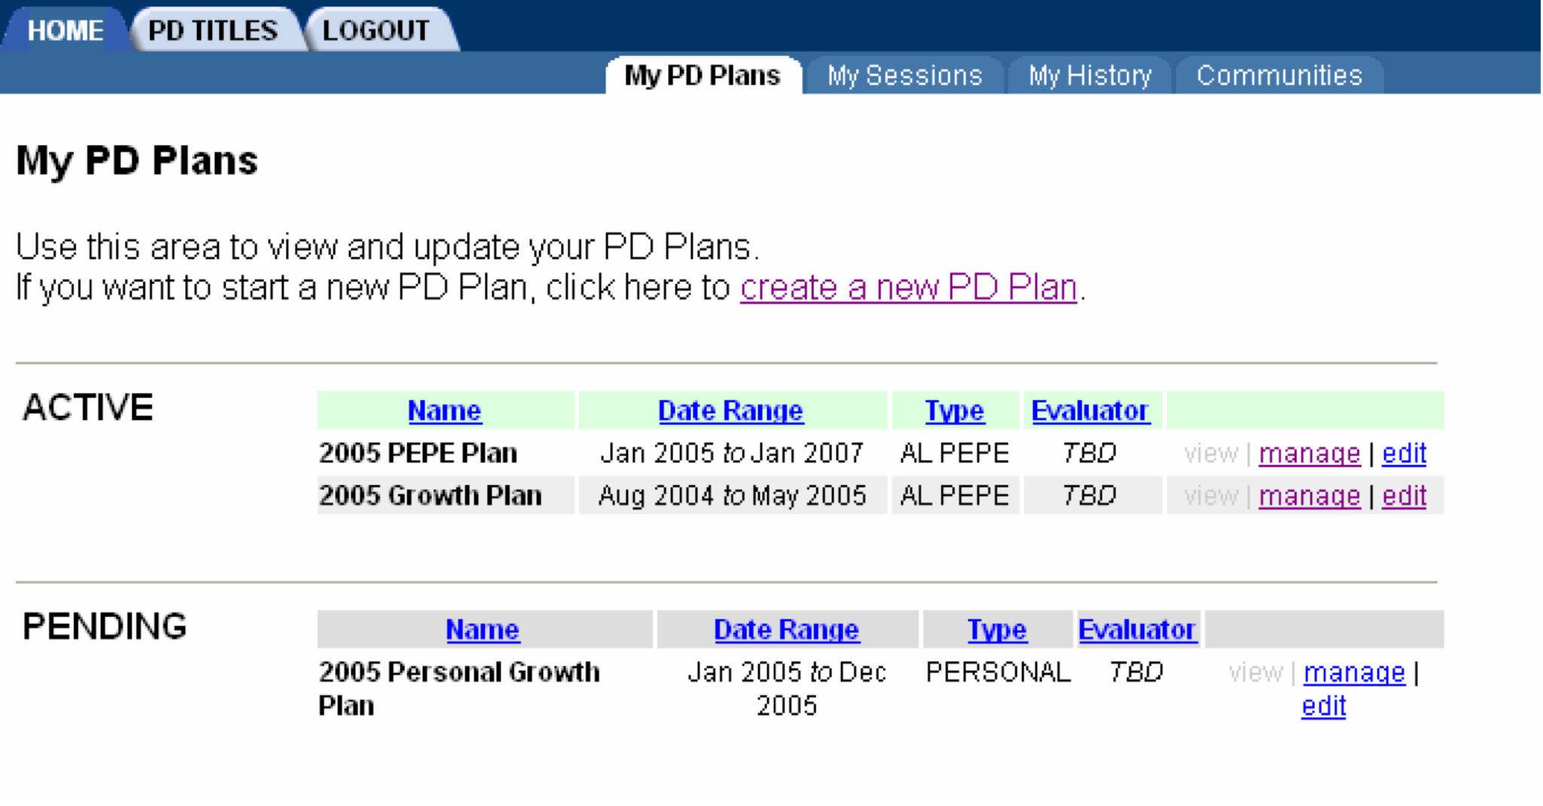

Step 2
On the Manage This PD Plan screen that opens, you may create a new PD Plan Area by clicking the new area link.
Note: If you have previously created PD Plan areas, they will also be listed on this screen.

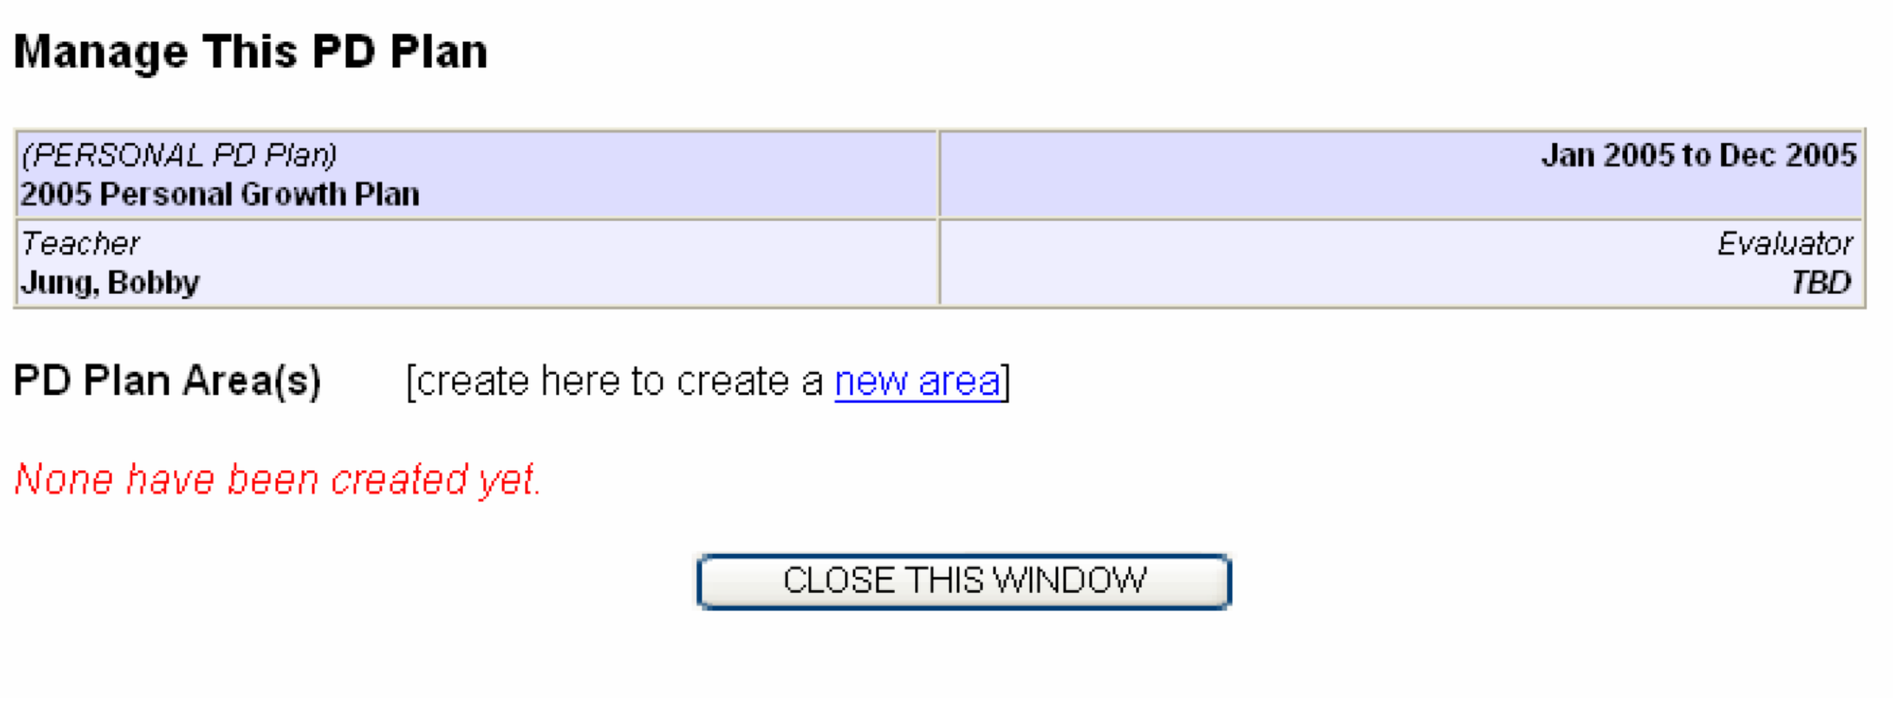

Step 3
Select the area Type and give it a name that is meaningful to you. Also, you may: enter the PD Related Goals & Objectives; add Goals & Objectives by Reference(s); enter any Proposed Activities; add Proposed PD Title(s); enter a Time Line; enter the appropriate Assessment Method(s); and add any Progress Check Dates.
When you are done, click the SAVE button on the right side of the screen. Otherwise, you may CANCEL your changes or completely DELETE the area.

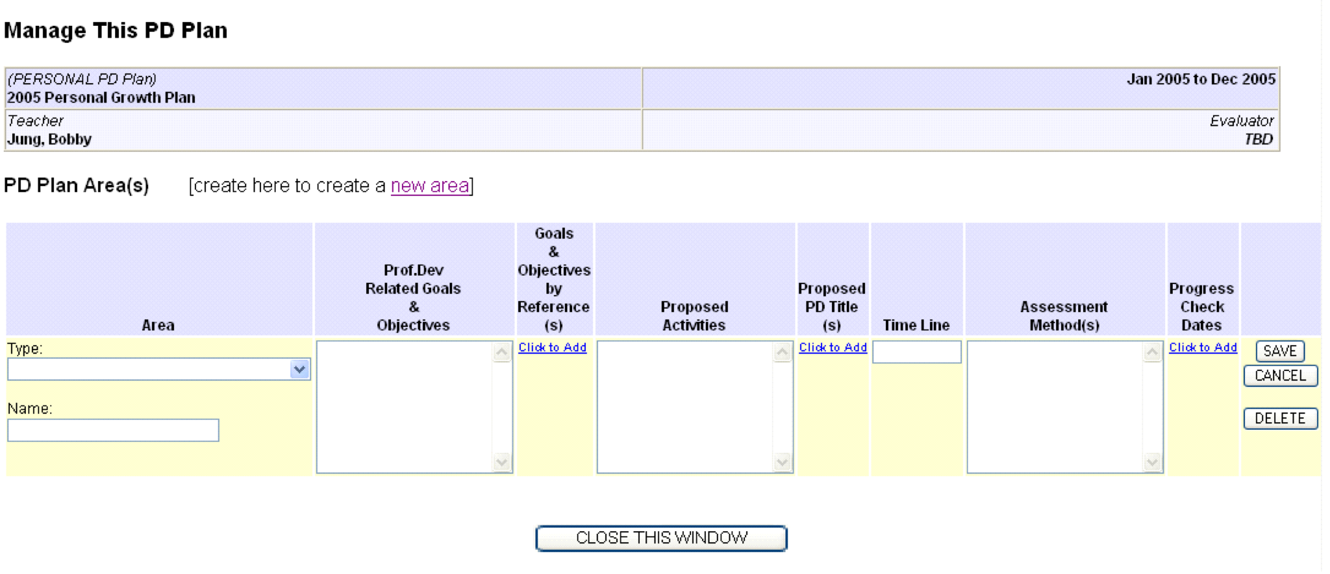

Learning Communities
About Learning Communities
The Learning Communities feature is provided to allow employees to post messages for other employees to view.
Learning communities may be accessed from either Communities link.

Closing the Program
Logging Out
You may log out anytime during your session. To log out, simply click the Logout link located on the menu bar.

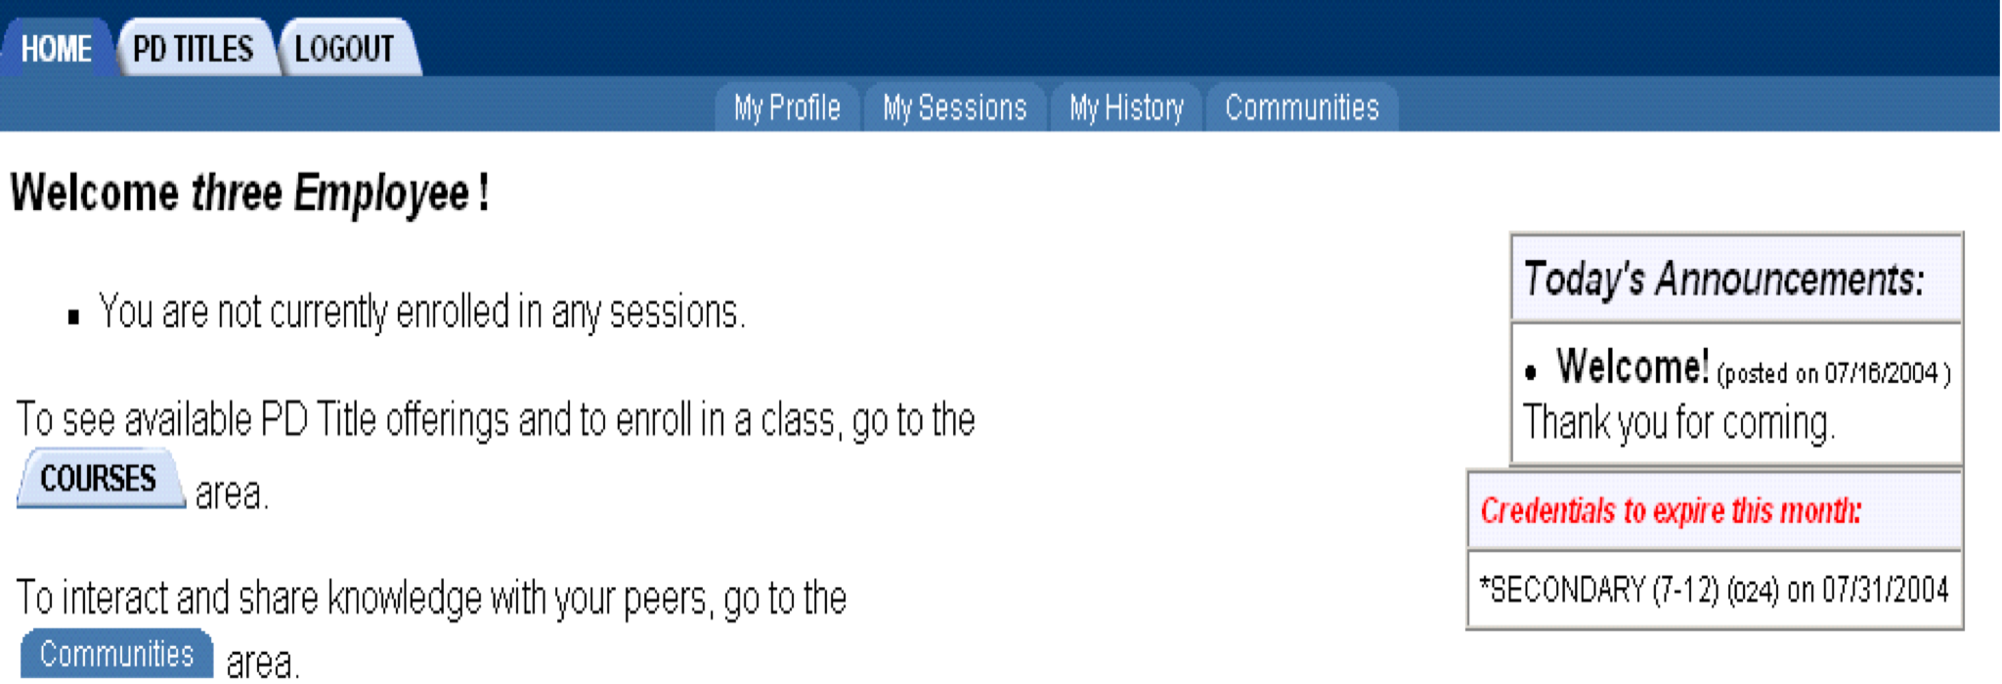

Index
A
About Learning Communities 15
C
Closing the Program 16
Creating a New PD Plan 12
E
Enrolling for a Session 4
G
Getting Started 1
L
Learning Communities 15
Logging In 1
Logging Out 16
M
Managing a PD Plan 13
My PD Plans 12
My Sessions 7
My Training History 10
P
PD Titles Catalog 2
S
Searching PD Titles Catalog 2
V
Viewing Session Schedule Calendar 7
Viewing Training History 10

