MATH WORK Week of April 21-27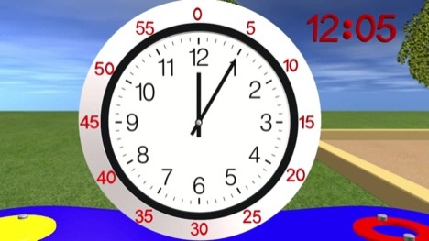 Ohio Standard 4.MD.2b Telling Time I hope that everyone is doing well. Last week, we attempted to deliver school work several different ways.
For students getting the work online, I continue to ask that the answer sheet be mailed to me when you are done.
For students getting a paper packet, I will enclose an answer sheet. Please return that answer sheet to me through the mail. (I don’t need all the worksheets back.)
If there is any problem that you don’t understand, please contact me at diana.pinkerton@southern.k12.oh.us.

Tuesday, April 21
Problems of the Day
- Every month, Jaylen earns $3000. He spends $1,400 on rent and bills, $700 on groceries, $200 on a car payment, and $100 on gasoline. Jaylen saves the rest. How much money does Jaylen save?___________________
- Emma wanted to ride her bike. It was 1 o’clock. Her mom said she had to clean her bedroom first. It took Emma 1 hour and 25 minutes to clean her room and 15 minutes to eat a snack. What time did she start riding bikes?_________________
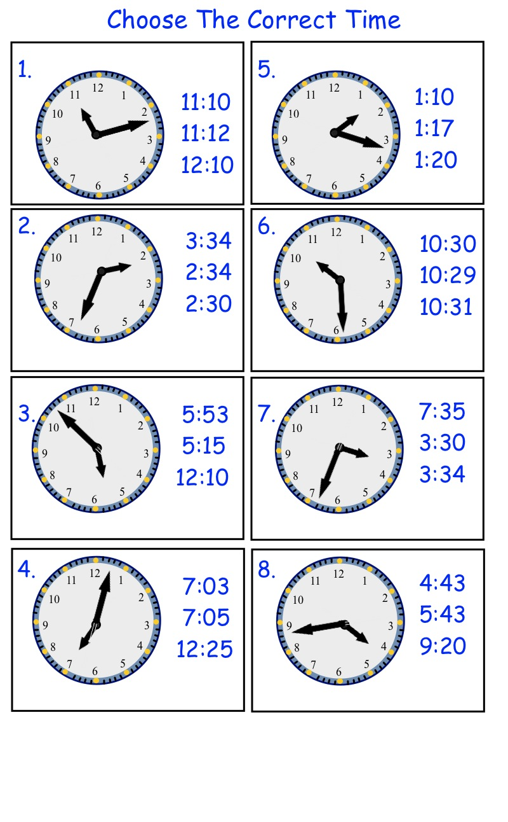
Wednesday, April 22
Problems of the Day
(Remember: There are 60 minutes in one hour.)
- Jeffrey and his sister watched a movie that lasted 1 hour and 45 minutes. The movie started at 3:00. When it was over, they read books until supper. If supper was at 5:30, how long did they read?___________________________________________
(Draw a clock if it helps.)

- Jessah talked to Rhiannon the phone for 2 hours and 15 minutes. How many minutes are in 2 hours and 15 minutes? _________________________________

- Rylie was at the amusement park for 3 hours. She spent 60 minutes on the rides, 40 minutes on the carnival games, and ate food for 30 minutes. The rest of the time she was waiting in line. How long did Rylie wait in line?____________________________________
Go to the next page.
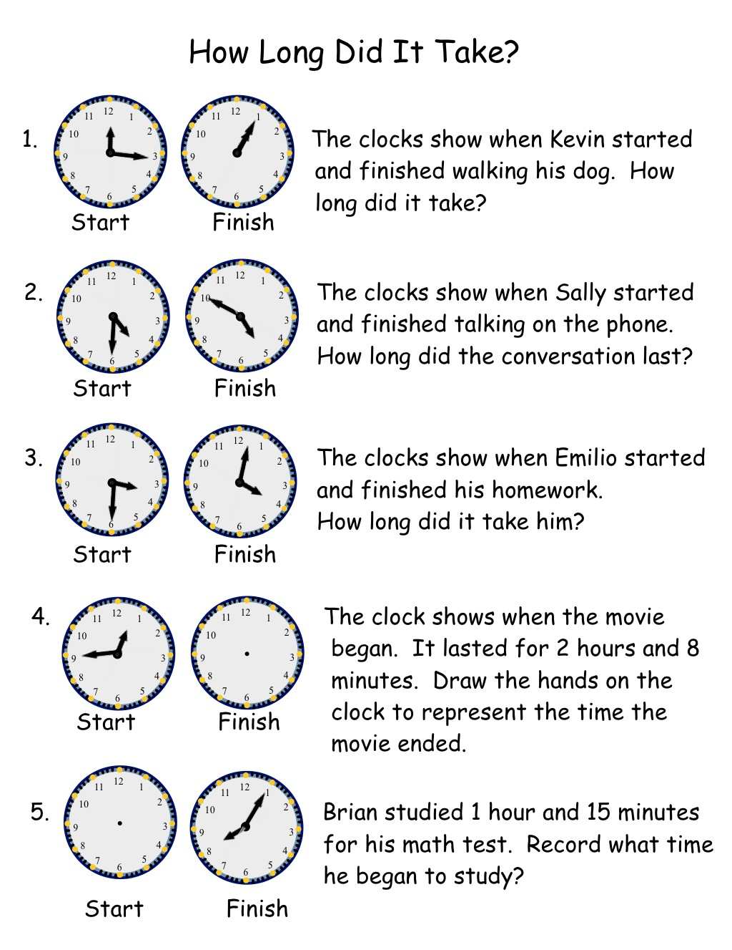
Thursday, April 23
Time flies when we are having fun. Today, track 3 activities you do and record how long you do it. (For online people, just write the times down as you can draw hands on clocks. )
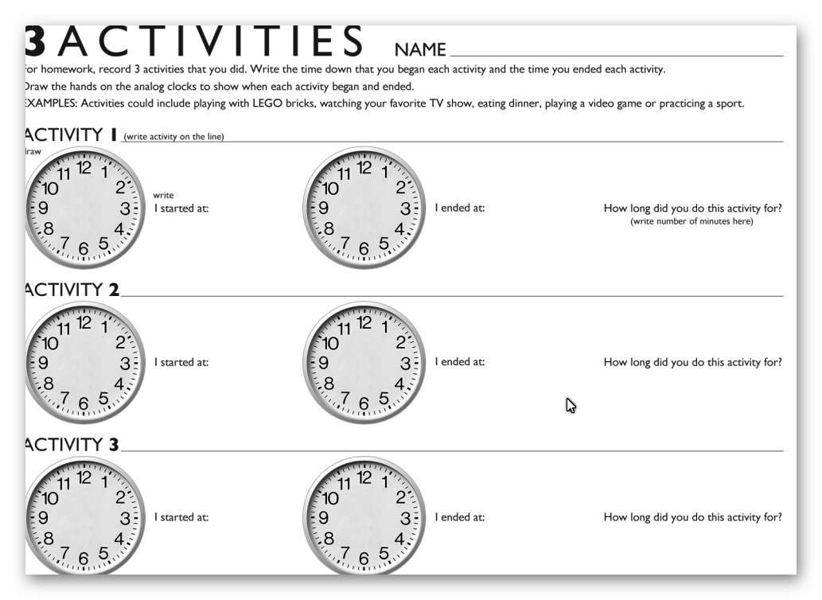
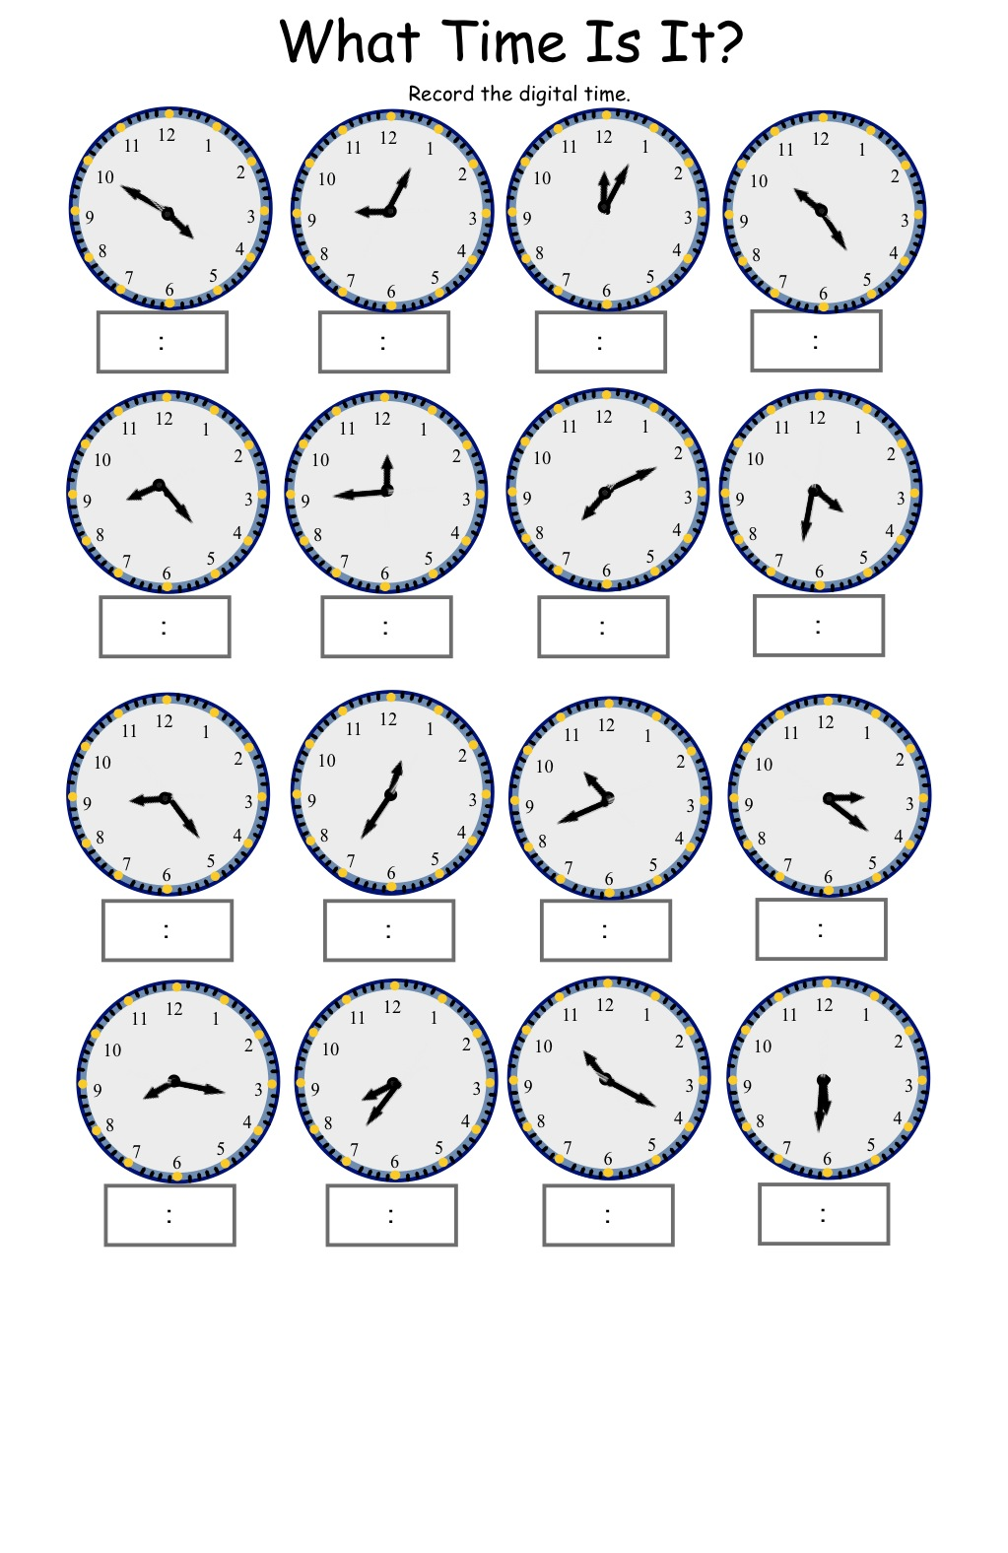
Friday, April 24
Monday, April 27
Problems of the Day
1.Hannah woke up at 7:15. It took her 15 minutes to dress and brush her teeth. She ate breakfast for 20 minutes. Then it took her 5 minutes to walk to the bus stop and wait for the bus to arrive. When did the bus arrive?_______________

2. Here’s an old poem:
30 days has September,
April, June and November,
All the rest have 31
Except February which has 28
(most of the time)
But in Leap Year has 29.
How many days does May have? _________________________

- If there are 24 hours in one day, how many hours are in one week?_______________________________

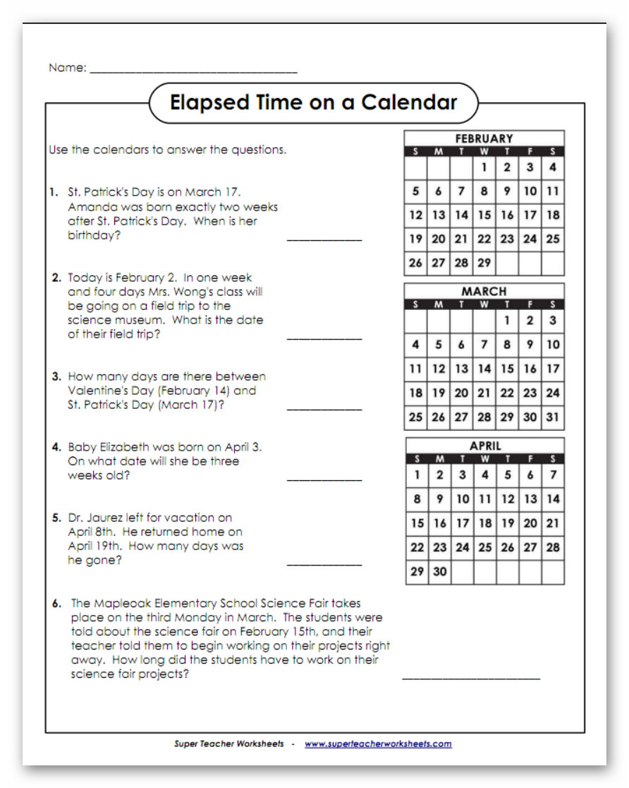
MATH Classwork for April 28-May 1
Ohio Standard 4.NBT.5 Illustrate and explain how to multiply whole numbers using equations and area models.

Tuesday, April 28, 2020
Problem of the Day.
Mary knew there are 7 days in one week. If May, June, and July have 13 weeks, how many days are in those months?__________________
Review the basic facts:
- 3 x 4=_______ B. 9 x 6 =_______ C. 12 x 5=_______
D. 6 x 6=______ E. 4x 6=________ F. 8 x 8=________
G 8 x 3=_______ H 2 x 12=_______ I 4 x 9=_________
J. 4 x 4=________ K. 6 x 4=________ L 3 x 7=_________

Wednesday, April 29
Problem of the Day
Braxton bought 12 packs of pencils before school started. Each pack had 20 pencils in it. How many pencils did Braxton buy?________
Remember: When we multiply by multiples of 10 (which end in a zero), we can solve in several ways. The easiest way is to multiply the numbers that are not zero then count and add the zeros to the end.
Example:
8000 x 30 = 24 with 4 zeros or 240,000 Complete the following page.
- 30 x 400=______________________
B 60 x 40=_______________________
C 3000 x 80=_____________________
D 90 x 200=______________________
E. 140 x 2000=____________________
F. 120 x 30=______________________
G. 500 X 700 =_____________________
H. 700X 30=______________________
I. 60 x 900=________________________
Optional: Watch Khan Academy “Multiplying by Multiples of Ten”online

Thursday, April 30
Problem of the Day
Alex was filling in his physical education report for Coach Randolph. He exercised every day for 30 minutes. After 7 days, how many minutes had he exercised?_________________________
Remember we solved 2 digit by 2 digit multiplication several ways.
One way was an area model 26 x 31 was broken down
20 6
30 x 20=600 | 30 x 6=180
1 x 20 = 20 | 1 x 6=6
30
We then added the answers in the boxes. 600+ 180+20+6=806
So our product is 806. The second way we did it so through partial products. Then we added them.
26
X31
26 Remember : Multiply 26 x 1 then since the 3 stands for 30
780 we add a zero under the 6 then multiply 26 x 3. Add.
806
31 x 72

56 x 32

45 x 83

Solve:
34 73
X46 X59

Friday, May 1 Problem of the Day
Miss Brenda was sewing a quilt for her bed using square pieces of fabric. Each row had 21 squares. She measured her bed and decided that there needed to be 35 rows. How many squares of fabric would Miss Brenda need to make her quilt?______________________
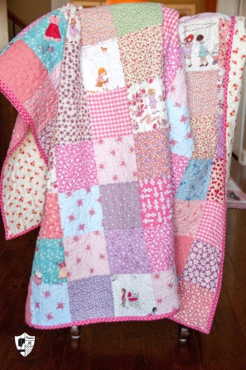
Complete the problems on the following page
