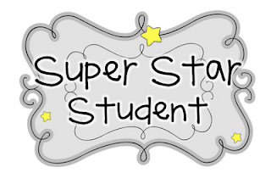
Keaton is our Star Student!
Here are a few of Keaton’s favorites.
Color- blue
Animal- dog
Food- burger
Movie-Guardians of the Galaxy
Number- 13
Keaton wants to be a veterinarian when he grows up.

