**Instructional Focus**:

**Reading**- Story for week- Simple Machines

Reading Skill: Main Idea and Details

**Phonics Skills**:

Review Skills: Vowel sound in ball: aw, au

New Skills: Diphthongs oi, oy / Suffixes –er –or

**Grammar Skill:** Pronouns

**Math** – Finish Topic 14 / Test on Topic 14

**Science/ Social Studies** – Habitats / Butterflies

**Leader in Me** – Review all 7 Habits

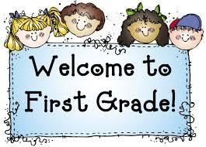 Week of May 17th – May 21st

Mrs. Lyness’ Newsletter

Spelling Words:

1. oil

2. point

3. coin

4. join

5. soil

6. boy

7. oink

8. voice

9. boil

10. toy

*Spelling Test Friday

**Important Dates Coming Up**:

May 24th – Field Day

May 27th – 1st Grade Awards Day @ 9:45 – 10:00

May 31st – No School; Memorial Day Holiday

June 3rd – Teacher In-service Day

June 4th – Last Day of School!

*If you can send in some Clorox Wipes and Paper towels that would be greatly appreciated.

High – Frequency Words:

1. aginst

2. goes

3. kinds

4. today

5. heavy

*On Reading Test Thursday