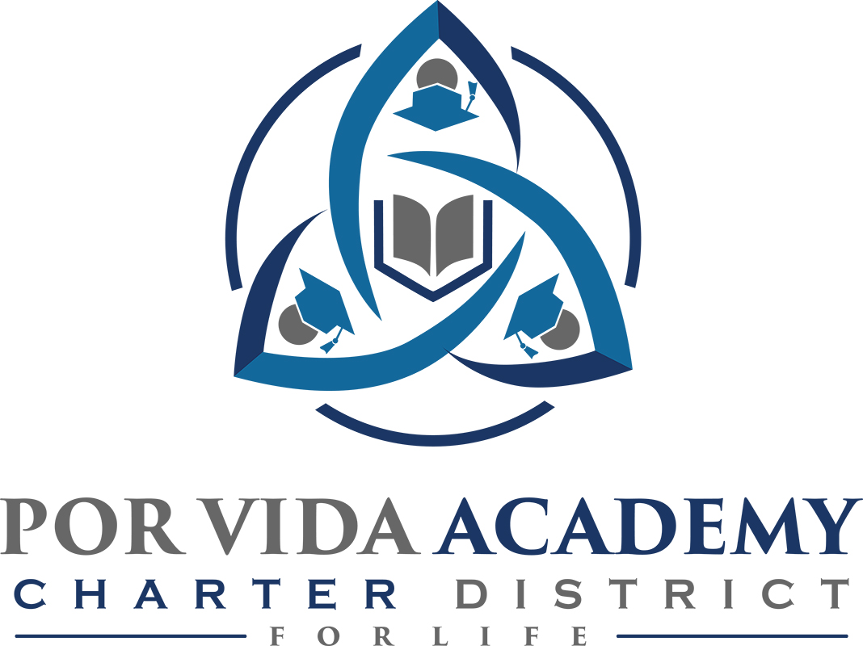

Thursday, January 10, 2019 at 12:00pm 1135 Mission Road, SA TX 78210

Minutes of Regular Called Board Meeting

- Call to Order and Establishment of Quorum
  - Roll Call & Recording of Board Members Present - Declaration of Quorum Present. Jose Gonzalez, Edith Cogdell, Sr. Odilia Korenek
  - Recording of the Executive Director/Superintendent and Staff Members Present. Joseph G. Rendon, Stephanie Rodriguez, Danette Salazar, Loren Franckowiak, Bertha Ramones, Alice Dikee, Claudette Yarbrough, Ivonna Gonzalez, Cristina Ordonez, Sandra Valencia, Ashley Trevino

- Closed Session: None

- Pledge of Allegiance

- Salute to the Texas Flag- “Honor the Texas Flag; I pledge allegiance to thee, Texas, one state under God, one and indivisible.”

- Public Testimony

- Approval of Minutes: October 19, 2018 & August 24, 2018. Edith Cogdell moves to approve. Jose Gonzalez seconded. Minutes approved as presented.

- Superintendent Items:
- Claudette Yarbrough discussion on sustainability
- Financial Management Report. Edith Cogdell moves to approve. Jose Gonzalez seconded. Financial Management report approved as presented.
- Charter FIRST
- School reports

- Financials - Current. Edith Cogdell moves to approve. Jose Gonzalez seconded. December 2018 financials approved as presented.

- Board Items: None

- Adjournment Sr. Odilia Korenek adjourned meeting at 1:53 pm.

_____________________________ _____________________
Sr. Odilia Korenek Date Edith Cogdell Date
President Secretary

