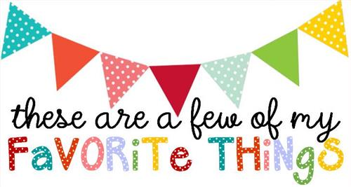

Name: Barbara Leaphart
T-shirt Size: Medium
Birthday: 11/13/1981
Monogram: BLC
Favorite Color: purple
Favorite Flower: daisy or sunflower
Favorite Scent: Vanilla??
Favorite Candy: peanut M&Ms
Favorite Drink: Dr. Pepper
Favorite Food: Mexican
Favorite Snack: Doritoes or Cheese-its
Favorite Fruit: Grapes
Favorite Restaurant: La Siesta
Favorite Places to Shop: Target and Commerce St Market
Favorite Bath and Body Words Scent: I don’t know!
Things I collect: old picture frames
Favorite Author/Book Series for my own personal reading: anything mystery/suspense
Wish List for Classroom: markers/ colored pens, paper towel, color copy paper

