One of the most common nutrients for the body is protein. Proteins are long chains of amino acids, which includes the elements of carbon, hydrogen, oxygen, and nitrogen. There are twenty different kinds of amino acids that combine to make proteins in the body. A person's body can make some amino acids, but like the other two macronutrients, carbohydrates and fats, proteins are obtained from food.
There are thousands of different proteins in the body and each has functions to help keep the body healthy. They are essential for life, and around 20% of the body is made up of proteins, and every cell in the body uses proteins to perform functions.
A few of the major groups and functions of proteins include the following:
. Structural: Proteins that provide structure for the body and includes collagen which is found in cartilage and tendons.
. Defensive: Proteins that help protect the body from diseases, and they make up antibodies that fight off foreign germs such as bacteria and other toxic substances.
. Transport: Proteins that carry essential nutrients around the body. Such as hemoglobin which carries oxygen in the red blood cells.
. Catalysts: Some of the proteins, called enzymes, act as catalysts to assist in chemical reactions, and they help break up and digest food, so it can be used by the cells in the body.
The best sources of protein are beef, poultry, eggs, fish, nuts, seeds, legumes, and dairy products. Protein builds, maintains, and replaces the tissues in the body. In fact, the muscles, organs, and the immune system are mostly made up of protein.
When a person eats foods that contain protein, the digestive juices in the stomach break down the protein in food into amino acids, which then can be reused to make the proteins the body needs to maintain body organs, muscles, blood, and bones.
The proteins in the body are sometimes described as long necklaces with a variety of shaped beads, and each bead is a small amino acid. They join to make thousands of different proteins, and scientists have found many different amino acids. However, only about 22 of them are very important to the health of the body.
The protein that comes from animal sources such as meat and milk is called complete because it contains all nine of the essential amino acids. Vegetable protein is considered incomplete because it does not have one or more of the essential amino acids, which can be a problem for people who do not eat animal products. However, there are some protein-rich vegetable foods. For example, a person cannot get all their amino acids from peanuts alone, but peanut butter on whole-grain bread has the protein that is needed.
Finally, the amount of food from the different Protein Foods Group depends on a person's age, sex, and level of physical activity. For example, about 0.5 grams of protein is needed for every pound a child weighs. As a person gets older, the amount of protein needed will increase.
In summary, protein is one of the three macronutrients a person's body needs for good health, along with carbohydrates and fats.

1) All the following are macronutrients the body needs for good health EXCEPT:

A: Vitamins
B: Proteins
C: Fats
D: Carbohydrates

2) Which of the major groups and functions of proteins provide structure for the body and includes collagen?

A: Structural
B: Defensive
C: Transport
D: Catalysts

3) Which of the major groups and functions of proteins carry essential nutrients around the body such as hemoglobin?

A: Structural
B: Defensive
C: Transport
D: Catalysts

4) Which of the following acts as catalysts to assist in chemical reactions in the body helping to break up and digest food?

A: Hemoglobin
B: Amino acid
C: Enzymes
D: Fats

5) All the following are best sources of protein EXCEPT:

A: Poultry and eggs
B: Beef and fish
C: Nuts and dairy products
D: Fruit and vegetables

6) If a young child weighs 50 pounds, about how many grams of protein would the child need each day for good health?
A: 50 grams
B: 25 grams
C: 5 grams
D: 125 grams

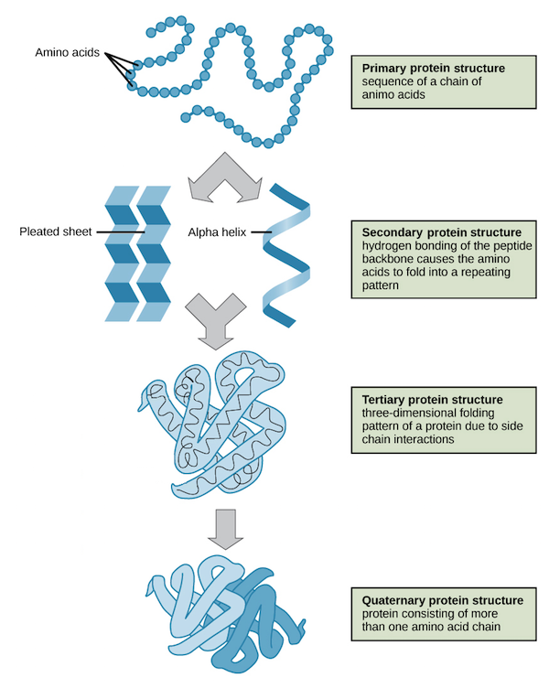
Proteins reading worksheet
A protein is an organic compound made up of small molecules called amino acids. Proteins help make up the structure of the cells in our muscles, organs, hair, nails, and more. There are 20 different amino acids commonly found in the proteins of living things. Small proteins may contain just a few hundred amino acids, whereas large proteins may contain thousands of amino acids.
Protein Structure: When amino acids bind together, they form a long chain called a polypeptide. Two amino acids are held together by a peptide bond. A protein consists of one or more polypeptide chains. A protein may have up to four levels of structure. The lowest level, a protein’s primary structure, is its sequence of amino acids. Higher levels of protein structure are described in Figure 1. The complex structures of different proteins give them unique properties which they need to carry out their various jobs in living organisms.

7. The structure of a protein starts with its sequence of amino acids. What determines the secondary structure of a protein?

8. What are two types of secondary protein structure?

FUNCTIONS OF PROTEINS

Proteins play many important roles in living things. Some proteins help cells keep their shape, and some make up muscle tissues. Many proteins speed up chemical reactions in cells. Other proteins are antibodies, which bind to foreign substances such as bacteria and target them for destruction. Still other proteins carry messages or materials. For example, human red blood cells contain a protein called hemoglobin, which binds with oxygen.
Hemoglobin allows the blood to carry oxygen from the lungs to cells throughout the body. A model of the hemoglobin molecule is shown in Figure 2.

9. Reread the para and circle the word protein each time you see it.

10. Underline the 5 jobs proteins do.

11. Match the columns

 | COLUMN A |  | COLUMN B
 | MONOMERS OF PROTEIN |  | STORED AS FAT
 | BONDS HOLDING TWO AMINO ACIDS |  | SOURCES OF PROTWINS
 | EXCESSIVE PROTEINS |  | PEPTIDE BONDS
 | MILK, EGGS, CHEESE, FISH, POULTRY AND RED MEAT |  | PROETIN REQUIREMENT EACH DAY
 | 2-3 SERVINGS PER DAY |  | AMINO ACIDS

12. Name the four levels of protein structure.

13. Three dimensional protein folding is seen in ……………………………………………………………..

14. Hemoglobin is an example of ………………………………………….

15. Give examples of proteins in your body.

