 | ENGLISH* | MATH* | SCIENCE* | SOCIAL STUDIES* | PATHWAY REQUIREMENTS | ACADEMY EXPERIENCES
9th GRADE | English 9 | Algebra I | Biology | World History | Leadership & Foundations for Success  PE - (JROTC can fulfill this  requirement)  Career Preparedness Course -  (JROTC can fulfill this requirement) | Kuder Portfolio  Guest Speakers  Drill Competitions  Physical Fitness Competitions  Public Speaking Activities  CPR Certification  Post-secondary Mentor  Field Trips/Tours  Field Experience(s)  Senior Project (Cadet Staff Ride)  Cooperative Education  Formal Inspections  NEFE Financial Planning Certification  Service Learning Project
10th GRADE | English 10 | Geometry | Physical Science | U.S. History to 1877 | Health  Army Leadership Education  and Training II  Army Leadership Education  and Training III  Army Leadership Education  and Training IV
11th GRADE | English 11 | Math Elective | Science Elective | U.S. History 1877 to Present
12th GRADE | English 12 | Math Elective | Science Elective | American Government/  Economics
Assessments  &  Credentials | SAT/ACT, ASVAB, Alabama Career Readiness Certificate/ACT Work Keys,  JROTC Certificate of Completion (Promotion Credential for those joining the Armed Forces), ACT ASPIRE, Kuder |  |  |  | Recommended Electives  Senior Project
Post  Secondary  Goals  and  Planning | Diploma requirements per institution of higher learning  (See your Guidance Counselor) |  |  |  | School and Community Involvement | JROTC Cadet Leadership Camp (JCLC)  College and Career Fairs  Joint Leadership Development Conference  Various Community Service Activities
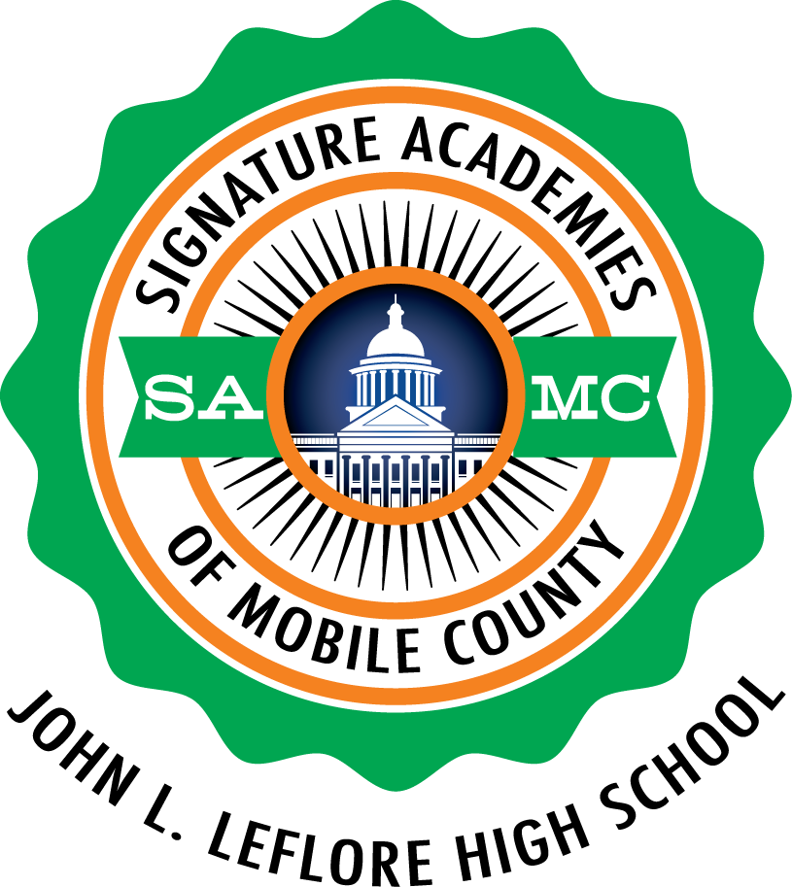
LEFLORE MAGNET HIGH SCHOOL
Leadership Academy
JROTC / LEADERSHIP PATHWAY

*Refer to the Educational Planning Guide.

