Unit 5: Forces and Motion
Student Notes

BIG IDEA: Forces cause objects to start moving, stop moving, change speed, or change direction. Understanding how the size and magnitude of forces impact objects can help us predict motion.

ENDURING UNDERSTANDING: A variety of forces are always at play for objects both in contact and not in contact with one another. These forces interact to create, change, or stop motion. Both the size and direction of forces can impact the motion of an object. Newton’s Laws of Motion help us to better understand and explain the motions we see in our daily lives.

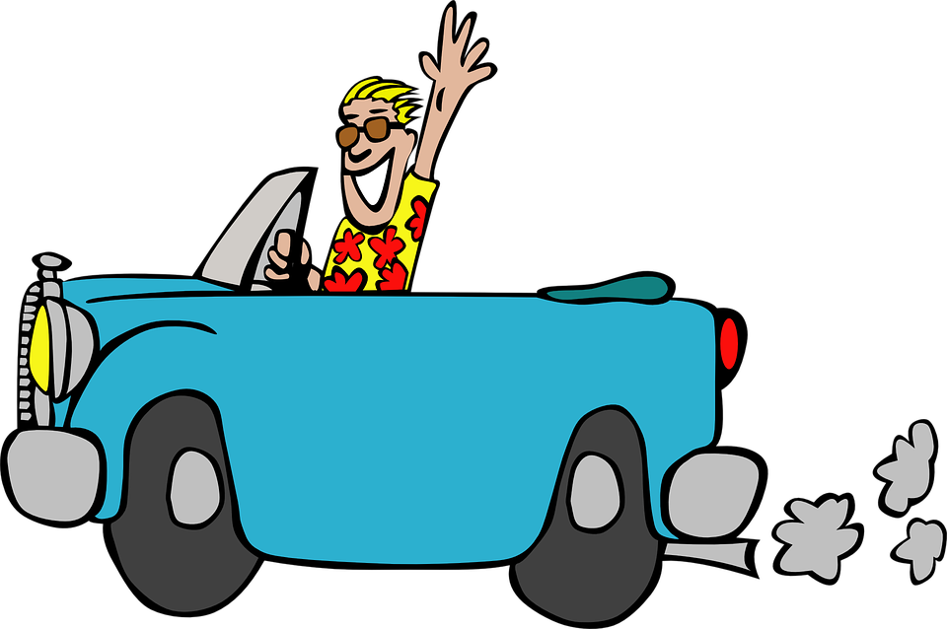
Position and Motion
- Imagine you are standing on a street corner watching cars go by. How do you know that the cars are moving?
  - Describing Changes in Position
    - Changes in position help us see that objects move. When an object’s distance or direction changes from the place where it started, we can say that motion has occurred. This original starting point is called a reference point and it helps us know HOW the object is moving .
    - Why are reference points important? When you ask Google for directions, Google asks for two pieces of information: Where you are headed and where you are currently. This information allows Google to build a set of directions to tell you how to move to get where you need to be. The directions from your home to the grocery store are probably very different from the directions from your school to the grocery store. This is because they begin with two different reference points.
  - Motion Relative to a Reference Point
Motion occurs due to a change in position. Remember that car in the beginning? It is moving because, from the sidewalk, you can see it changing position. But what about the people in the car? From the reference point of the car itself, the people in the car are not moving in reference to the car.

- Distance vs. Displacement
  - Distance and displacement are both ways to describe motion that has occurred when an object moves from Point A to Point B.
    - Distance is the total amount of length traveled. This can vary based on the path you take to get from Point A to Point B.
    - Displacement is the straight-line distance from Point A to Point B regardless of the path taken. It depends only on the initial position and the final position.
    - Example: At your school, you have a track around your football field. It takes four laps to make a mile. During PE, you walk 4 laps and end up exactly where you started. Your distance would be 1 mile, but your displacement would be zero because your initial position and your final position are the same.

NOTE INTERACTION:

- A runner starts at the Starting Line (A) and runs to the Finish Line (B) which is 25 meters away.
  - What is the runner’s distance?
  - What is the runner’s displacement?

A
B
25 meters
- A runner starts at the Starting Line (A) and runs to the Finish Line (B) which is 25 meters away. The runner then runs all the way back to the Starting Line (A).
  - What is the runner’s distance?
  - What is the runner’s displacement?

A
B
25 meters

Speed and Velocity
- Speed
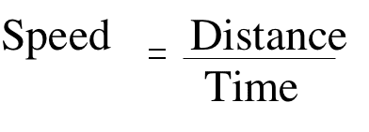
  - Speed is a measure of the amount of distance an object can travel in a certain amount of time. Think about driving on the highway. If a vehicle is traveling at 70 miles per hour, that means that in 60 minutes, the vehicles will be 70 miles further down the road.
  - You calculate speed by dividing the distance traveled by the time it takes to travel that distance.
  - The scientific units for speed are meters per second (m/s). Depending on the speed of the object, other units, such as kilometers per hour (km/h), may be used.
  - Constant Speed vs. Changing Speed
    - The speed limit on the highway is 70 mph, and you can drive this constant speed by paying close attention to your speedometer. Unless you use the cruise control in a car, you usually speed up and slow down on the highway as you navigate other vehicles.
    - If you are changing speed, you can calculate your instantaneous speed at a specific instant in time. The instantaneous speed is what a car’s speedometer tells you at any given moment.
  - Calculating Average Speed
    - It is easy to describe an object’s speed if it is constant, but what about an object that is speeding up and slowing down? How can you describe that object’s speed?
    - The average speed equation is similar to the speed equation above

Example:
Savannah rides her bike 250 meters in a time of 50 seconds. What is her average speed?

Speed = 250 meters/50 seconds = 5 m/s

Wes drives his car to see his grandmother. His grandmother lives 225 miles away and it usually takes him about 2.5 hours to get there. Will his mom be angry about the speed he’s going?

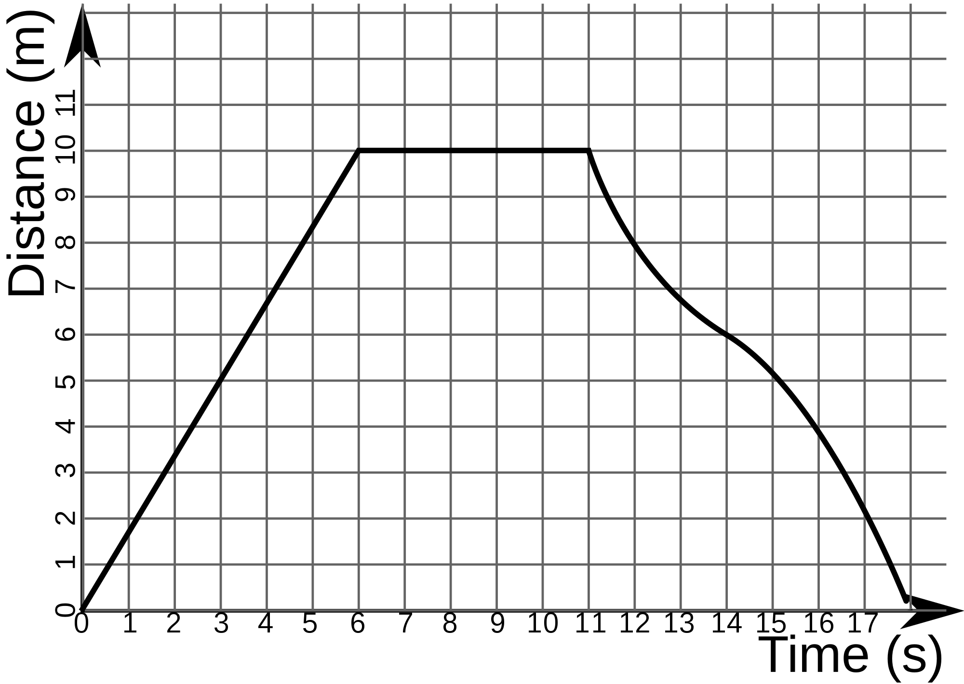
- Position vs. Time Graphs
  - Position vs. Time graphs, also known as distance vs. time graphs, allow you to visually see how the position of the object changes over time. It is important to remember that time always goes on the x-axis for these specific types of graphs! Each time the line changes on a position vs. time graph, this tells us that the motion of the object is changing.
  - Types of Position vs. Time Graphs
    - A straight line with a slope (positive or negative) tells us that the object is moving at a constant speed.
    - A straight line with a slope of zero tells us that the object is not moving.
    - A curve tells us that the object is changing speed.
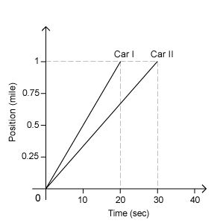
  - Comparing slopes
    - The slope of the graph can tell us quite a lot when comparing two graphs. The steeper the slope of the line, the faster the object is moving. You can see that the object is covering more ground in less time. In the example to the right, Car I is travelling at a faster speed. We can see that the line has a steeper slope than the slope of Car II. Car I reached 1 mile in 20 seconds while Car II reached it in 30 seconds.
  - Calculating speed
    - You can calculate the speed of the cars in the graph above by dividing the distance the cars traveled by the time it takes them to travel. Car I traveled 1 mile in 20 seconds so Car I is traveling 0.05 miles per second. Car II traveled 1 mile in 30 seconds so Car II is traveling 0.03 miles per second.
- Velocity
  - Describing the speed of an object often does not completely describe its motion. To accurately describe the motion, we would need to use speed AND direction, which is velocity.
  - Objects can move at the same speed but with different velocities. For example, imagine two cars that are back to back. If they start driving away from each other at the same rate, we can say they have the same speed, BUT their velocities would be different because they are each headed in opposite directions.
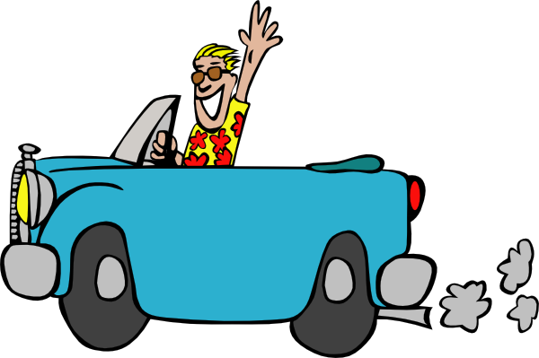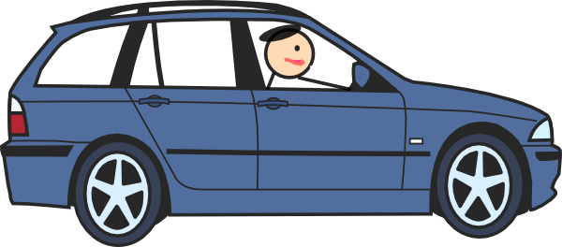
  - The velocity of an object changes when either the speed, direction, or both speed and direction for the object changes.

NOTE INTERACTION

- Brandon is flying to the Western United States. His plane manages to cover 700 miles in 2 hours.
  - At what speed was Brandon flying?

  - What was his velocity?

- Use the graph to answer the questions.
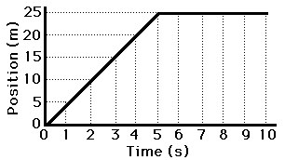
  - What is happening to the motion of the object from seconds 1-5?

  - What is happening to the motion of the object from seconds 6-10?

Acceleration
- When velocity changes (either the speed, direction, or both) we refer to this change as acceleration. Acceleration is a measure of the change in velocity over a certain period of time.
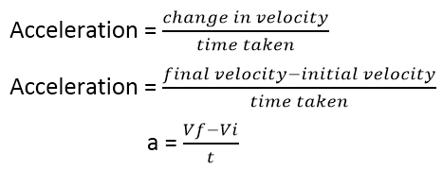
  - You experience negative acceleration when someone slams on the brakes in the car you are traveling in. You experience positive acceleration when someone speeds up to run through a yellow light.
  - When you change velocity, you now have two different velocities that can help to calculate the acceleration. The initial velocity (v_{i}) is the velocity the object was traveling at prior to the acceleration. The final velocity (v_{f}) is the velocity the object travels at after the acceleration. If you know the time it took to change from initial to final, you can calculate the acceleration.
  - Calculating Acceleration Examples
    - Using the formula to the right, we know we need three pieces of information to solve these types of problems: initial velocity, final velocity, and acceleration.
    - The units for acceleration are meters per second per second or m/s². This occurs because you are dividing m/s by s, which means in the denominator you will have s*s.
Example 1: A man decides to go for a walk. After 2.0 seconds, the many is moving at a speed of 1.5 m/s. After 5 seconds, his speed has increased to 3.5 m/s. What was his acceleration during the time from 2.0 seconds to 5.0 seconds?

v_{i}= The initial velocity at 2.0 seconds was 1.5 m/s
v_{f}= The final velocity at 5.0 seconds was 3.5 m/s
t= In this case the time elapsed was 3.0 s because it went from 2.0 seconds to 5.0 seconds

(v_{f}-v_{i})/t = (3.5 m/s - 1.5 m/s)/3.0 s = 0.67 m/s²

- Speed vs. Time Graphs
  - Just like you can use a position vs. time graph to show the speed of an object, you can use a speed vs. time graph to show the acceleration of an object. Once again, time will always be on the x-axis for these graphs!
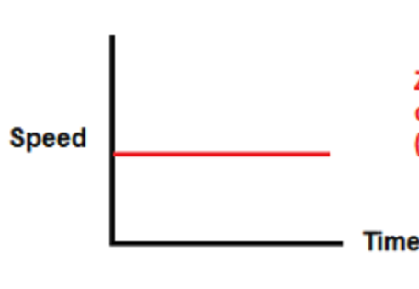
  - Trendlines on these types of graphs can also provide information about the movement of an object.
    - A horizontal line on a distance vs. time graph means that the speed is zero. However, a horizontal line on a speed vs. time graph shows us that the speed stays the same as time progresses. This mean that the object is traveling at a constant speed.
    - A straight line with a slope tells us that the object is either speeding up at a steady rate or slowing down at a steady rate. If the slope is positive, the object is speeding up. If the slope is negative, the object is slowing down.
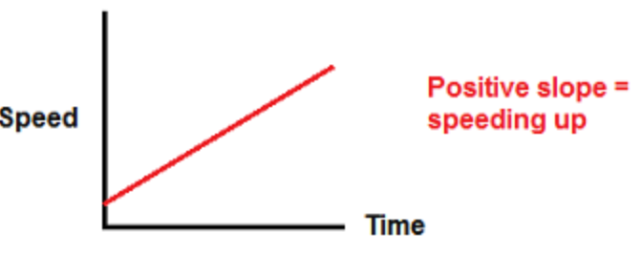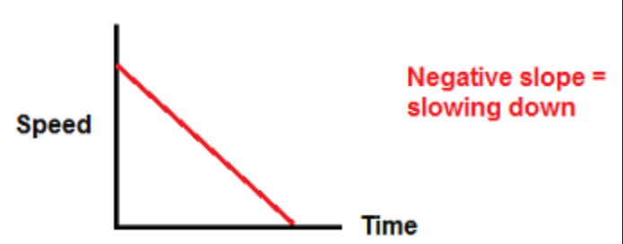

NOTE INTERACTION

A speeding car passes a cop going 55 miles per hour. Ten seconds later, the car has slowed down to 35 miles per hour. What is the acceleration of the car?

Think about a plane taking off from a stopped position on a runway. If we were to graph the speed of the plane vs. time, what shape would the graph have? Draw it below.

Forces
- What is a force?
  - A force is a push or a pull that an object experiences from another object or even a person.
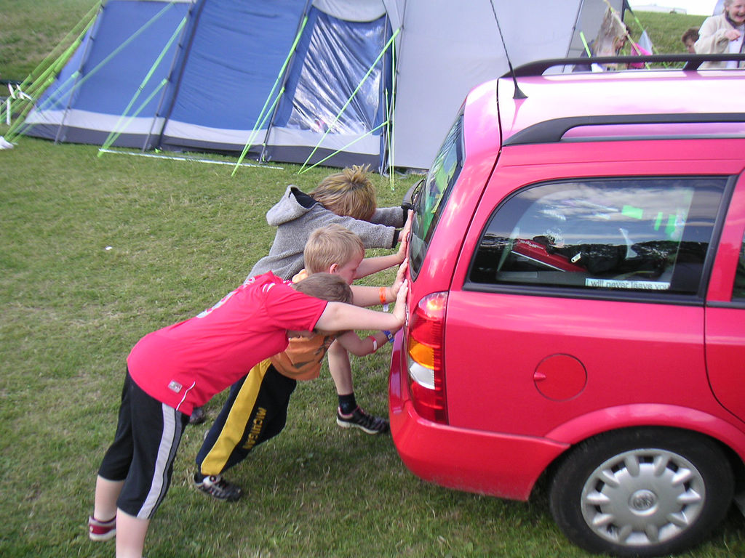
  - Some forces are contact forces, meaning the objects have to be physically touching in order for the force to be exerted.
    - If your car breaks down in the middle of the road, you must get out, put your hands on the car, and exert force to move the car. The car will not magically move without this contact force.
    - Examples of contact forces include applied force (like pushing the car), air resistance (an object’s contact with air particles as it moves through air), friction (a force that resists motion).
  - Some forces are non-contact forces, meaning the objects do not have to touch in order for the force to be exerted.
    - Think about rubbing an inflated balloon on your hair and then pulling the balloon away. Even though the balloon is no longer touching your hair, force is being exerted.
    - Examples of non-contact forces include gravity (an attraction between two objects) and magnetism.
- Strength and Direction of Forces
  - The strength and direction of forces determines the motion of the object on which the force is acting. All forces, both contact and non-contact, have both strength and direction.
  - Force is measured in Newtons (N). 1 Newton is equal to 1 kg(m²)/s². You apply about one Newton of force when you pick up an apple.
  - When drawing forces, the size and direction of a force are represented by arrows. The length of the arrow often represents the size of the force. For example, an arrow for 300 Newtons would be longer than an arrow for 100 Newtons.

50N
100N
- Balanced vs. Unbalanced Forces
  - Balanced forces cause NO CHANGE in direction or motion of an object. If an object is stopped, it will stay stopped. If it is moving, it will stay moving in the same direction with the same speed.
  - Unbalanced forces CHANGE motion. They can slow down, speed up, stop, start, or change the direction of an object.
  - The only way to know if forces are balanced or unbalanced is to calculate the net force on an object. When you calculate the net force on an object, an answer of 0N means that the forces are balanced, or they cancel each other out. Any answer other than 0N means that the forces are unbalanced, and the motion of the object will change.
- Calculating the amount of Net Force on an object
  - Net force is the total amount of force acting on an object. Often an object will have more than one force acting on it at a time. If you are pushing a box that your friend is also pulling, you are both applying force to the box.
    - To calculate the net force on the object, you must add forces that are in the same direction (because they are working together) and subtract forces that are in opposite directions (because they work against one another). The direction of the force always goes in the direction of the largest force.

25N
25N
    - These forces are in the same direction. Because they are working together, we need to add to find the net force. The net force on this object is 50 N to the right. The forces on this object would be considered unbalanced because the net force is a number other than zero. The motion of this object would change.
    - The forces on this object are working against one another and therefore need to be subtracted. The net force on this object is 0 Newtons. The force on this object would be considered balanced because the net force is 0. The motion of this object would not change.

25N
25N
    - In this scenario, the forces on the object are also working against one another, but one of the forces is larger than the other. The forces still need to be subtracted and the direction of the force will be in the direction of the larger force. The net force on this object is 25 N to the left. This is unbalanced.

25N
50N
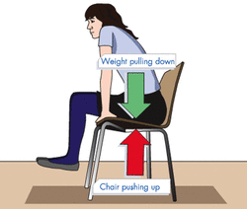
- Free Body Diagrams
  - Free body diagrams show all of the forces that act on an object at any instant in time.
  - As you sit in your chair and read these notes, forces are acting on you. One force that is acting on your body is the force of gravity pulling you toward the center of the Earth. The reason you don’t fall through the floor is due to normal force which is pushing back on you from the chair.

NOTE INTERACTION:

Calculate the net force on the following object. (Remember that your answer needs to include both the size of the force and the direction of the force!)

10 N
15 N
Is the above object balanced or unbalanced? How do you know?

10 N
25 N

Is the above object balanced or unbalanced? How do you know?

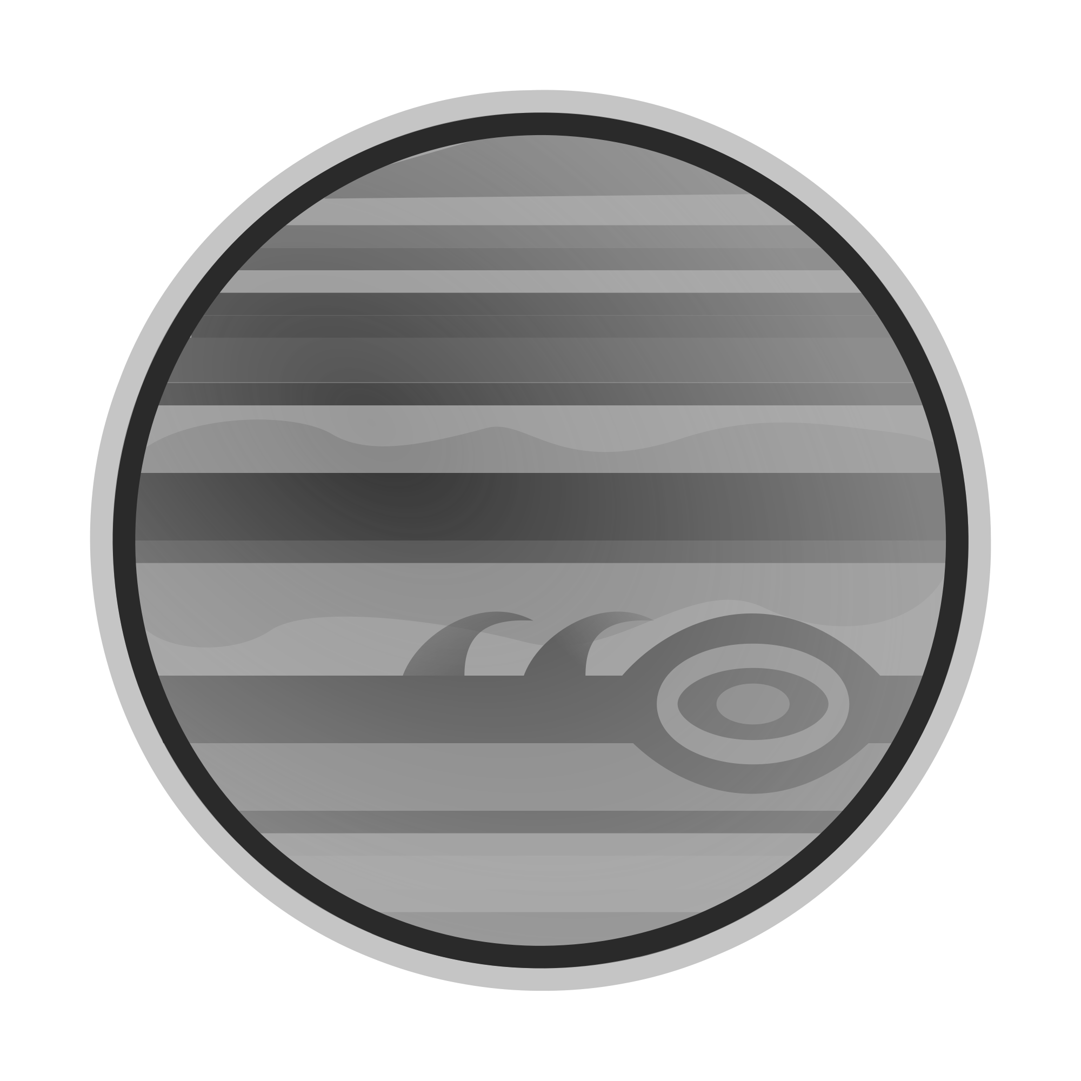
Gravity
More Mass = More Pull
- Gravity is the non-contact force of attraction between any two or more objects. This attraction is directly related to TWO variables: MASS and DISTANCE
  - The more mass an object has, the MORE gravitational pull it will have.
  - The more distance between the two objects, the LESS gravitational pull.
365 Million Miles
More Distance = Less Pull
  - Sir Isaac Newton used these ideas to create the Law of Universal Gravitation.
- Because gravity is a non-contact force, the objects do not have to touch in order to experience the force.
- We often assume that gravity is pulling us “down” when in fact, we are actually being pulled toward the center of the Earth. Just as the Earth is pulling on you with its gravity, you also have gravity that is pulling on the Earth! Because you are so much less massive than Earth, your pull is also much smaller.
- Weight is a measure of the Earth’s gravitational pull on your mass. Remember that your mass is a measure of the amount of matter that you are made of--think of it as the number of atoms that are in you.
  - Why do we weigh less on the moon?
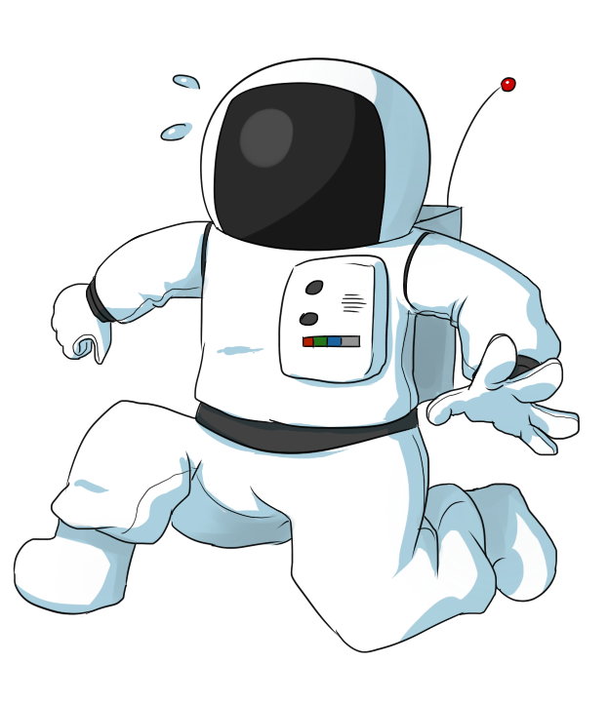
    - You may have heard that you weigh only ⅙ of your Earth weight on the moon. Why do you think that is? While your mass is not affected by where you travel (you would be made of the same number of atoms here as you would on Pluto), your weight changes based on the gravity of your location. The reason you would only weigh ⅙ of your Earth weight on the moon is because the moon only has ⅙ the gravity of Earth due to its smaller mass!
  - Your weight can actually change based on where you are on the Earth as the gravity is not consistent everywhere. What you weigh here may be different than what you would weigh in Australia!
- Acceleration due to gravity
  - The gravity of Earth constantly and consistently pulls things toward it. This is why when you jump, you are pulled back to Earth. Gravity is also what makes bungee jumping and skydiving possible.
  - When you skydive, as you fall, you continue to speed up. This is called the acceleration due to gravity. On Earth, all things fall at the same rate--9.8 m/s². This means that for each second an object falls, it speeds up by 9.8 m/s. So after 5 seconds, objects will be moving at a speed of 49 m/s. This is equivalent to almost 110 miles per hour--after only 5 seconds of falling! !
  - Free Fall
    - At the beginning of a skydive, once you jump out of the plane, you are only under the force of gravity as it pulls you back to Earth. This is known as free fall.
    - What gets in your way as you fall? Although you may not realize it, falling through all of those air particles has an effect on you. The air particles are creating air resistance as you fall through them.
  - Terminal Velocity
    - During a skydive, your body will reach a certain velocity where the air is pushing up on your body as much as gravity is pulling you down. This is referred to as terminal velocity. It is the fastest you will travel.
NOTE INTERACTION:

1. Consider the Sun and Mars. Which of these would have a more powerful gravitational pull and why?

2. If you are falling at 9.8 m/s², how fast will you be going after 3 seconds?

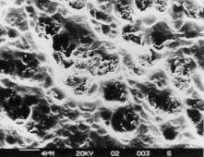
Friction
- Friction is a resistance to motion. It is a force that is the result of two surfaces rubbing against one another. At the microscopic level, all surfaces are “bumpy”. Even surfaces as smooth as glass, as pictured to the right, will have hills and valleys that can rub against other surfaces.
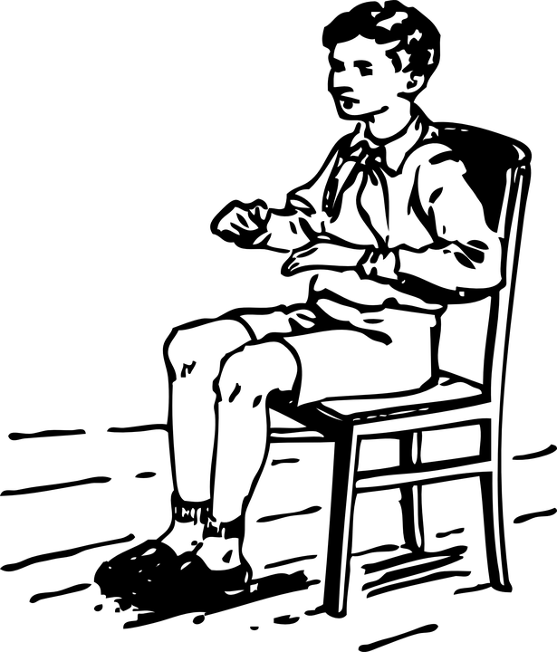
- Static vs. Sliding
  - Static friction prevents the surfaces of objects from sliding past each other. Static friction is what keeps you in your chair as you read this. It is also what allows all of the stuff in your bedroom to be in the exact same place as you left it yesterday.
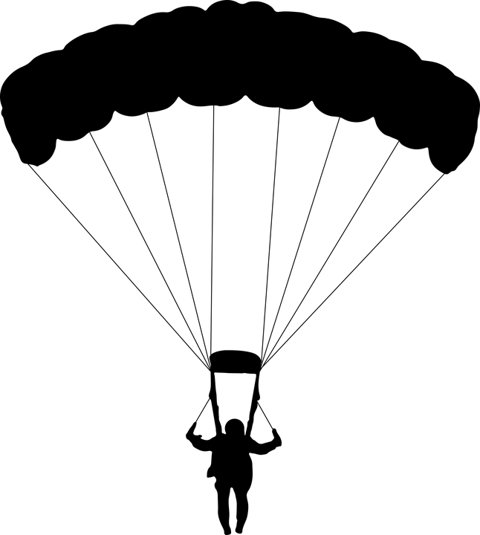
  - If you apply enough force to slide the surface of one object past another object, you create sliding friction. Sliding friction still opposes the motion that is occurring. If you stop pushing the object, sliding friction is what will slow it to a stop.
- Fluid Friction
  - Fluid friction occurs between a surface and a fluid. Remember that a fluid is not always a liquid. Air is considered a fluid and air resistance is the result of objects moving through the air. If it weren’t for air resistance, skydiving would not be possible!
- Factors that Influence Friction
  - Some factors can influence the amount of friction that is experienced when two objects rub together.
    - Surface type (bumpy vs. smooth surface)
    - Mass (the amount of matter each object contains)
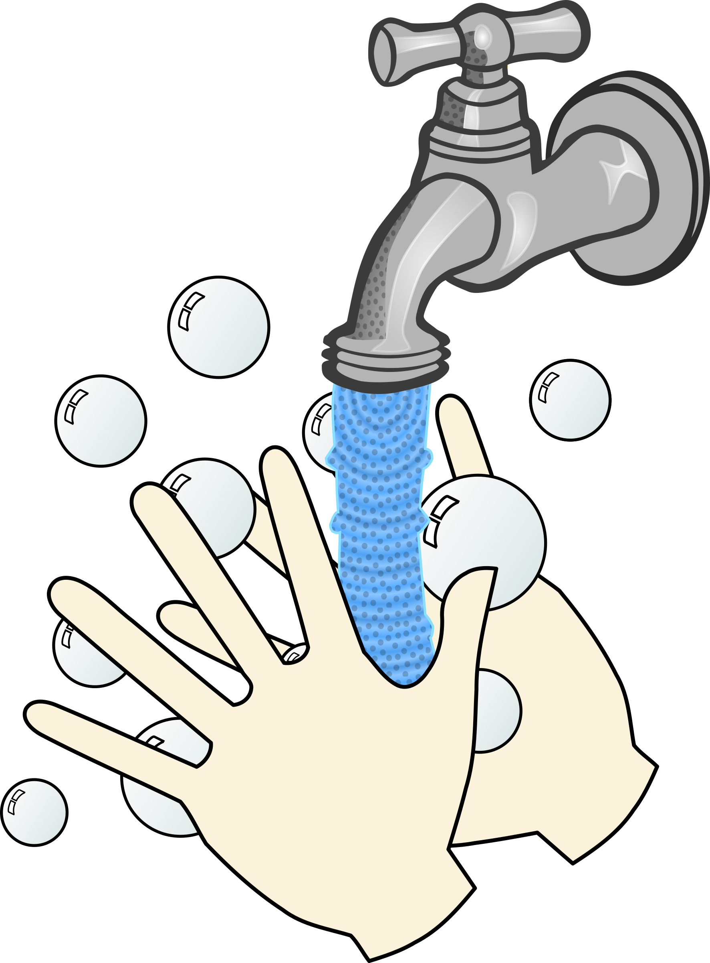
- Reducing friction
  - Lubricants are one way to decrease the amount of friction two surfaces experience. A lubricant helps by creating less contact between the hills and bumps of each surface allowing them to slide past one another. Motor oil is a lubricant for your car that reduces friction in your engine’s moving parts. When you put soap on your hands, you probably notice that they become more slippery due to the soap lubricating your hands.
NOTE INTERACTION

Would you rather push a heavy piece of furniture across a carpeted floor or a hardwood floor? Explain why using the word “friction” in your explanation.
Electric Force and Magnetic Force
- Electric Charges and Electric Forces
  - Recall that all matter is made of atoms and atoms are made of even smaller charged particles. Both protons (positive) and electrons (negative) have an electric charge.
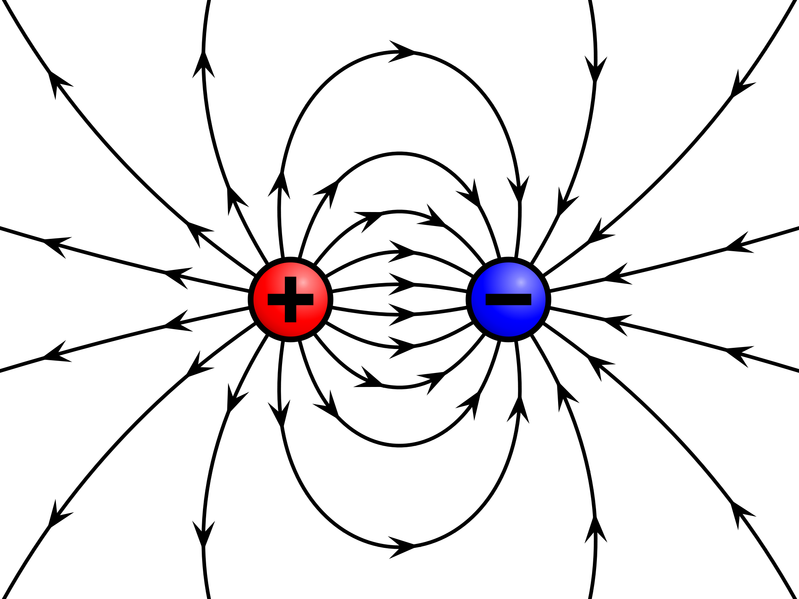
  - Larger objects can also be charged depending on the number of electrons the object holds. Electrons can move from one object to another, throwing off the balance of charges. When you have an unbalanced positive or negative charge on an object, this is referred to as static charge.
  - The region surrounding the charged object is called an electric field. This field applies a force to other charged objects even if the objects do not touch! (This is a noncontact force!) It can also interact (attract or repel) with fields from other objects!
  - The amount of electric force in the electric field depends on two variables:
    - The amount of charge: If the amount of charge on two objects increases, the strength of the electric field also increases.
    - The distance: If the distance between two charged objects increases, the strength of the electric field will decrease.
  - Have you ever touched someone and gotten shocked? This is called an electric discharge and it is the process by which an unbalanced charge becomes balanced. The discharge can happen quickly (such as a shock or lightning) or slowly (like when your clothes are full of static but it eventually goes away). The amount of electric force greatly decreases after a discharge.
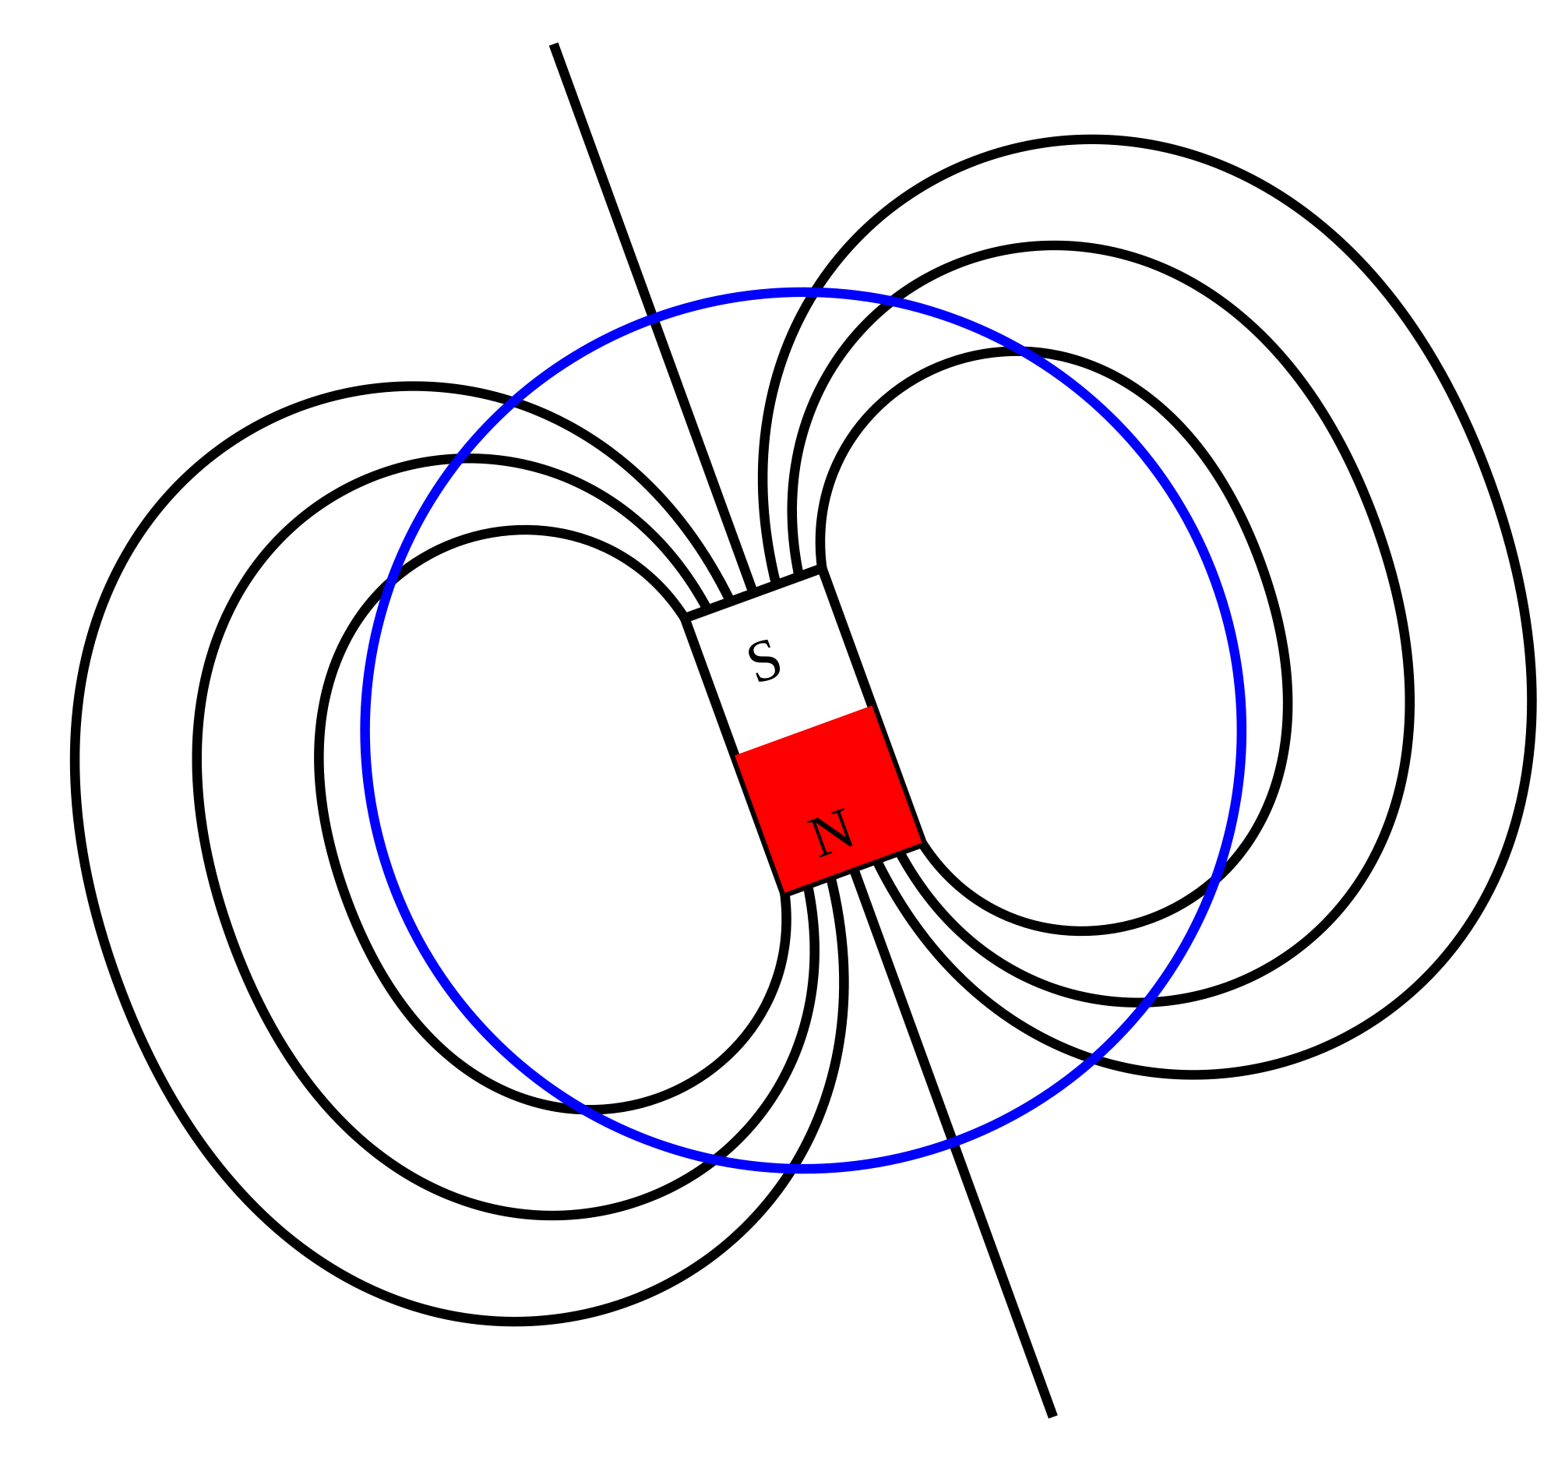
- Magnets and Magnetic Fields
  - A magnet is any object that attracts iron. While you may not realize it, magnets are used in many everyday objects. Aside from holding papers on your refrigerator, they are also used to generate electrical energy using the magnetic field created by the magnet.
  - Magnets have magnetic poles, or places on the magnet where the magnetic force is the strongest. Each magnet will have a north pole and a south pole.
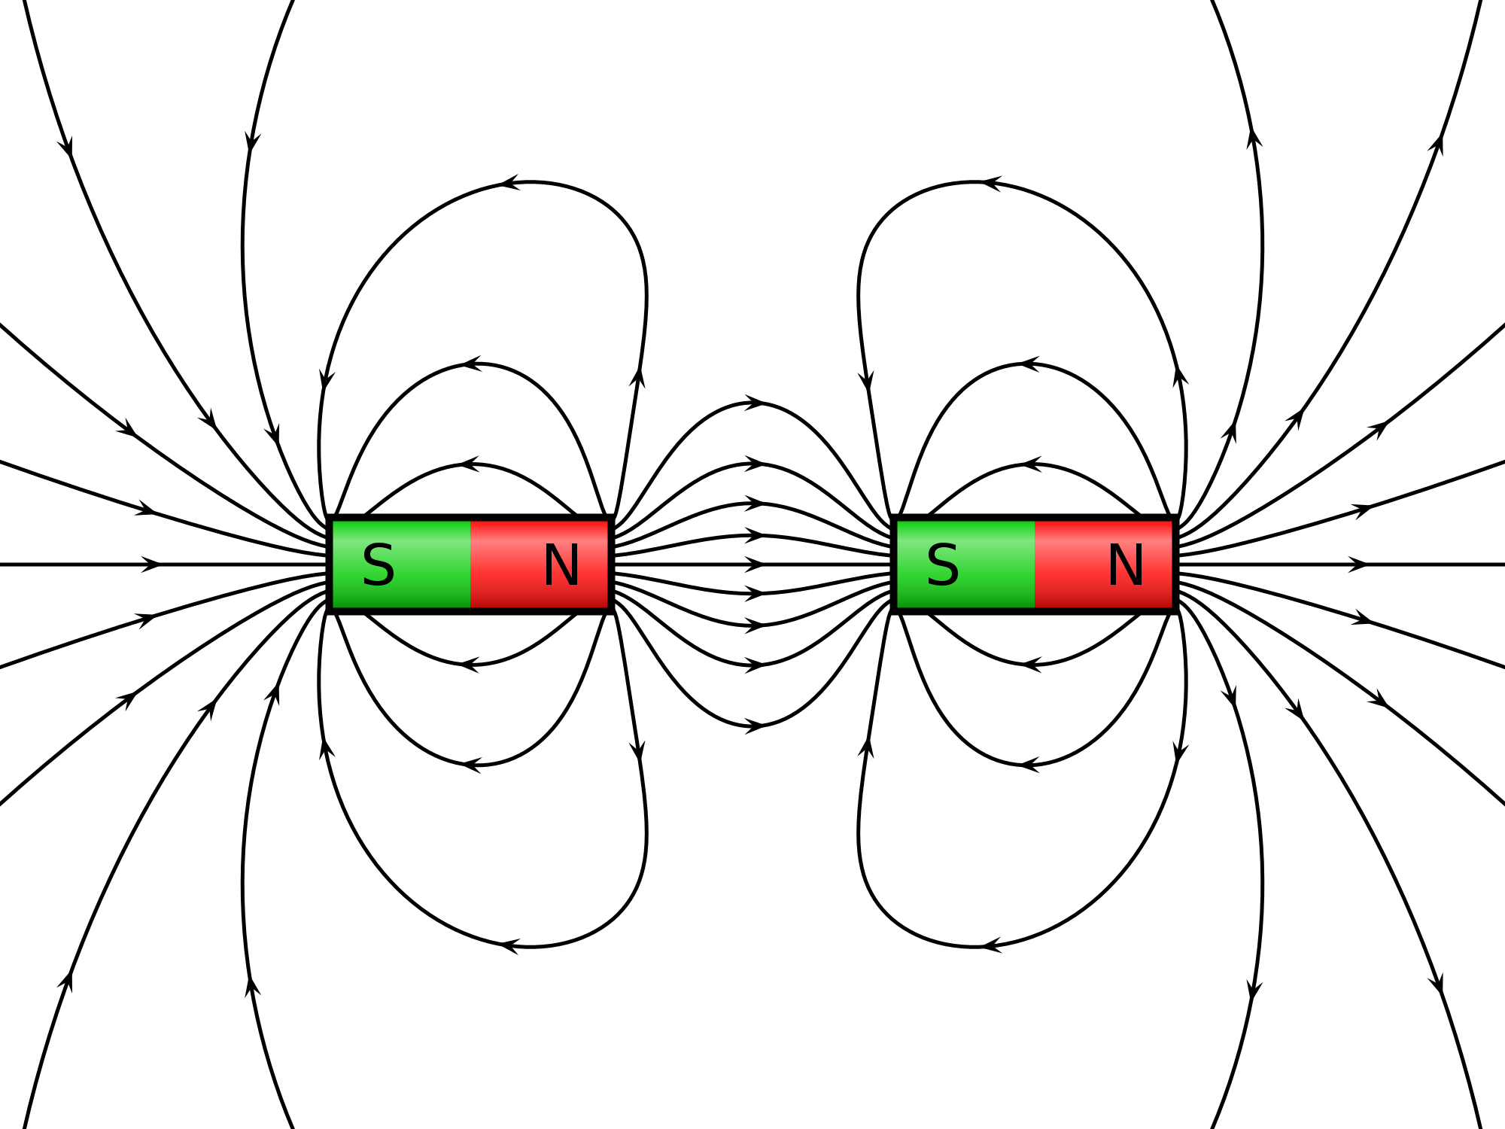
  - Depending on how you position to magnets, they will attract one another or repel one another. This is where the term “opposites attract” comes from. A north pole will attract a south pole but repel another north pole. This force of attraction or repulsion is called magnetic force.
  - The closer the magnets are to one another, the stronger the magnetic force. The further apart the magnets, the weaker the magnetic force.
  - Just like electric force, magnetism is a noncontact force that does not require the magnets to touch to exert force on one another. A magnetic field is produced around the magnets even if they do not touch.
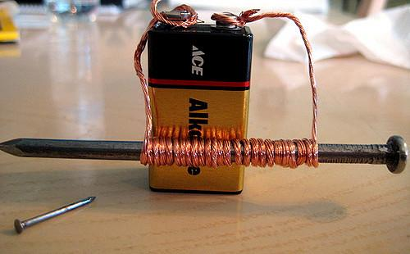
- Electromagnetism
  - Wires are one way that electrons can be carried from one object to another. Anytime electrons are carried in a wire, this creates and electric current. In addition, the electric current creates a magnetic field around the wire. The magnetic field around the wire increases as the amount of current in the wire increases.
  - An electromagnet can be created by wrapping a current carrying wire around a ferromagnetic core. The magnetic field of the wire coil causes the core to become a magnet itself. As the number of loops of wire increases, the strength of the magnetic field also increases.
  - Devices that use electricity and have moving parts, such as a hair dryer or the fan inside a computer, use electromagnets.
NOTE INTERACTION

The Earth has its own magnetic field. How do you use the Earth’s magnetic field in your life?

Name three possible places you might find electromagnets in your home.

Newton’s Laws
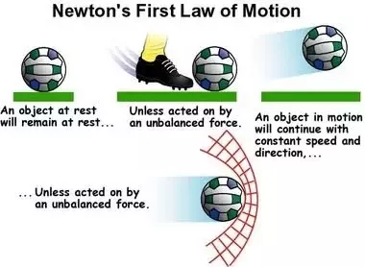
- Newton’s First Law of Motion
  - Newton’s First Law of Motion states that an object at rest will stay at rest and an object in motion will stay in motion in a straight line at the same velocity unless acted upon by an outside force.
  - From what we have already learned about forces, this means that all of the forces on the object must be balanced for it to continue doing what it is doing. Only an unbalanced force can change the object.
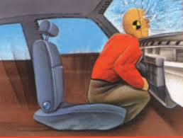
  - The name for this property of matter is inertia which is the tendency of an object to resist change in its motion. Inertia is the reason your body flies forward in a car when someone slams on the brakes. It is also the reason all of the plates stay on the table when someone whips the tablecloth out from under all of the dishes.
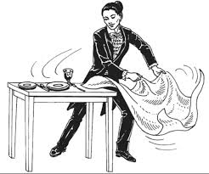
  - If inertia exists, why do objects stop moving?
    - Why does a ball rolled down the hall not continue on forever? Remember that Newton’s First Law can only be true for balanced forces. In most cases, unbalanced forces, like friction, cause objects to slow down as some of the motion is converted to heat energy from the rubbing of the surfaces.
- Newton’s Second Law of Motion
  - Newton’s Second Law of Motion describes the relationship between an object’s mass and acceleration based on the amount of force applied to it. The equation associated with Newton’s Second Law of Motion is
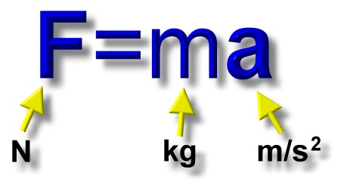
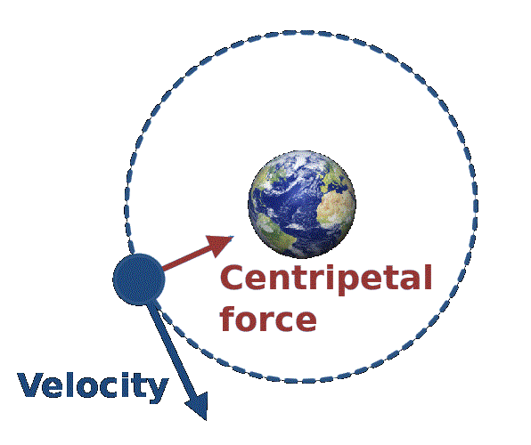
  - In this equation, force is measured in Newtons, mass in kilograms, and acceleration in m/s².
  - Circular Motion and Centripetal Force
    - Centripetal force is the force experienced by an object that is traveling in a curved path (a circle). In accord with Newton’s 2nd law, an object which experiences an acceleration directed toward the center of the circle, it must also be experiencing a net force in the same direction. The inward force acting upon the object in order to cause its inward acceleration is referred to as centripetal force. Without centripetal force, the object would fly off in a straight line. https://www.youtube.com/watch?v=KvCezk9DJfk
    - Centripetal means “center seeking”. According to Newton’s 2nd Law (F=ma), the higher the mass or the velocity of the object, the greater the centripetal force must be.
    - Think about the moon orbiting the Earth. The Earth’s gravity pulls on the moon as the moon traveling in a circle around the Earth. Because the pull of gravity is perpendicular to the path of the moon, it is a centripetal force.
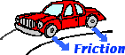 |  | 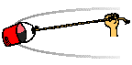
As a car makes a turn, the force of friction acting upon the turned wheels of the car provides centripetal force required for circular motion. |  | As a bucket of water is tied to a string and spun in a circle, the tension force acting upon the bucket provides the centripetal force required for circular motion. | As the moon orbits the Earth, the force of gravity acting upon the moon provides the centripetal force required for circular motion.

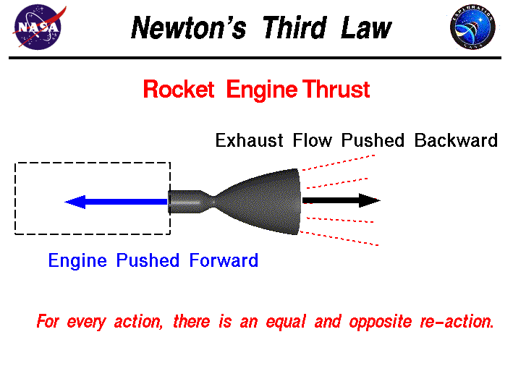
- Newton’s Third Law of Motion
  - Newton’s Third Law of Motion relates forces between two objects. When one object exerts a force on a second object, the second object exerts an equal amount of force in the opposite direction on the first object.
  - For example, as you sit in your chair reading this, your weight is exerting a force down on the chair. The chair is, in return, exerting a force back on you. If it didn’t, you would fall through the chair on to the floor.
  - Consider another example: Jumping. When you jump, you push down on the ground and the ground pushes up on you.
  - Newton’s Third Law often refers to force pairs because the forces from two object apply to each other.
    - If the forces are always equal but in opposite directions, why don’t they cancel each other out? The reason is that each force is acting on a different object.
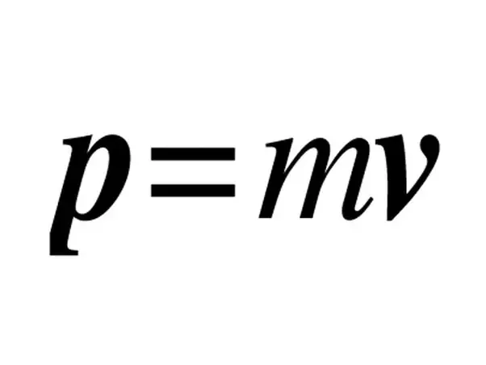
    - In these force pairs, you have the action force and the reaction force, which is why many often say “For every action, there is an equal and opposite reaction.”
  - Momentum
    - Momentum is a measure of how hard it is to stop a moving object. It is the product of an object’s mass and its velocity. (Momentum is signified in the formula to the right by the letter “p”.)
    - Why is momentum important? Think about a large semi-truck and a small car traveling at the same speed on the highway. If they both crest over a hill and see that traffic is stopped, which one will take more time to come to a stop? The truck! Because it has more mass than the car, it also has more momentum! Now let’s consider the stopped traffic. Right now it has very little momentum because the velocity of each vehicle is zero. What happens if the truck cannot stop in time? Momentum is transferred from the truck to the vehicles it collides with.
NOTE INTERACTION

Consider two shopping carts, one empty and one full. You want to accelerate both shopping carts to 3 m/s. Which cart will require more force? WHY?
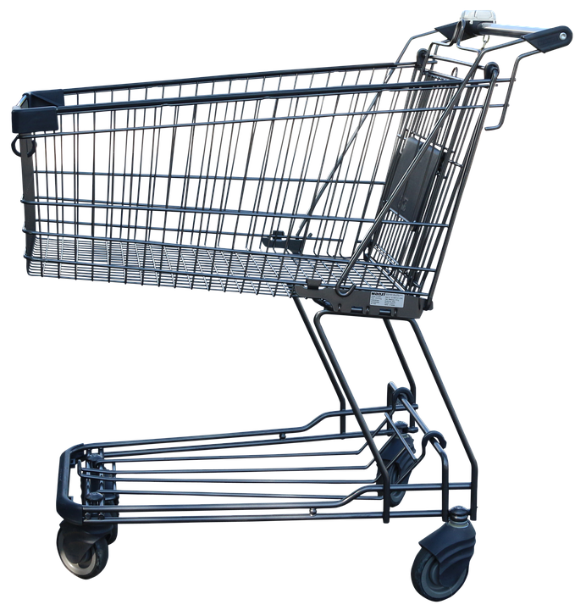
Which law of motion does this relate to? How do you know?

    - When two objects collide, their momentum is conserved. The momentum in a system remains the same after the collision.
      - An elastic collision is one in which total kinetic energy and the total momentum before and after the collision are the same.
        - One object bounces off the other.
        - A moving object hits a stationary object and causes it to start moving.
      - An inelastic collision is one in which some of the kinetic energy gets converted into other forms of energy such as sound or heat.
        - Ex. Football players who stay together after colliding.
        - Coupling railroad cars.
https://www.youtube.com/watch?v=Xe2r6wey26E

