WEEK 5 (April 20-24) – read the passage and do the following TWO things:
- Determine your Words Per Minute (WPM). Set a timer for one minute as you read. When the timer ends, stop reading and count how many words you read in one minute. Use this chart to help you find out how many WPM your grade level can read:
Grade 5 = 130 Grade 6 = 140
Grade 7 = 150 Grade 8 = 160
Grade 9 = 170 Grade 10 = 180
Grade 11 = 190 Grade 12 = 200

- Answer the seven questions that follow the passage.
- Email completed assignments to robert.brown@dcsms.org
- Your email should include the following:
- The week’s number for that assignment (Week 3, Week 4, etc…) can go in the “Subject line”.
- The student’s name and a list of the letter choices you pick as answers to the multiple-choice questions that follow the passage can go in the body.
EXAMPLE e-mail:
To: robert.brown@dcsms.org
Subject: Week 4
Johnny Brown – ACDBCAC
__________________________________________________________
SCROLL DOWN TO SEE THE PASSAGE and 7 QUESTIONS

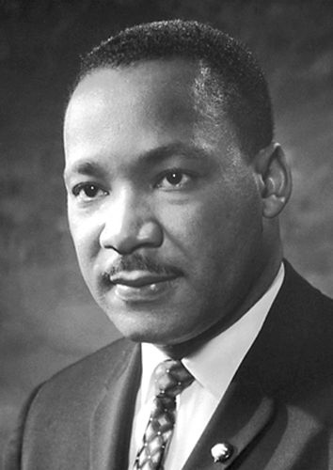

Excerpt from Martin Luther King Jr.'s Letter from the Birmingham City Jail

You may well ask, Why direct action? Why sit-ins, marches, etc.? Isn't negotiation a better path?" You are exactly right in your call for negotiation. Indeed, this is the purpose of direct action. Nonviolent direct action seeks to create such a crisis and establish such creative tension that a community that has constantly refused to negotiate is forced to confront the issue. It seeks so to dramatize the issue that it can no longer be ignored. I just referred to the creation of tension as a part of the work of the nonviolent resister. This may sound rather shocking. But I must confess that I am not afraid of the word tension. I have earnestly worked and preached against violent tension, but there is a type of constructive nonviolent tension that is necessary for growth. Just as Socrates felt that it was necessary to create a tension in the mind so that individuals could rise from the bondage of myths and half-truths to the unfettered realm of creative analysis and objective appraisal, we must see the need of having nonviolent gadflies to create the kind of tension in society that will help men rise from the dark depths of prejudice and racism to the majestic heights of understanding and brotherhood. So the purpose of the direct action is to create a situation so crisis-packed that it will inevitably open the door to negotiation. We, therefore, concur with you in your call for negotiation. Too long has our beloved Southland been bogged down in the tragic attempt to live in monologue rather than dialogue…
We must use time creatively, and forever realize that the time is always ripe to do right. Now is the time to make real the promise of democracy, and transform our pending national elegy into a creative psalm of brotherhood. Now is the time to lift our national policy from the quicksand of racial injustice to the solid rock of human dignity.

1. As explained by Martin Luther King Jr., what is the purpose of nonviolent direct action?
- It creates an environment of tension in which no one is willing to negotiate.
- It delays negotiation until people are ready to confront an issue.
- It prevents negotiations from taking place.
- It dramatizes an issue so that it can no longer be ignored.

2. Communities in the South refused to address the problems of inequality and racism. What solution did Martin Luther King Jr. propose?
- take violent direct action so that people are forced to pay attention
- take nonviolent direct action so that the problem cannot be ignored
- wait for community leaders to agree to peaceful negotiations
- work and preach against violent tension within communities

3. Thinkers and leaders other than Martin Luther King Jr. have created tension to bring about change.

What evidence from the passage supports this statement?
- “Just as Socrates felt that it was necessary to create a tension in the mind so that individuals could rise from the bondage of myths...”
- “You may well ask, Why direct action? Why sit-ins, marches, etc.? Isn't negotiation a better path? You are exactly right in your call for negotiation.”
- “I just referred to the creation of tension as a part of the work of the nonviolent resister. This may sound rather shocking. But I must confess that I am not afraid of the word tension.”
- “Too long has our beloved Southland been bogged down in the tragic attempt to live in monologue rather than dialogue...”

4. Which audience did Martin Luther King Jr. most likely target when writing this letter?
- people who supported his work
- people who lived in the North
- people who fought for civil rights
- people who questioned his methods

5. What is the main idea of this excerpt from King’s letter?
- Without violent tension and fighting, change would be too slow.
- Nonviolent direct action is needed to bring about change.
- Negotiation is a better method than direct action to cause change.
- Socrates also used nonviolent tension to bring about change.

6. Read the following sentences: “Nonviolent direct action seeks to create such a crisis and establish such creative tension that a community that has constantly refused to negotiate is forced to confront the issue. It seeks so to dramatize the issue that it can no longer be ignored.”

As used in this sentence, what does the word “dramatize” mean?
- make a situation seem funny and less important
- write a play or a musical about a situation
- make a situation seem more important or serious
- pay no attention to a situation, problem, or issue

7. Choose the answer that best completes the sentence below.

Martin Luther King Jr. preached against violent tension, _____ believed strongly in nonviolent tension.
- so
- then
- like
- but

