Mrs. Cook’s Messages
April 26-30, 2021
Grammar (capital letters) and
Reading Skills (compare and contrast) Tests: Thursday
Vocabulary and Spelling (inflected endings -ed, -ing) Tests: Friday
Story:  “Just Like Josh Gibson”  by Angela Johnson  Phonics/Fluency:  inflected endings  -ed, -ing  Text-Based Comprehension:  compare and contrast;  monitor and clarify  Grammar:  using capital letters |  |  |  | Selection Vocabulary Words (Students will be tested on these):  - bases- places that are stations or goals in certain games, such as baseball  - cheers- yells of encouragement  - field- a piece of land used for some special purpose  - plate- a hard rubber slab that a baseball player stands beside to bat  - sailed- moved smoothly like a ship with sails  - threw- sent something through the air by force of your arm  Amazing Words  athlete, effort, disguise, professional,  challenge, dainty, champion, shortstop
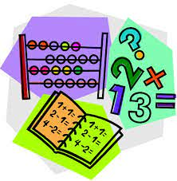  Topic 15: Measuring Length  Lesson 3: Centimeters  Lesson 5: Centimeters and  Meters  Lesson 6: Measuring Length  Quiz on centimeters and meters  will be Friday! |  |  |  |  |  | Social Studies/Science  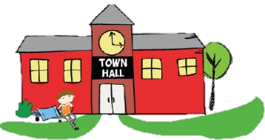  We are focusing on rights and responsibilities this week. Students will learn about elected officials in their community. We will discuss that rights and responsibilities reinforce each  other and promote the  common good.
Spelling Words:
- tried  - trying  - planned |  |  | - planning  - liked  - liking |  |  |  | - skipped  - skipping  - heavier | - heaviest  - lighter  - lightest

