CASTLEN ELEMENTARY SCHOOL
Fourth Grade School Supply List
2020-2021
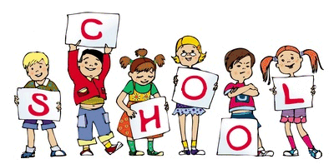
Central Office is requesting that parents provide a face mask for their child to have with them at school each day. Cloth is preferred due to durability.
(6) 3-prong plastic folders
(4) composition notebook
(3) packs of wide ruled notebook paper
(4) packs of 12 pencils -no mechanical pencils
(1) boxes of 24 count crayons
(4) highlighters
(4) dry erase markers-preferably Expo brand
(2) red pens
(2) glue sticks
Sharpie Markers
Scissors
Crayon Box-small enough to fit in bookbag

WISH LIST
Lysol Wipes
Kleenex
Hand Sanitizer
Paper Towels

