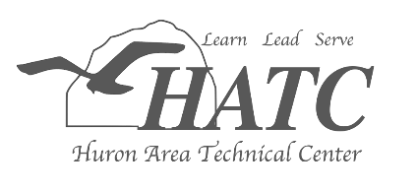
Did you know?
Hospitality/Food Service

Program Description:
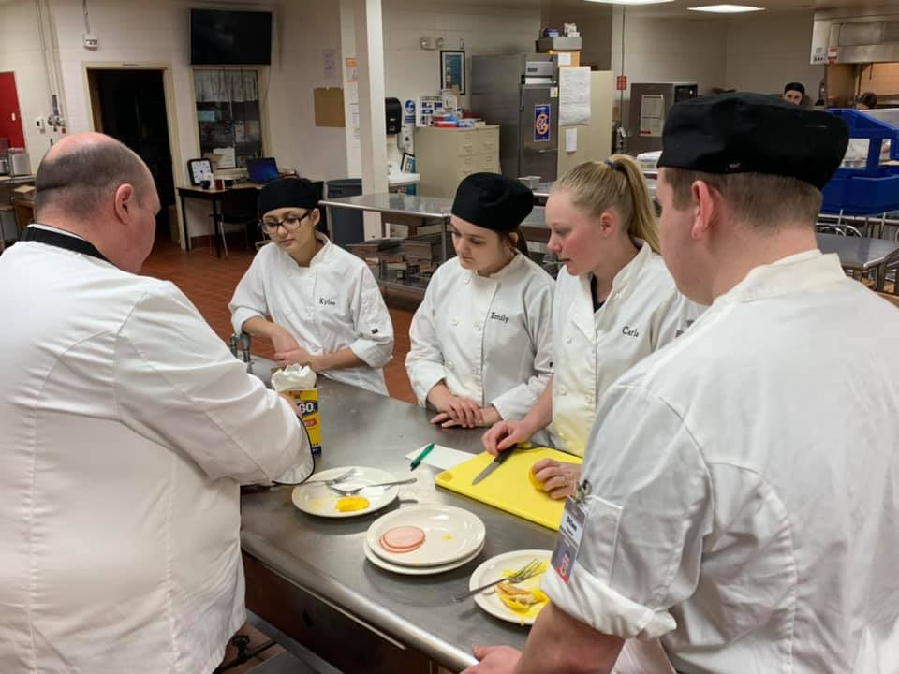
The Hospitality/Food Service (HFS) curriculum concentrates on skills from entry level baking and pastry, culinary arts to entry level management. The skills students will learn in class include: table service, cash handling, customer relations, baking, quantity food preparation, short order cookery, sanitation, culinary arts, Garde manger and management. The program offers job specific training in each area and the opportunity to earn college credit by becoming ServSafe certified. Students operate “The Snack Shop”, an in-house banquet facility, as well as a restaurant, The Main Street Café. Upon graduation, students are ready to continue their training at the college level or for entry-level employment.
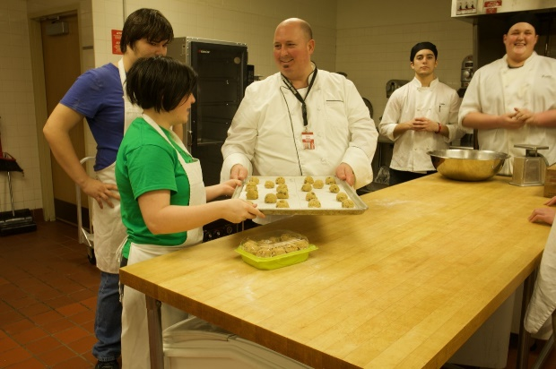
This program is for those students interested in the following careers:
- Chef
- Baking or Pastry Chef
- Industry Business Owner
- Catering
- Food Truck
- Restaurant Management
- Hotel Management
- Resorts, Cruise Lines or Tourism
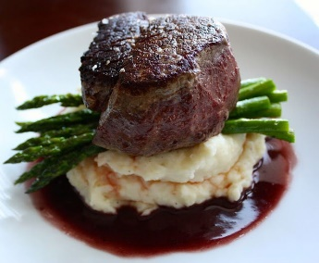
Program Highlights:
- Train and participate in SkillsUSA
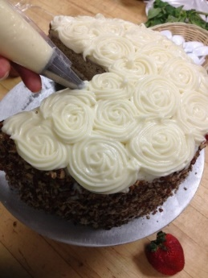
(HFS has students place in the top 10 in the nation!)
  - Culinary Arts
  - Commercial Baking
  - Team Banquet
- Learn to cook, bake, and create!
- Operate the Main Street Café and cook for monthly buffets
- Work one on one with area restaurant owners and chefs
- Class related field trips
- Earn ServSafe Certification and college credit
“The reason I picked the Hospitality/Food Service class over others is that for me it really came down to the great kitchen and equipment along with the hands-on professional training from a great instructor who makes cooking enjoyable.” -Westin Bowles, Lakers Senior

Meet your instructor:
Mr. John Miles, Instructor
Mr. Miles graduated from Grand Valley State University with a Bachelor’s Degree in Hospitality and Tourism Management, has an Interim Occupational Certification from Ferris State University, and a Master’s degree in Career and Technical Education Instruction from Concordia University. He is a nationally recognized ServSafe instructor and exam proctor. He has experience working in restaurants and hotels across the state of Michigan, as well as doing consulting work with several restaurants. Mr. Miles owns and operates a BBQ catering business and owns an organic mushroom farm that supplies area fine dining restaurants. His favorite part of teaching the Hospitality/Food Service program is working with students on expanding their knowledge and understanding of the Culinary Arts field, and then seeing their excitement when they perfect a new recipe or technique.
Attending the Huron Area Technological Center (HATC) was always my favorite part of the day throughout my junior and senior years of high school. I thoroughly enjoyed the many activities.. One of my favorites was getting to compete in the SkillsUSA-Commercial Baking Competition. At first, I wasn't really sure about competing, but I'm glad I decided to do it both years. Not only did it help me gain more skill, it also helped me gain confidence and I honestly had so much fun doing it. Mr. Miles set up the opportunity for me to train with the head chef of the baking department, Chef Scott Twichell, at the Culinary Institute of Michigan-Port Huron campus before competing at the state-level my senior year. That was an amazing opportunity I will never forget and I am so thankful for all of the memories I made through the Hospitality/Food Service Program at the Huron Area Tech Center.
Natasha, Owen-Gage, Class of 2018
Culinary Institute of Michigan graduate 2020

What do students have to say?
Articulation Agreements
Articulation agreements are made between colleges and the HATC, which allows students to receive college credit at an institution for completing the HATC program.

The following agreements are in place for this program at this time:

Delta College
Schoolcraft College
The Culinary Institute of Michigan
Grand Rapids Community College
Great Lakes Culinary Institute at Northwestern Michigan College
Mott Community College
Dorsry Culinary Academy
Les Cheneaux Culinary School
Kalamazoo Valley Community College
Grand Valley State University
Northern Michigan University
Ferris State University

“Taking classes at the Huron Area Tech Center allowed me to get a jump start on my schooling and thus my career. Being able to start my training in the culinary field in my Junior year gave me a huge advantage when I moved onto college. I was able to have a strong base from which to stand out from the crowd and improve upon”
Josh, BAHS, Class of 2016
Culinary Institute of Michigan graduate 2018
College level 2018 ACF Chef de Cuisine State Champion
College level 2018 ACF Chef de Cuisine Midwest 3rd place

Huron Area Technical Center
1160 South Van Dyke Road
Bad Axe, MI 48413
(989) 269-9284
www.huronisd.org
For more information or to enroll, please contact:
John Miles, Instructor jmiles@huronsid.org
Lane Walker, Principal lwalker@huronisd.org
Theresa Hessling, Assistant Principal thessling@huronisd.org
Sandi Smith, Student Services ssmith@huronissd.org

