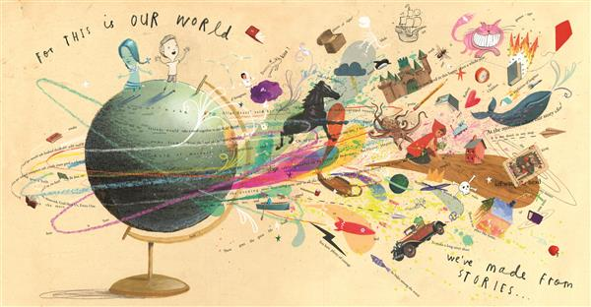
English II Course Syllabus
Ms. Hundley, Room J32
2020 - 2021

Welcome to English II! Last year you explored the various genres that the literary field has to offer. This year, we will travel around the world to explore literature and storytelling as common characteristics of the human condition. Thomas C. Foster describes this human connection best: “There’s only one story…Everywhere. Always. Wherever anyone puts pen to paper or hands to keyboard or fingers to lute string or quill to papyrus. They all take from and in return give to the same story…That one story that has been going on forever is all around us. We – as readers or writers, tellers or listeners – understand each other, we share knowledge of the structures of our myths, we comprehend the logic of symbols, largely because we have access to the same swirl of story. We have only to reach out into the air and pluck a piece of it.”

RCSS Course Description: ENGLISH II
Prerequisite: English I credit and/or Teacher/Principal Recommendation
Students in the course will explore world literature more widely and deeply, including more challenging and/or complete print and non-print texts. This course introduces literary global perspectives focusing on literature from the Americas (Caribbean, Central, South, and North), Africa Eastern Europe, Asia, Oceania, and the Middle East. It also includes the study of influential U.S. documents and a Shakespearean play will also be included in this course. The honors English course fosters intellectual curiosity by encouraging students to generate thought-provoking questions and topics and to research diverse sources. Honors courses will require students to work as self-directed and reflective learners, both independently and in groups as leaders and collaborators. Higher level thinking skills will be emphasized through interdisciplinary and critical perspectives as reflected in the quality of student performance in oral language, written language, and other media/technology. Additional outside reading and research will be required. This course is highly recommended for the college bound student. *This course has an End-of-Course test requirement – students must score a Level III or above to be deemed proficient.

*Notice: For health and safety, we will follow all RCSS and NCDHHS guidelines including, but not limited to, mask-wearing (covering nose and mouth), social distancing, and hand sanitizing. Thank you for your cooperation and concern for others!

The 4 major rules for my classroom are:
- Be prompt - be on time to class and on time to daily Google Meet live lesson
- Be prepared - pencil, paper, homework completed, etc.
- Be polite - Listen to other people without interrupting and treat others as you want to be treated
- Be productive - Keep your focus, ask questions, get your work done on time

Ms. Hundley’s Classroom Goal: Students are encouraged to let themselves have fun while learning. I promise it is possible. Remember the cliché that is so true: YOU GET WHAT YOU GIVE. This will require you to read all assignments, write to the best of your ability, and push yourself beyond what you think you are capable of in all aspects of class. Chances are, if you did not get the grade you wanted, I did not get the work I wanted.

Semester percentages:

-The EOC provided from the state will count as the exam grade for this course, comprising 25% of the course grade.

- Quizzes including EOC Practice Passages - 30%
- Tests (also projects, notebook checks, etc.) - 35%
- Classwork/Remote Participation - 35%

Materials Needed/Required:
-Literature Book (provided and left in classroom)
-Black pen or pencil
-Blue or Red pen for editing

-Composition Notebook for Major Writings/Projects –
sewn edge, not spiral
-Notebook paper
-1 Three Ring 1 inch+ Binder (Highly Suggested)

Possible Reading Selections:

A Midsummer Night’s Dream – William Shakespeare
Oedipus Rex – Sophocles
The Epic of Gilgamesh
The Iliad – Homer
Night – Elie Wiesel
A variety of short stories & poems from around the globe
Related nonfiction selections

Julius Caesar – William Shakespeare
Nectar in a Sieve – Kamala Markandaya
A Doll’s House – Henrik Ibsen
The Alchemist – Paulo Coelho
The Princess Bride - William Goldman
Life of Pi – Yann Martel
Red Queen – Victoria Aveyard

*Note: The teacher reserves the right to modify any and all assignments and their due dates.
**Note: Some of the content of our readings may be young-adult to adult themed in nature. Our readings are chosen, not for shock value, but for proven literary merit and future reference material. You are expected to treat the material with the maturity and respect it deserves.

It is my desire for each of you to not only pass this course but to graduate from high school and have a successful life. I hope you grow as an individual and challenge yourself to reach new horizons. I am excited to work with you!

Sincerely,
Ms. Hundley
Master of Arts in Teaching
School Contact: shundley@randolph.k12.nc.us (preferred) / 336-861-6870 (THS) / 4th block planning

