A Parent’ s Guide To Google Classroom

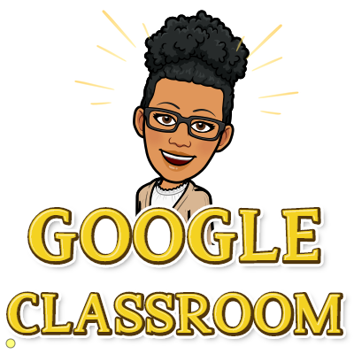

A step-by-step guide to understanding Google Classroom and helping your child to be successful

Table of Contents
Overview…………………………………Page 3
How to Access Classroom…………Pages 4-5
The Classroom Main Page……….Page 6
Tabs………..……………………………...Page 7
The Stream……………………………...Page 8
Classwork……………………………….Pages 9-10
Submitting Assignments……………Pages 11-12
Email Summaries……………………..Page 13

Overview
A growing number of school districts are turning to Google’s educational products to facilitate the use of technology in the classroom. This can be both exciting and overwhelming for parents and students alike. This guide will help you navigate Google Classroom and make use of all of its features to help your child be successful.
What is Google Classroom?
Google Classroom is a safe and secure web service that allows teachers to create, distribute and grade assignments in a paperless way. The primary purpose of Google Classroom is to streamline the process of sharing files between teachers and students. It can improve communication between teachers, students and parents by providing access to assignments, resources, grades and due dates. You can think of it like a “digital binder” for your child’s assignments and resources.
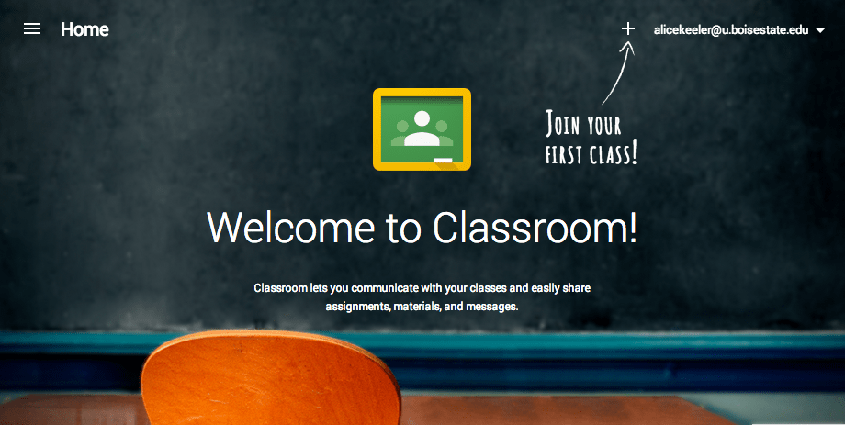

Accessing Google Classroom
How do I find my child’s classes?
At this time, the easiest way to locate your child’s Google Classrooms is to log in using their school Google account. In addition, some districts will provide teachers with access to a feature that enables them to send parents weekly or daily email summaries of assignments, announcements and due dates. Follow the steps below to locate all of your child’s classes: 1. Log in to Google with your child’s school email account. 2. Locate the “waffle” or Google Apps icon and select Google Classroom from the drop down menu.
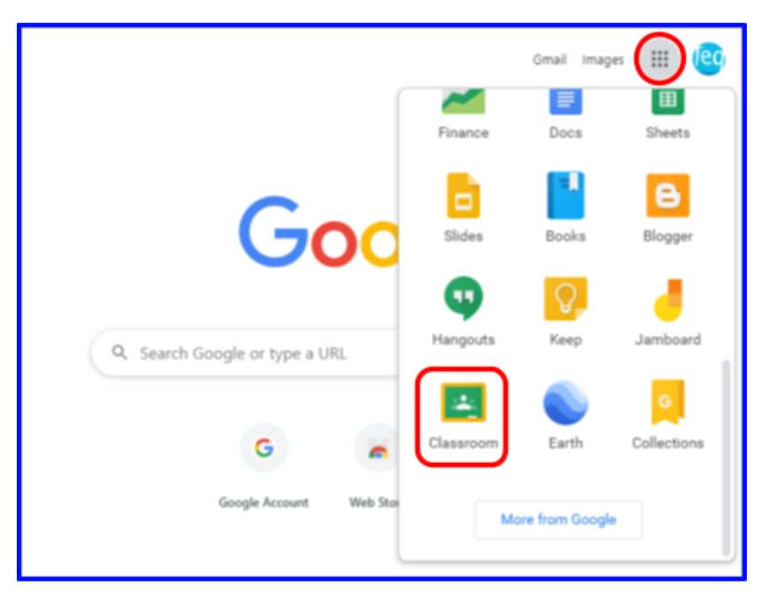

3. This will take you to all of the classes that your child has joined. Click on any class to enter or click on the icon in the upper left corner to see a list of classes and switch between classes.
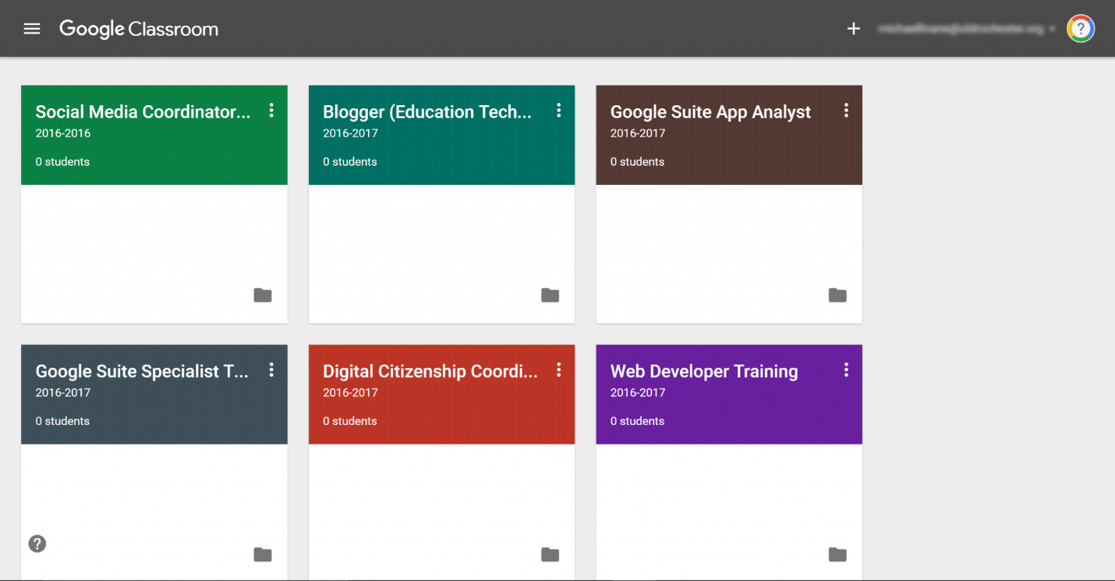

The Main Page
What information is on the main page and how is it organized? On the main page of the classroom you will find tabs at the top of the screen that will help you navigate between the stream, classwork and people section. More about each of these tabs will follow. In addition, you will find the stream, which will be explained in detail in the next section and due dates for assignments.

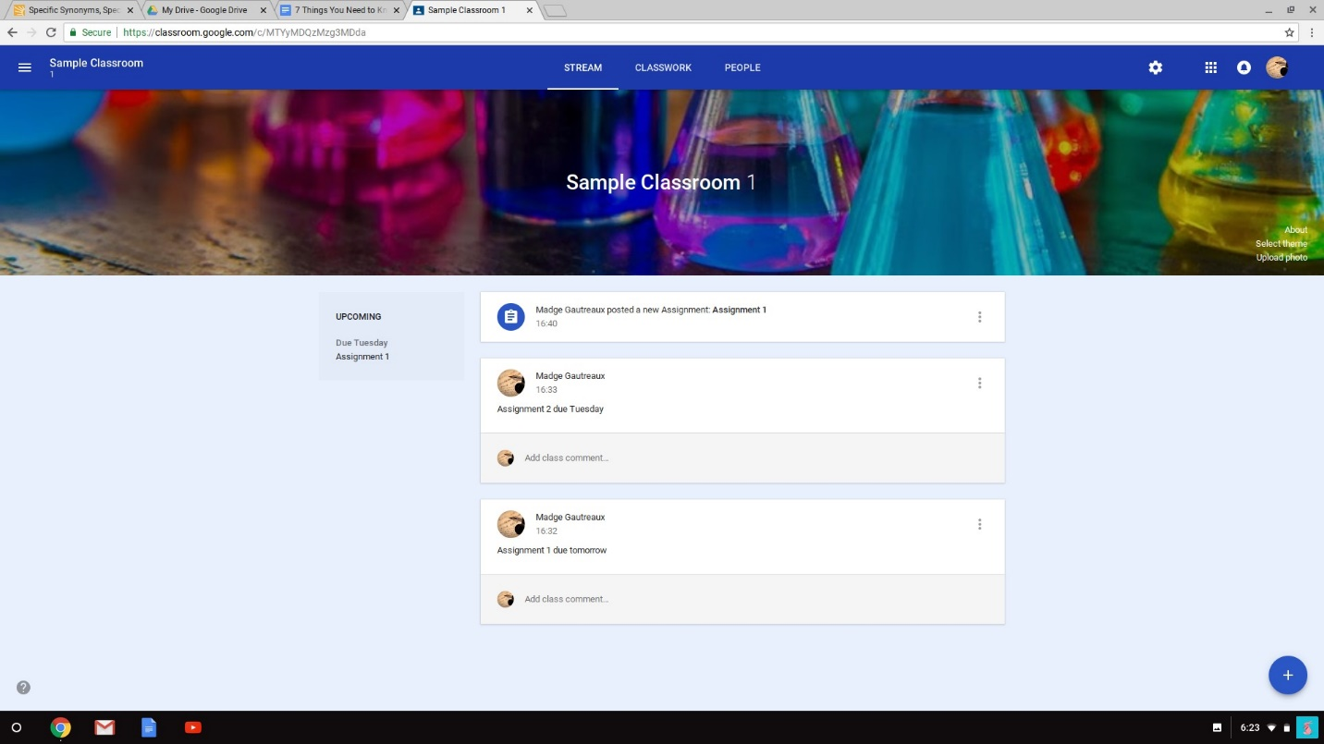

Tabs
What are tabs and what can I do with them?
There are three main tabs located at the top of the classroom which help students and parents navigate to different sections of the classroom. When you initially open the classroom you will be on the tab with the stream. Then second tab is titled “classwork” and contains assignments, questions and resources to complete work. The third tab is titled “people” and contains school email addresses of all students in the class and well as the teachers.
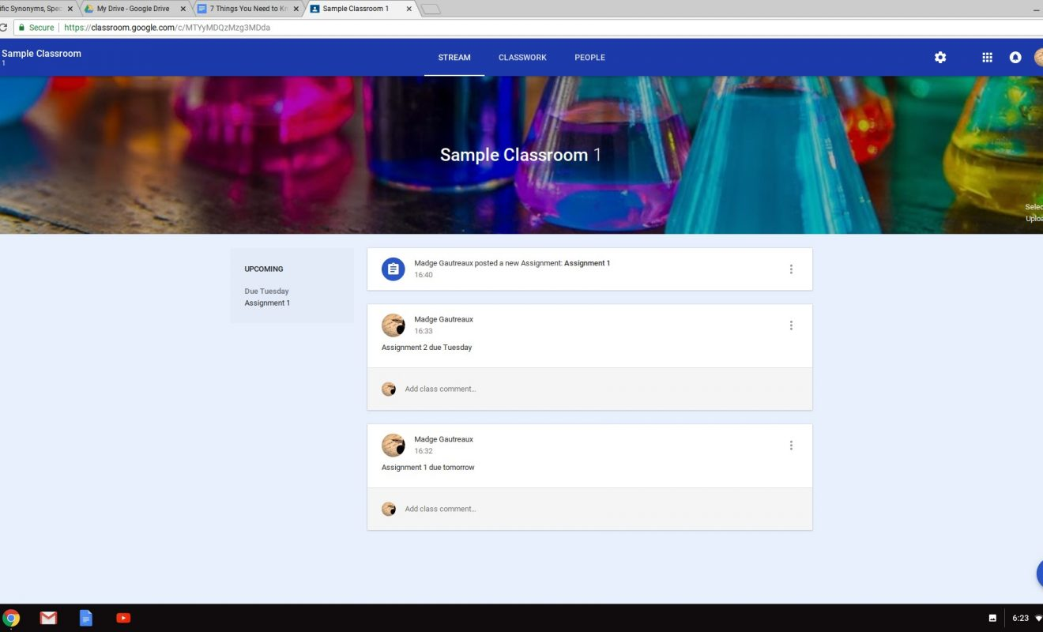

The Stream
What is the stream and what information can I find there?
The stream is where teachers post information for students. If you are accessing an older version of Google Classroom you will find announcements, assignments and questions. The newer version of Classroom has announcements in the stream, with assignments and questions under the tab titled “Classwork.”
Announcements:
Announcements are reminders or messages to students. They are organized with the most recent posts on top and older posts below. They may also have attachments such as forms for school pictures, flyers for school events or supply lists. Some teachers may also list homework assignments in the stream for easy access. Announcements will have a white header without the clipboard in the corner.
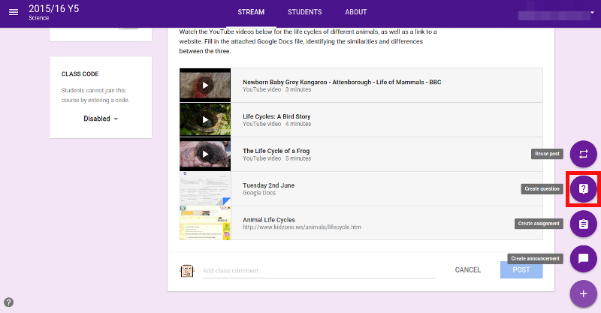

Classwork
The classwork tab is where you will find your child’s assignments. Teachers may also post links and other resources needed to complete assignments. In addition, teachers may post questions for students to answer in order to facilitate a class discussion on a topic of study.
Assignments:
Assignments in Google Classroom are paperless versions of traditional assignments that students would receive through a hand out. The clipboard icon in the upper left corner indicates that the post is an assignment for students to complete. When a student clicks on an assignment, it will take them to a Google Doc, Google Form or other tasks that they must complete and submit electronically. There may also be links to other resources that will help students complete those assignments. Teachers may grade assignments and return with a score via the classroom as well.
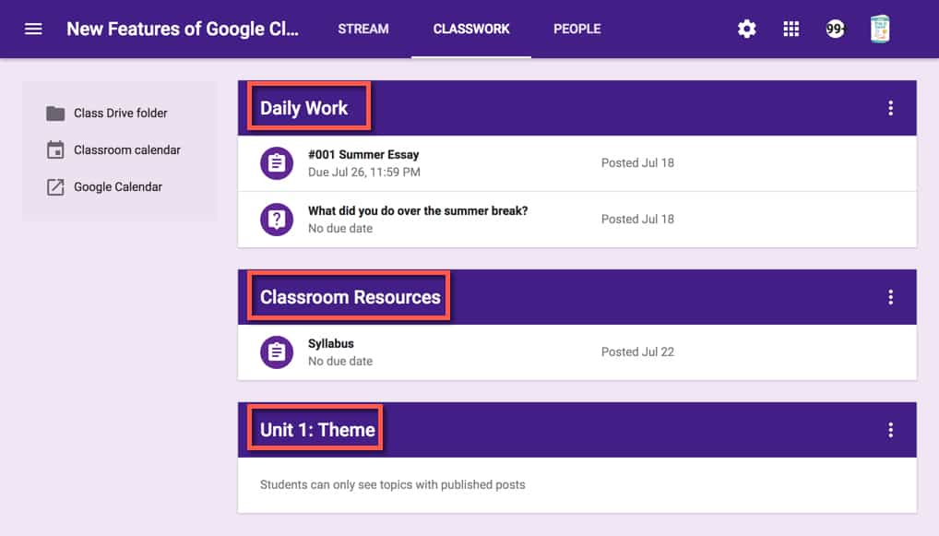

Questions:
Teachers can post questions for students to answer on the stream and encourage debate and conversation. If enabled, students may also respond to answers of their classmates.
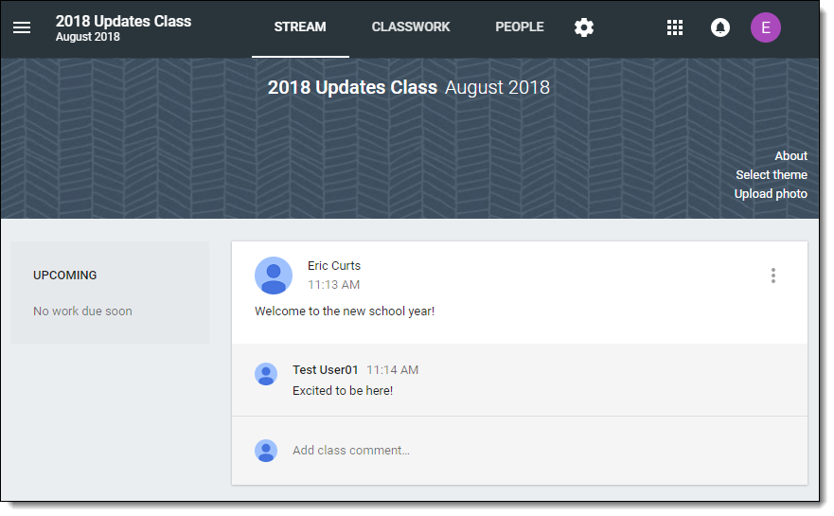

Submitting Assignments
How does my child submit completed assignments and how can we tell if assignments are done or late?
When a student opens an assignment there will be a “turn in” button at the bottom of the post. In addition, students will find the same button at the top of assignment document. In the top right hand corner of the assignment post will be status message telling you if the assignment is “not done”, “done” or “late.” You may also see a message indicating that the assignment has been returned with a grade.
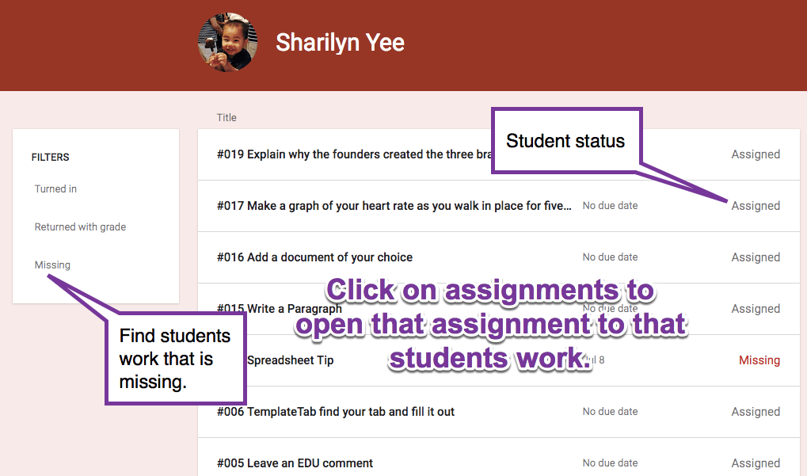

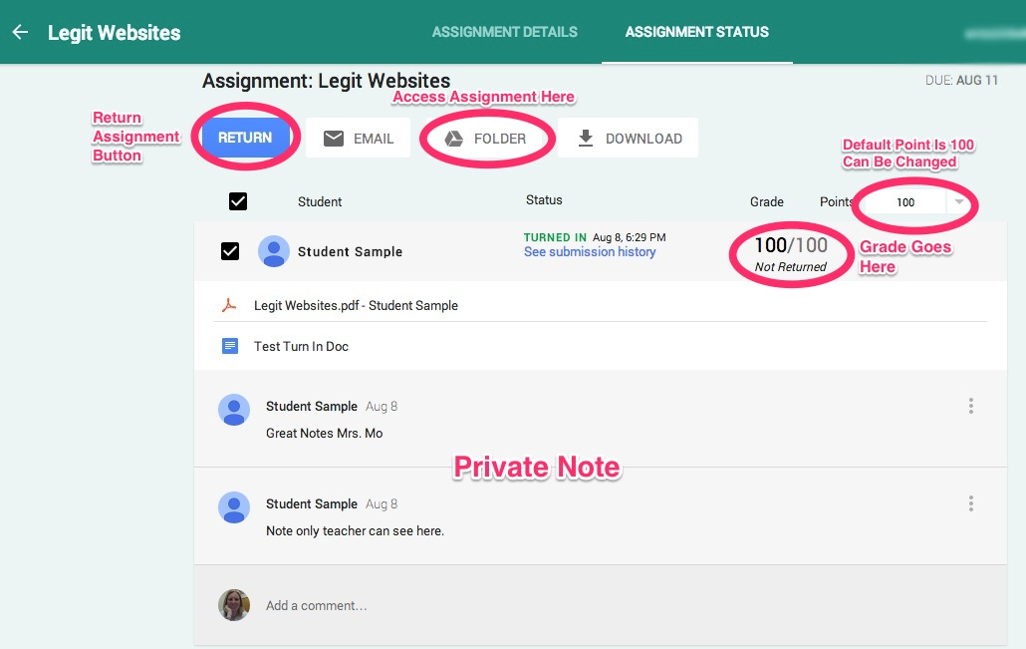

Email Summaries
What information can I get from email summaries and how do I get them?
Email summaries are a terrific communication tool for parents and teachers. If your child’s school district and classroom teacher have enabled this feature, you may receive daily or weekly emails including missing work, upcoming due dates for work and announcements. You need to have a Google account and you can determine the frequency of the emails. 1. You will receive and email from your child’s teacher that includes an invitation. When you accept that invitation, you can go to the settings to choose the frequency. 2. Log in to your Google account and choose settings at the bottom of an email summary. Sign in to the email settings page, choose frequency and the email that you would like to receive summaries. A sample parent summary page is shown below:
