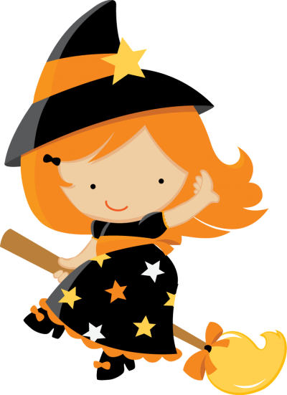

Weekly news from

Mrs. Newburn’s Class

**Upcoming Events / Reminders…**

* Tuition was due **Tuesday, October 15th.** If you haven’t turned it in yet, please do so ASAP
* Scholastic book orders are due by Wednesday, October 30th.
* The Halloween Party will be on Halloween this year (Thursday, October 31st). *See attached for party information.*
* There will be NO SCHOOL on Wednesday, November 6th – the teachers will be in *another* training!
* If you’re interested…Sunday, November 10th is the benefit dinner for Mrs. Sloan at the school from 1-5.

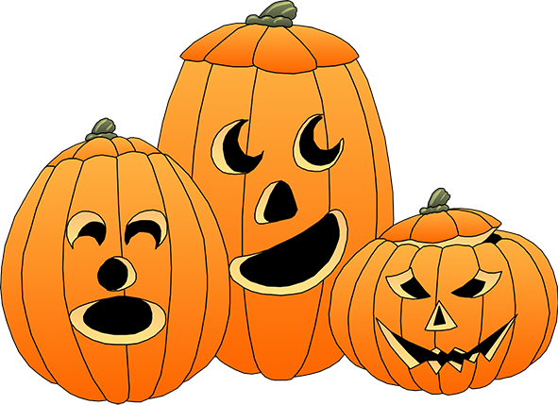

**Skills we are working on…**

* The letters “Aa, Tt, Ff, & Ii”, their sounds and how to make them in sign language
* Writing names/recognizing letters in names
* Fine motor skills (writing, coloring, and cutting)

**Things to work on at home…**

**Things to work on at home…**

* Days of the week
* The more practice with fine motor skills, the better! Practice writing, coloring, and cutting!
* Help your child write the first letter of their name