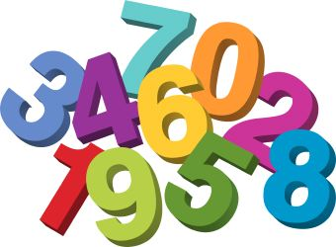
8th Grade Pre-Algebra Class Syllabus
Welcome to Ms. McLean’s Class!
Contact Information
Room: 18
Email: kmclean@dalecountyboe.org
Remind:
Planning Periods: 1st and 5th
What is Pre-Algebra?
Pre-Algebra is a foundation course that will guide you through the world of integers, one-step equations, inequalities, geometry concepts, linear equations and much more. This course will prepare students for the study of Algebra at the high school level.
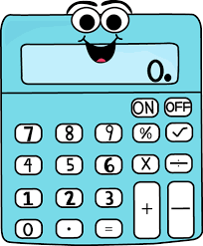
What do I need?
- Calculator
- Composition Notebook
- Pencils
How do you grade?
- Assessment: Tests are given at the end of each unit. There will be a review day before each test. There will also be weekly quizzes. Students may use their class notes and bell ringer activities on the quizzes.
  - 55% tests and projects
  - 45% daily grades and quizzes
  - No final exam
- Homework: You will not routinely be given homework; however, if you do not finish in class you will have to finish at home.
- Make-up and Late Work: Late work will be uploaded into ICU. Parents will be notified of all missing assignments. Any late work will have 15% subtracted from the grade. Students will be pulled during 6th period PE to make up work.
- Bonus Grades: Bonus assignments will be given randomly and may not be requested.
- Notebooks: We will make interactive notebooks. You will need a composition notebook.

Ms. McLean’s Class Rules and Procedures:
- Entering the Classroom - Students should enter my classroom with a positive attitude and quickly find their seats. Once in their seat, they are expected to get out their materials and begin work on the bell ringer activity.
- Tardy - If a student is tardy to my class, they should quietly come in, place their pass on my desk, and immediately go in their seat and begin participating in class. This is to minimize distractions associated with coming in late. On the fourth tardy, you will get a white referral and detention. On the fifth tardy, you will get an office referral.
- Absences - If a student is absent, they should check the class website or email me to find out what they missed. It is the student’s responsibility to find out what they missed, not the teachers.
- Absence on test/quiz day - A student’s absence must be excused to make up a test/quiz. If the absence is excused, it is the student’s responsibility to set up a make‐up time to take the test/quiz. I will pull you out of PE if you do not set up a time.
- Turning in an assignment - Homework, projects, or other assignments can only be turned in at the time designated by the teacher. The student’s name and the date should always be at the top of the assignments.
- Cell Phone - You may not be on your phone while in this classroom.
- Restroom - If you need to go to the restroom, you will be allowed to go to the restroom. However, be respectful of what is taking place inside the classroom. You will have to sign out in your planner and on bathroom pass form.
- Extra Credit - Extra credit assignments are not routinely given. If you feel as if you need extra credit assignment, make sure that you have first turned in all homework assignments.
- How to get help from the teacher - If you need assistance from the teacher during class, raise your hand and I will come to you as soon as possible. If you need assistance outside of class, talk to me about a time outside of class that will be convenient. If you need help after you get home, you can communicate with me by email. Please know that if you email me, I cannot guarantee that I will be able to get back to you during the night. I will try to answer any emails regarding homework by the next morning.
- Borrowing materials from the teacher - If you forget a pencil/pen or other material needed for class, first ask a fellow student if you can borrow one. If necessary, to ask the teacher, please do. However, I do expect to get back my materials. Do not be surprised if I ask for something from you to ensure that the borrowed material is returned.
- Classroom Management - The purpose of my discipline policy is to insure the rights of each students to attend South Dale in a safe, positive and productive learning environment.
First Offense: Warning
Second Offense: Parent Phone Call
Third Offense: Office referral
Severe disruptions will be handled on an individual basis and may include sending students directly to the office.

I have read and understand the rules of Ms. McLean’s Pre-Algebra Class.

_________________________________________________
Parent Signature

_________________________________________________
Student Signature

