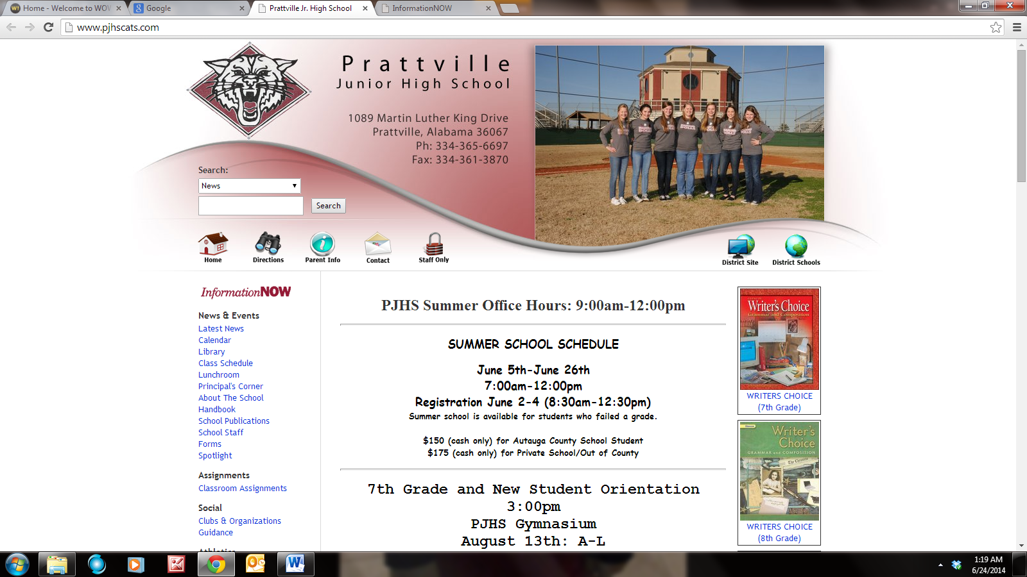

Preparing You For Future Success
Syllabus for

COURSE NAME: Computer Education Elective I

PREREQUISITE(S): None scholastic; basic computer familiarity and availability.

INSTRUCTOR: Mr. C. Hawkins
PLACE: Room 19
CONTACT: 334-365-6697 or chester.hawkins@acboe.net

COURSE DESCRIPTION: This course surveys both computer hardware and software. The hardware portion will focus on understanding the numerous parts of a computer and computer networking. The software portion will allow each student to develop skills in writing HTML code to build a website. This variety makes this course both interesting and academically challenging.

COURSE OBJECTIVES:
· To gain a better understanding of computer technology, to include the historical progression.
· To become familiar with the various parts of computer hardware in the standard desktop/laptop.
· To be able to differentiate between different variations of computer hardware cards and boards.
· To become familiar with the concepts of binary and hexadecimal numbering systems.
· To become familiar with the major types of computer networking hardware and their appropriate usage.
· To develop an understanding of processes involved in computer programming.
· To develop an understanding of the various programming languages used to build computer programs.
· To become familiar with the basic methods and concepts of website design.
· To become familiar with usage of HTML coding language for webpage development.

FORMAT: The format will be equal parts lecture and practical application; including several in-class demonstrations, exercises, videos, and discussions. I chose this format so that you can see the relevance of computers to everyday life. Consequently I do not attempt to cover the entire spectrum of computer hardware and software, but rather select certain topics to cover in more depth. I welcome questions at any time and hope that you will ask them! This course is viewed as a cooperative learning partnership between the teacher and the student. The success of this partnership depends on everyone involved being fully prepared for each class, maintaining independent readings and other assignments, and conducting themselves in a professional manner
The teacher’s role is to provide guidance, resources, and information as needed, to provide timely feedback, and to provide assistance in integrating information throughout the course. Students will be expected to demonstrate ingenuity and expertise in completing the course assignments. The responsibility of being an independent learner as well as working with other class members lies with each student. Your success depends on you.

READINGS: It is greatly to your benefit to read technology articles online and in print. This will allow you to better understand classroom discussions and be able to take much better notes.

PARTICIPATION: A portion of your grade will be participation. Becoming knowledgeable on the subjects to be discussed will benefit you and your peers in the class.

EVALUATION: There will be three major projects that must be completed to pass this class. There will also be other small projects/assignments and tests throughout the semester to assess your comprehension of the concepts discussed. If you fail to take a test, you will be assigned a 0 for that test.

COURTESY: If you come to class late or leave early, please do so in a manner that is the least disruptive to the class. Keep cell phones off and out of sight. There is no eating of food or drinking in this class as both can cause catastrophic harm to our computers. Talking, other than classroom discussion, will not be tolerated and will result in appropriate disciplinary actions.

TIPS FOR SUCCESS:
· Read related articles online and in print.
· Take notes.
· Ask questions in class.
· Later in the day, go over your notes and fill in parts you missed.
· Begin studying for a test several days before the test.
· Learn your notes well enough so that you could teach a friend.
· Test yourself to evaluate how well you have learned the material.
· See me in my classroom (either before or after school, or during break) if you have any questions or are not doing as well as you’d like.
· See me sooner than later. Don’t wait until you are in trouble.

_____________________________
Chester Hawkins, Instructor

________/s/_____________________
Janice Stockman, Principal

