**What are we learning?**

**We want to keep things as simple as possible for all students. We have created the 3 R’s. This is what your child with internet at home can do every day.**

**3 R’s: Read/Reflex/ReadingEggspress**

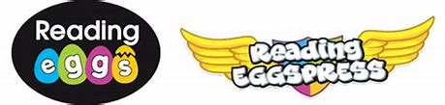

Reading Eggspress. This week we have books for you to read and online quizzes to complete.

Fiction Book: Cupcakes with Sally Ride

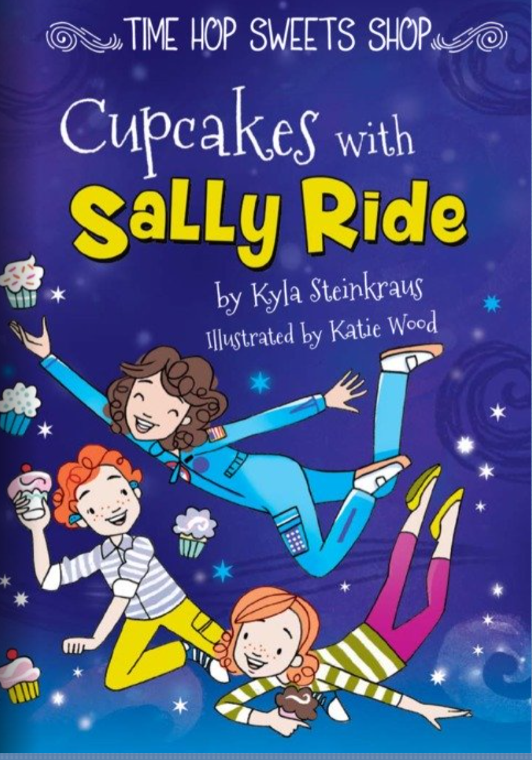

Non-Fiction Book: Sky and Season

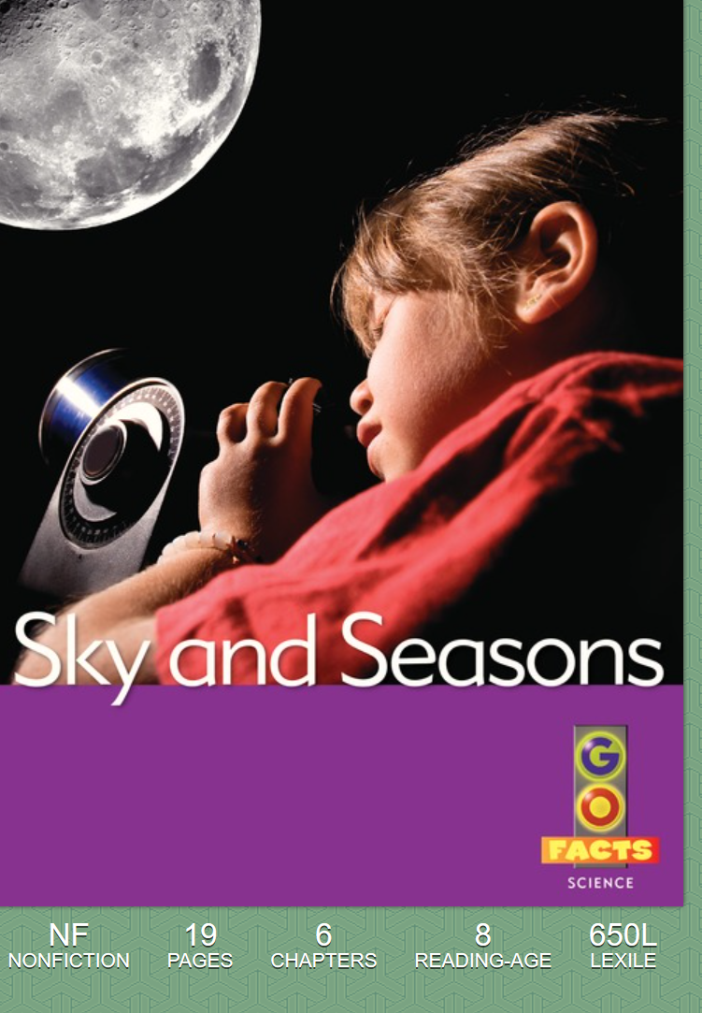

### DCPS

April 6th-10th

2nd Grade News

**Math Skills**

😊Did you get a green light on Reflex today?

This week your teacher will post on their website:

* Word Problem of the Day
* 9 Box Review

Remember you can do this on notebook paper too.

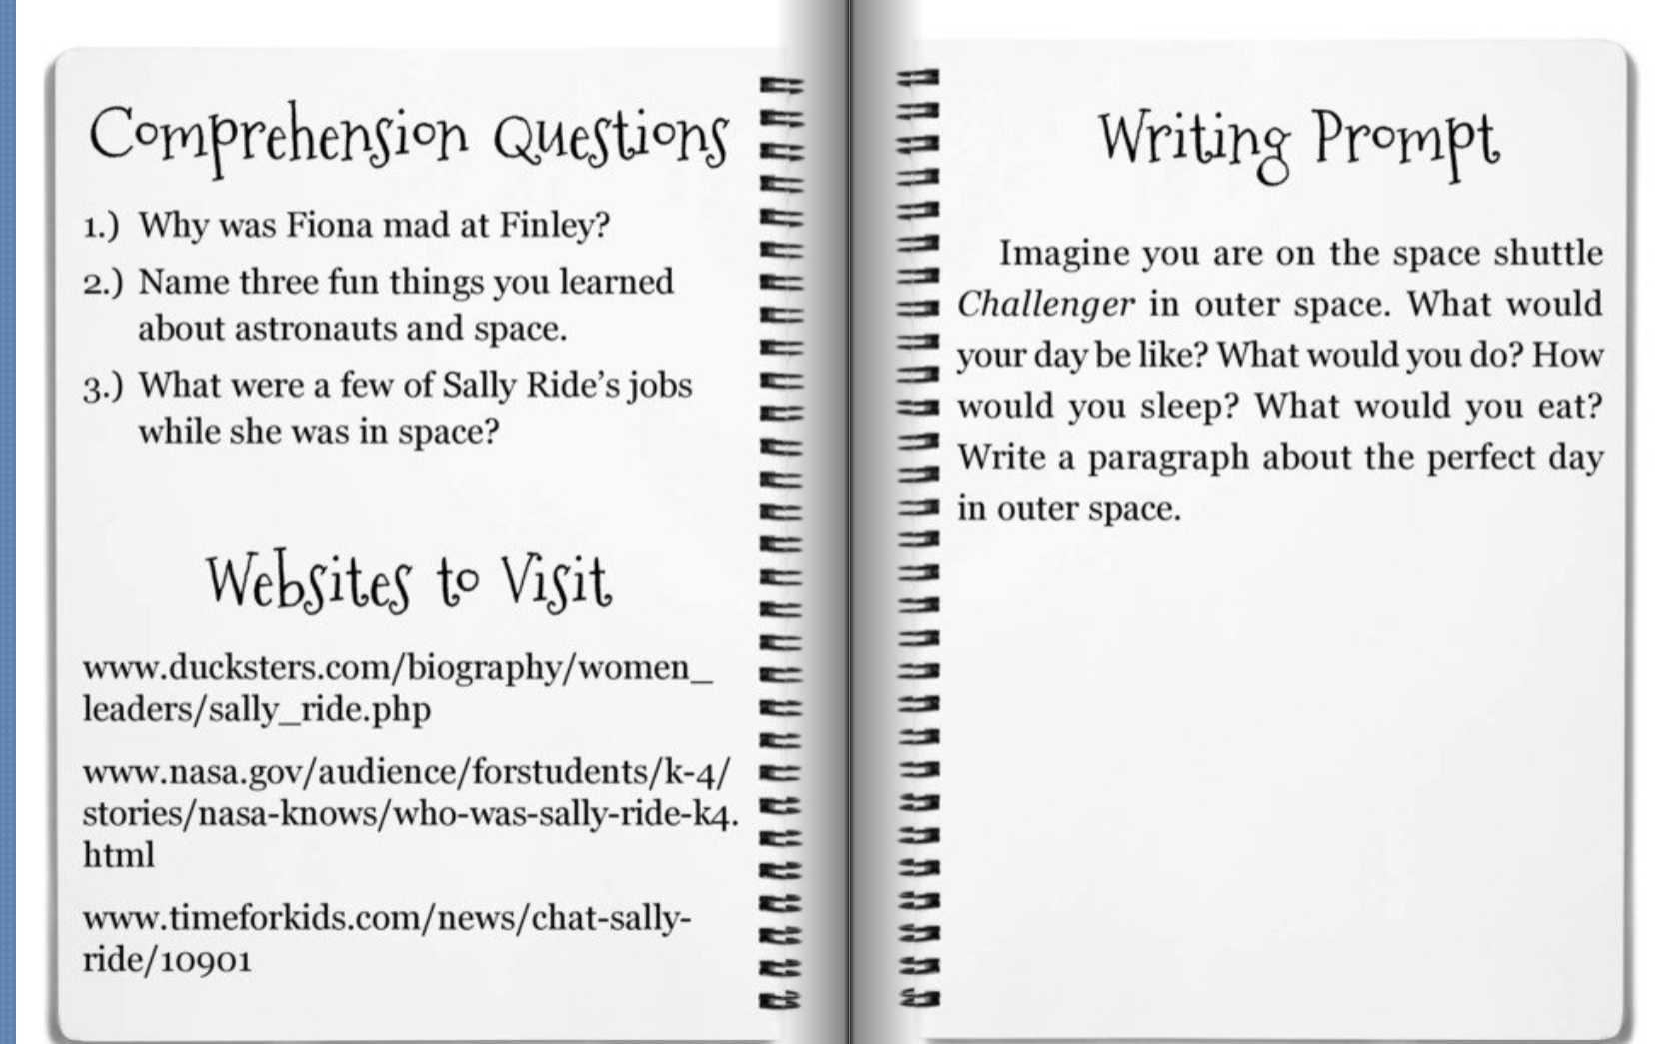

**Remember me**

**Please contact your child’s teachers for any questions. We miss you all!**

**Website/Facebook:**

Please look at your teacher’s website for more links and information. We have also created a DCPS 2nd Grade Facebook group that you can follow for more ideas and websites.

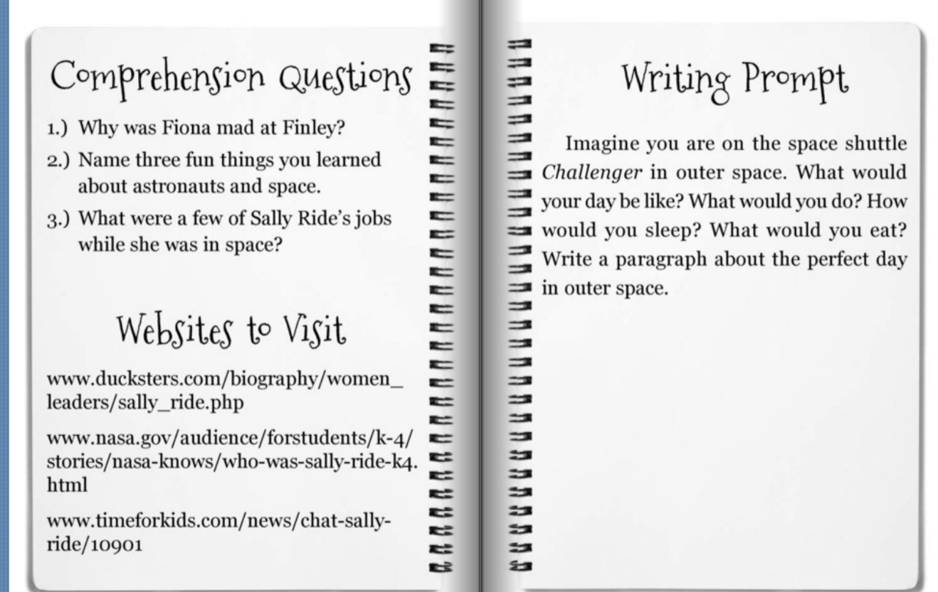

**Comprehension Questions Parents Can Ask:**

1. Name three fun things you learned about.
2. Would the book be different if it had been written 10 years ago?

**Comprehension Questions Parents Can Ask:**

1. Why was Fiona mad at Finley?
2. What were a few of Sally Ride’s jobs while she was in space?

## Phonics