

Weekly news from Mrs. Newburn’s Class



**Upcoming Events / Reminders…**

* October 3rd we will be getting a visit from local firemen/women to teach us about fire safety!
* October 7th (Monday) we will visit the book fair from 9:45-10:15
* October 7th is the Breakfast with a Loved One (there was a change in the day)…the time is still 9:30-10:30
* Conferences are Thursday, October 10th. If you haven’t sent your form in, please do so ASAP!
* Tuition is due on or by the15th of each month!
* There is **NO SCHOOL** on Monday, October 14th (Columbus Day) and Tuesday, October 15th (Teacher in-service).
* The Halloween Party will be on Halloween … Thursday, October 31st. The head mom will be contacting you shortly with details!

[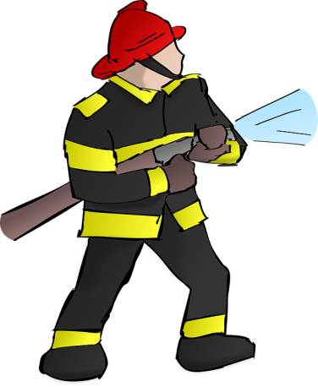](https://www.google.com/url?sa=i&rct=j&q=&esrc=s&source=images&cd=&cad=rja&uact=8&ved=0ahUKEwjxlcrH0crWAhWI6yYKHesjCJ0QjRwIBw&url=https://pixabay.com/en/photos/water%20hose/&psig=AFQjCNFyxmSCDaWVmDDViUADlZn1ZOEr6g&ust=1506782796699235)

**Skills we are working on…**

* The letter “Aa”, its sound and sign language
* The letter “Tt”, its sound and sign language
* Writing names/recognizing letters in names
* Days of the week
* Fine motor skills (writing, coloring, and cutting)

**Things to work on at home…**

**Things to work on at home…**

* Days of the week
* The more practice with fine motor skills, the better! Practice writing, coloring, and cutting!
* Help your child write the first letter of their name