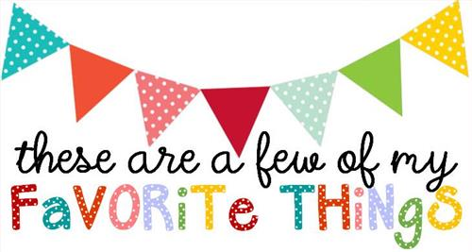

Name: Kristan Norris
T-shirt Size: Bella or Gildan-L / Comfort Colors-XL
Birthday: September 29
Monogram: KNP
Favorite Color: Red
Favorite Flower: Dark red gerber daisy
Favorite Scent: Cucumber Melon or Pumpkin Spice
Favorite Candy: Take 5 or Peanut M&M’s
Favorite Drink: Coffee, Unsweet tea with Blackberry flavoring from Sonic, or Coke
Favorite Food: Asian cuisine
Favorite Snack: Yogurt or raw veggies with spicy hummus
Favorite Fruit: Kiwi, pears, or mango
Favorite Restaurant: Urban Japanese Fusion, Amerigo’s, or Flight
Favorite Places to Shop: Ulta, Pink Coconut, or Amazon
Things I collect: Owls, Elephants, or Coffee Mugs
Favorite Author/Book Series for my own personal reading: Ted Dekker, Jessica R. Patch, or Christian Mystery & Suspense
Wish List for Classroom:
https://www.amazon.com/hz/wishlist/ls/1WUI3F5IP5UD8?ref_=wl_share

