

**Coffee County Schools**

**Title I Programs**

*Dr. Morris Leis*

*Superintendent*

#### *Kim Miller*

#### *Director of Federal Programs*

#### *Destination Graduation*

#### *For College, Career, and Life*

#### 2016-2017

**Title I is a federally funded**

**program under the**

**Every Student Succeeds Act**

**Purpose:** To help low-achieving students meet the state’s challenging academic content and performance standards. The Title I program offers a variety of services which may include: additional teachers and support staff, extra time for instruction, a variety of teaching methods and materials, smaller classes and additional training for staff.

**Qualifications:** Schools qualify for funds based on economic need. All schools in Coffee County are Schoolwide Programs.

**School-wide Requirements:** Comprehensive needs assessment: The school must identify areas of greatest need

• School-wide reform strategies to include those that:

Strengthen the core academic program

Increase the amount and quality of learning time

Meet the needs of underserved populations

Address needs of all, but particularly low-

achieving students

• Instruction by highly qualified teachers

• Professional learning for teachers

• Parent involvement strategies

**Homeless Children and Youth**

The Coffee County School System has policies and procedures in place that identify and remove any barriers for homeless children and youth in accordance with the McKinney-Vento Act. Please contact Dr. James Banks at 912-384-2086 for more information.

**Status: There are no schools in Coffee County identified as needs improvement schools according to criteria determined by the Georgia Department of Education.**

**For more information or questions, please contact**

**Dr. Bernie Evans at 912-384-2086 ext 6507**

#### 2012

**Parents have the right…**

to know the professional qualifications of their child’s teacher(s) including the degrees and certifications held, and whether the teacher is certified in their respective area of instruction.

to know the school improvement status of the school.

to know the level of achievement of their child in each area of the state assessment.

to know if their child has been assigned, or has been taught for at least four consecutive weeks, by a teacher who does not meet the highly qualified definition.

to be involved in the planning and implementation of the parent involvement program in their school.



**For more information, please contact Kim Miller**

**Director of Federal Programs**

**912-384-2086**

http://www.gadoe.org/School-Improvement/Federal-Programs/Pages/Parent-Engagement-Program.aspx

As part of its Assurances within ESEA program grant applications and pursuant to Section 9306 on the Elementary and Secondary Education Act an LEA accepting federal funds also agrees to adopt local written procedures for the receipt and resolution of complaints alleging violations of law in the administration of covered programs.

**For more information or questions, please contact**

**Dr. Bernie Evans at 912-384-2086 ext 6507**

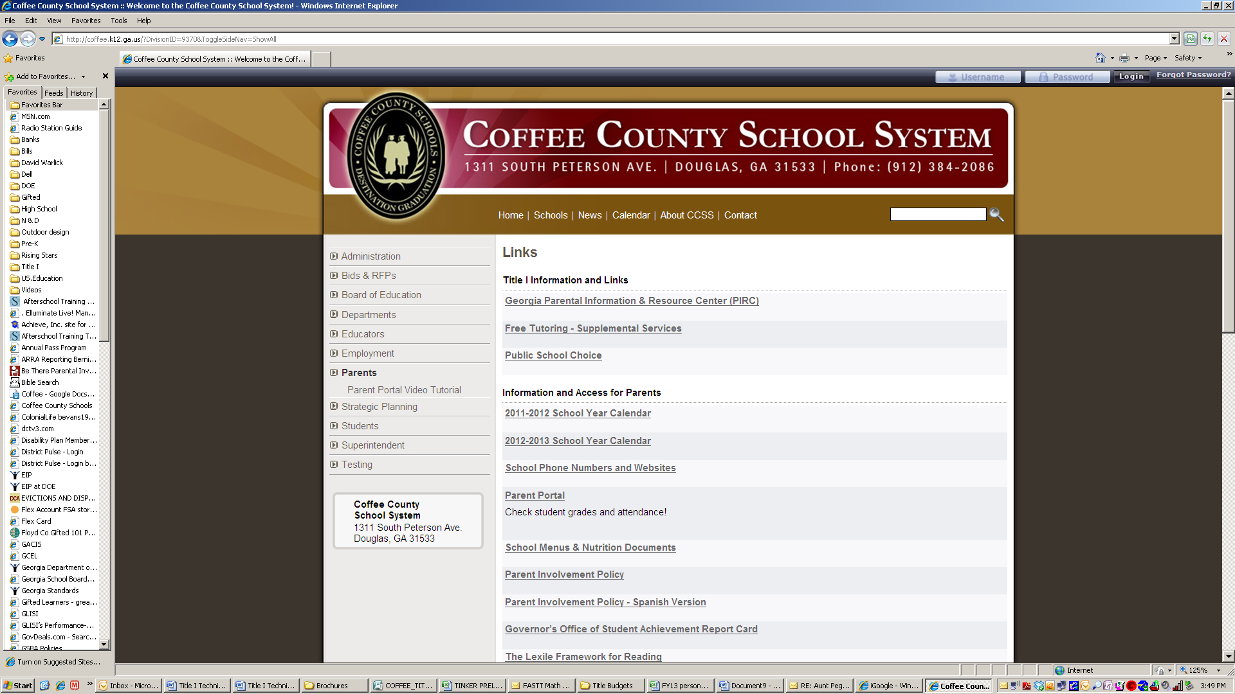

Visit our website at coffee.k12.ga.us

**Georgia Parental Information and**

**Resource Center (PIRC)**

Parent strategies, best practices and research

www.georgiapirc.net

**Homeless Children and Youth**

The Coffee County School System has policies and procedures in place that identify and remove any barriers for homeless children and youth in accordance with the McKinney-Vento Act. Please contact Dr. June Munford at 912-384-2086 for more information.

**Homeless Children and Youth**

The Coffee County School System has policies and procedures in place that identify and remove any barriers for homeless children and youth in accordance with the McKinney-Vento Act. Please contact Dr. June Munford at 912-384-2086 for more information.

**Homeless Children and Youth**

The Coffee County School System has policies and procedures in place that identify and remove any barriers for homeless children and youth in accordance with the McKinney-Vento Act. Please contact Dr. June Munford at 912-384-2086 for more information.