Origin of life studies
Although scientists cannot directly address how life on Earth arose, they can formulate and test hypotheses about natural processes that could account for various intermediate steps, consistent with the geological evidence. In the 1920s, Alexander Oparin and J. B. S. Haldane independently proposed nearly identical hypotheses for how life originated on Earth. Their hypothesis is now called
the Oparin-Haldane hypothesis, and the key steps are:
- formation of organic molecules, the building blocks of cells (e.g., amino acids, nucleotides, simple sugars)
- formation of polymers (longer chains) of organic molecules, that can function as enzymes to carry out metabolic reactions, encode hereditary information, and possibly replicate (e.g., proteins, RNA strands),
- formation of protocells; concentrations of organic molecules and polymers that carry out metabolic reactions within an enclosed system, separated from the environment by a semi-permeable membrane, such as a lipid bilayer membrane
The Oparin-Haldane hypothesis has been continually tested and revised, and any hypothesis about how life began must account for the 3 primary universal requirements for life: the ability to reproduce and replicate hereditary information; the enclosure in membranes to form cells; the use of energy to accomplish growth and reproduction.
Miller-Urey experiment
Stanley Miller and Harold Urey tested the first step of the Oparin-Haldane hypothesis by investigating the formation of organic molecules from inorganic compounds. Their 1950s experiment produced a number of organic molecules, including amino acids, that are made and used by living cells to grow and replicate.
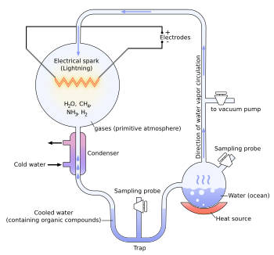
Miller-Urey experiment, Wikimedia Commons illustration by Adrian Hunter
Miller and Urey used an experimental setup to recreate what environmental conditions were believed to be like on early Earth. A gaseous chamber simulated an atmosphere with reducing compounds (electron donors) such as methane, ammonia and hydrogen. Electrical sparks simulated lightning to provide energy. In only about a week’s time, this simple apparatus caused chemical reactions that produced a variety of organic molecules, some of which are the basic building blocks of life, such as amino acids. Although scientists no longer believe that pre-biotic Earth had such a reducing atmosphere, such reducing environments may be found in deep-sea hydrothermal vents, which also have a source of energy in the form of the heat from the vents. In addition, more recent experiments – that used conditions that are thought to better reflect the conditions of early Earth – have also produced a variety of organic molecules including amino acids and nucleotides (the building blocks of RNA and DNA)
https://www.youtube.com/watch?time_continue=4&v=NNijmxsKGbc watch the video at this link

