Noah mowed lawns in June for extra money. He made $56 the first week, $32 the second week, $28 the third week, and $15 the fourth week. How much money did he make in June? | 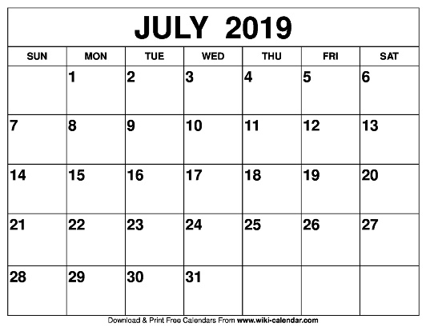  Izzy gets her allowance on Monday. She gets $2 each week for walking the dog. How much will Izzy make this month?  How many weekend days are there in July? | Which answer choice shows skip counting back by 10’s.  A) 46, 56, 66, 76, 86  B) 153, 253, 353, 453  C) 102, 92, 82, 72, 62  D) 75, 70, 65, 60, 55, 45
Choose the correct number sentence for the array above.  A) 9 + 9 = 18  B) 3 + 3 + 3 + 3 + 3=18  C) 6 + 6 = 12  D) 3 + 3 + 3 + 3 + 3 + 3 =18 | Salma made a scarf for her grandmother. She knitted 28 inches in the morning. She knitted more in the afternoon. When she finished the scarf it was 62 inches long. How much did she knit in the afternoon? | Kaden has 7 quarters, 3 dimes, 5 nickels, and a penny. He used $1.50 to buy a drink. How much money does he have left?
There are 752 students are DCPS. There are 216 kindergarteners and 298 first graders. How many of the students are second graders? | Solve.  419 + 265 = ? | Milla has the coins below. How much money does Milla have in all?    

